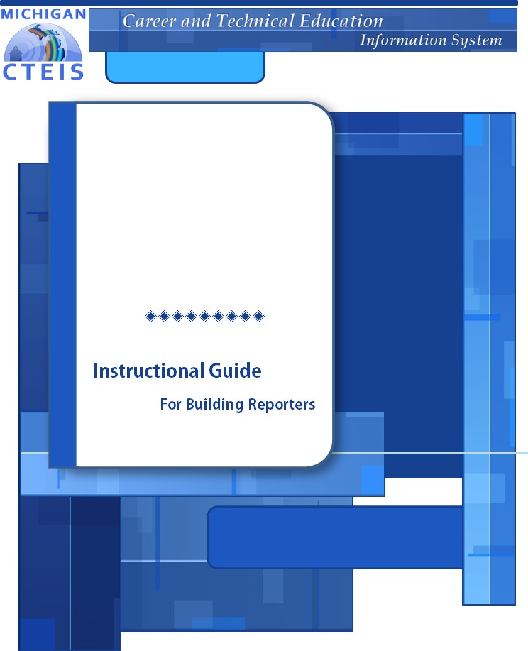

Fall 2021 - 2022

Fall Data Entry and

Review

Instructional Guide

Due to CEPD June 16, 2022
Due to OCTE June 23, 2022

WELCOME TO

COURSE INFORMATION

The objective of PTD Technology computer software training is to produce capable, self-confident, and proficient software users. We emphasize education concepts based on ‘real world’ scenarios. Using the new CTEIS 2022 Web application, our goal is to provide you with the very best in ‘hands-on’ instruction and materials to assist you and your organization in achieving your reporting goals.

To further enrich your training experience, PTD Technology provides valuable reference manuals. We trust you will find our educational methods and proven training experience synergistic with your goals. Help Desk Support is also available to clients requiring additional assistance at no charge to the districts.

As a pioneer in instructor-led computer training since 1978, we continue in our mission to deliver the most effective and professional computer training to you. We encourage your comments or suggestions as to how we might better serve you.

For more information about PTD Technology, call us at (517) 333-9363 Ext. 128, or visit our website at www.PTDtechnology.com.

WELCOME TO

SUPPORT

PTD Technology provides technical support to districts operating Career and Technical Education (CTE) programs.

The PTD Help Desk is staffed by experienced PTD training specialists, consultants, and dedicated support staff. Due to rapidly changing software versions and new releases, we may require additional time consulting with other professional staff.

When using this service, please be sure to provide your contact information including your name, school district, phone number, and/or email address. For CTEIS reporting, please also provide the name of the report you are preparing.

TECHNICAL HELP:
cteis.help@PTDtechnology.com (800) 203-0614 or (517) 333-9363
Extension 128

REPORTING POLICY HELP:
Joan Church ChurchJ@michigan.gov (517) 335-0360

OCTE WEBSITE:
www.michigan.gov/octe

TABLE OF CONTENTS

Course Information | 2

Support | 3

Introduction to CTEIS Data Entry | 9

Fall Tasks | 9

Reference Documents | 10

Overview | 11

Checklist for Fall Data Entry | 13

Log into CTEIS | 14

Manage Courses | 14

Reporting Course Sections, Segments, and Competencies | 14

Open the Manage Courses Page | 16

Course Sections and Subsections | 16

Add New Courses | 17

Course Section Fields | 21

The Course Information Panel | 21

The Segment Profile Panel (P4 Courses Only) | 24

The Competency Profile Panel (P5 Courses Only) | 26

Special Cases | 28

FCS CIP Code 19.0000 | 28

Dual Enrollment and Early Middle College | 29

Search Courses | 30

Edit Courses | 31

Copy Course Information | 33

Determine Course Status | 33

Deactivate an Active Course | 34

Copy a Course Section | 34

Add Staff to Courses | 36

Add a Staff Member to a Course | 36

Mass Course Edits | 38

Open the Mass Course Edits Page | 38

Apply Mass Course Edits | 39

Deactivate Courses | 40

Importing Courses | 41

Before You Begin Importing Courses | 41

Import Course Data | 41

Review Courses | 43

Instructional Design Report | 43

List of Courses by Building | 44

Generate Your Reports | 44

Printing from CTEIS | 45

Manage Credentials | 46

Open the Manage Credentials Screen | 46

Import Credentials | 50

Importing Credentials: Potential Errors and Resolutions | 52

Work Based Learning | 53

What Is Work Based Learning? | 53

Work Based Learning Continuum | 54

How to Enter Work Based Learning | 55

Manage Work Based Learning | 57

Work Based Learning Data Reporting Tracking Sheet | 62

Generating a Work Based Learning Report | 63

Import Work Based Learning Entry | 64

Manage Work Based Learning Through Enrollments | 66

Additional Work Based Learning Information | 69

Work Based Learning Import Table | 69

Manage Staff | 72

Open the Manage Staff Page | 72

Points to Remember When Managing Staff | 73

Staff Information Fields | 74

Add a Staff Member to the CTEIS Database | 75

Edit Staff Information | 76

Manage Students | 77

Open the Manage Students Screen | 77

Navigate the Manage Students Screen | 78

Add a New Student Record | 78

Student Demographic Fields | 79

Program Details and Current Enrollment | 85

Edit or Review an Existing Student | 86

Importing Students | 87

Before You Begin Importing Students | 87

Import Student Data | 87

Review Students | 89

Check UIC Button | 89

Bad UIC by Building Report | 90

UIC With No Current MSDS Report | 90

Manage Enrollment | 91

Open the Manage Enrollment Screen | 91

Enroll Students | 92

Edit Enrolled Students | 94

Copy/Transfer Marked Students | 95

Grade Input | 97

Letter Grade Definitions and Comparable GPAs | 99

Importing Enrollments (with Grades) | 100

Before You Begin Importing Enrollments | 100

Verify Imports | 101

Review Enrollment Information | 102

The Program Enrollment Details Panel | 103

Class Student List Report | 103

Fall Course and Staff Entry | 104

Enrollment Validation | 106

Validate Your Enrollment Data | 106

Troubleshoot Enrollment Data Entry Issues | 108

Review Student UICs and Grades | 110

Bad UIC by Building Report | 110

Current Year Missing Grades Report | 110

UIC With No Current MSDS Report | 111

Enrollment Issues | 112

Issue Tables | 113

Student Core Information Error Messages | 113

Error Messages | 114

Warning Messages | 118

Review Completers | 119

Verify Instructional Design | 119

Completer Assessment Report | 120

Program Enrollment History Report | 120

Complete Your Report | 122

Further Assistance | 122

Appendices | 123

General CTEIS Information | 124

Steps for Gaining Access to www.cteis.com | 124

Logging Into CTEIS | 124

Troubleshooting Your Login | 124

CTEIS Terms/Abbreviations | 125

Deadlines for 2021 - 2022 | 126

Additional Definitions | 127

CTE Segments and Grades | 128

Import Formats | 130

Excel Spreadsheet Format | 130

Course Data Heading Formats | 131

Excel Format – Course Data Headings | 131

Excel Format – Segment Data Headings | 133

Student and Enrollment (with Grades) Heading Formats | 134

Excel Format – Student and Enrollment (with Grades) Headings | 134

INTRODUCTION TO CTEIS DATA ENTRY

Welcome to CTEIS, the Career and Technical Education Information System! This guide contains a list of terms common to CTEIS, an explanation of the purpose and processes surrounding the Web-based reporting system, a discussion of reporting requirements, and useful contact information for those seeking assistance with CTEIS throughout the reporting cycle.
CTEIS is a Web-based application that allows you to report enrollment information for state-approved CTE programs to the State of Michigan. To access it, you may log into the system at www.cteis.com using your MEIS username and password. The average building-level reporter will focus on completing three reports throughout the course of the year.

Enrollment | Expenditures | Follow-Up
Begin in September | Begin in September | Begin in October
Fall Course and Staff Entry: Com- plete in mid-September | Complete in November | Complete in January
Spring Collection
(including credentials and WBL): Complete in June

Fall Tasks
- Receive class instructional design from staff, enter instructional design into CTEIS, and verify design structure by obtaining signatures from teachers.
- Enter all available courses and student information into CTEIS, print student class lists, and obtain teacher signatures.
- Run CTEIS validation and begin to address student UIC and MSDS data issues.

- Fall Course and Staff Reporting — Complete fall student enrollment and course entry and run CTEIS validation. Verify all entries by printing student class lists and obtaining teacher signatures.
- Expenditure Reporting — Enter and validate all CTEIS expenditures.
- Follow-Up Reporting — Conduct the Follow-Up survey.

REFERENCE DOCUMENTS

You may download the materials that are referenced in this manual from the CTEIS Knowledge Base at support.cteis.com. These include:

Under Enrollment ➔ Fall Data Entry:
- Fall Data Entry instructional guide

Under Enrollment ➔ Special Collections:
- Competencies Instructional Design guide
- Manage Credentials guide
- Work Based Learning guide

Under Importing:
- Importing Students guide
- Importing Courses guide

Importing (Students)
- Excel Format - Student Import File Specifications guide
- Excel Format - Student Import Headings file

Importing (Courses)
- Excel Format - Course Import File Specifications guide
- Excel Format - Course Import Headings file
These documents are discussed in detail during the Spring Enrollment and Completion training course.

OVERVIEW

In preparation for the Spring Enrollment Report, you are strongly encouraged to begin your data collection, entry, and validation as early in the school year as possible. The fall update provides an opportunity to begin collecting, entering, and verifying your fall data well before the spring deadline. Furthermore, reporters are required to enter at least one fall course per teacher per PSN by the end of September. Because the information from this report is used to determine funding allocations as well as to fulfill federal reporting requirements, it is important that all data be complete and accurate.

The purpose of this guide is to assist you with optimizing your spring enrollments and to ensure that you maximize your student concentrators and completers. This guide outlines the best practices for:

Data Entry

Data entry is done through:
- Manual data entry using the following CTEIS screens:
  - Manage Courses
  - Manage Students
  - Manage Enrollment –OR–
- Importing data.

Utilizing the File Import feature is highly recommended—this tool can save you valuable time and will minimize data entry errors. You may upload error-free records into your CTEIS database at any time; furthermore, if CTEIS detects problems with your import file, it will generate a list of warnings and errors for you to review. The system stores the affected records until you correct your data file and import it again.

Data Review

This guide focuses on the importance of reviewing your data with the help of CTEIS validation and reporting tools. You will learn how to verify the instructional design of

your courses and to leverage reports and tools such as the Check UIC feature. These reports and tools allow you to quickly verify data entries and ultimately ensure that your information is complete and accurate.

CTEIS validation tools are useful for illuminating invalid data—that is, information that does not meet the system's specified criteria; however, information that has been entered improperly will not always produce errors. Examples of common data entry mistakes include enrolling students into the wrong course section and incorporating incorrect segments or competencies into your courses. Mistakes such as these can cause your programs to produce fewer completers than expected. To prevent this, you are required to review your instructional design and the available summary reports with the individuals who provide your information. Accurate information projects completers correctly.

CHECKLIST FOR FALL DATA ENTRY

Task | Done!
Manage Courses  - Enter, import, or update course section information by checking that:  - * All courses and primary instructors for the school year are entered. Enrollments, segments, and competencies are not required at this time but should also be entered.  - EMC and Dual Enrollment courses are identified and entered correctly.  - Dates for the courses are correct.  - Additional staff are assigned to each course.  - Course section codes are correct.  - Instructional design allows proper segment and competency allocation. | □
Manage Staff  - Enter or update teacher information by verifying that each classroom staff member has a record in CTEIS. | □
Manage Students  - Enter or update student information either manually or via import.  - Review student information using:  - The Check UIC button.  - The reports: Bad UIC by Building and UIC With No Current MSDS. | □
Manage Enrollment  - Enroll students in course sections either manually or through the use of the CTEIS File Import feature.  - Check student enter and exit dates to make sure that they fall within the course section dates.  - Check CSCs to ensure students are enrolled in the correct courses.  - Verify that students are within the correct subsections.  - Verify that students will receive the proper segments and competencies. | □
Manage Credentials  - Enter or update student credential information either manually or via import. | □
Manage Work Based Learning  - Enter or update student work based learning experiences either manually or via import. | □
Validation and Submission  - Use the validation tool to check for errors.  - Resolve any student UIC or MSDS issues.  - Review student profiles to ensure completers are progressing correctly.  - Review reports to verify the number of expected completers.  - Submit fall course and student enrollment data. | □

LOG INTO CTEIS

To begin the data reporting process, you will first need to log in to CTEIS.

- Open a Web browser of your choice and navigate to www.cteis.com.
- Click the Login link in the top right corner of the screen, then enter your MEIS User Name and Password into the indicated text fields.
- Click the Log In button.

Additional information related to MEIS accounts and logging into CTEIS can be found in the Appendix: General CTEIS Information on page 124 of this manual.

MANAGE COURSES

The Manage Courses screen allows you to add, edit, and review course sections, segments, and competencies. Course sections, segments, and competencies are very important in identifying student completers.

REPORTING COURSE SECTIONS, SEGMENTS, AND COMPETENCIES

Proper reporting of course sections, segments, and competencies is critical to determining your students’ completion statuses as well as the 61a(1) (Added Cost) funds your programs may be eligible to receive. In Perkins IV courses, students are identified as “enrollees,” “participants,” “concentrators,” or “completers” based on the segments reported for each course section in which they received a minimum grade of 2.0.
  - Enrollee (P4) — This student has completed, with a grade of 2.0 or better, course sections covering fewer than 4 segments of a CTE program.
  - Participant (P4) — This student has completed, with a grade of 2.0 or better, course sections covering at least 4 segments of a CTE program.
  - Concentrator (P4) — This student has completed, with a grade of 2.0 or better, course sections covering at least 8 segments of a CTE program.
  - Completer (P4) — This student has completed, with a grade of 2.0 or better, course sections covering all 12 segments of a CTE program.

When working with Perkins V classes, courses are called Perkins Courses (PCCs), which are determined by groups of competencies that are unique to each CIP Code.
Students are identified as “pre-participants,” “participants,” “concentrators,” or “completers” based on the competencies reported for each course section in which they received a minimum grade of 2.0.
  - Pre-Participant (P5) — This student has earned competencies but has not completed at least 1 PCC within a CTE program.
  - Participant (P5) — This student has earned enough competencies, with a grade of 2.0 or better, to complete at least 1 PCC within a CTE program.
  - Concentrator (P5) — This student has earned enough competencies, with a grade of 2.0 or better, to complete at least 2 PCCs within a CTE program.
  - Completer (P5) — This student has earned all competencies within a CTE program with a grade of 2.0 or better.

Open the Manage Courses page to begin the enrollment process.
See the individual CIP Code instructional design forms on the CTEIS Knowledge Base for more details.

OPEN THE MANAGE COURSES PAGE

To open the Manage Courses page:

- 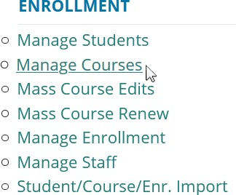Log into CTEIS at www.cteis.com using your MEIS username and password.

- From the navigation bar, click Data Entry, then Manage Courses.

- If necessary, use the Select District drop-down menu to choose a district. The grid is populated with active courses within that district.

COURSE SECTIONS AND SUBSECTIONS

In CTEIS, a course section (also referred to as a "course") is defined by its parent program, location, time and duration, staff, and content. Courses may be further divided into subsections, and the instruction provided in each class is either represented as a series of curriculum standards called segments (Perkins IV classes) or demonstrable skills and knowledge known as competencies (Perkins V classes). In Perkins IV classes, twelve segments exist in all, and each course subsection delivers between one and eleven segments of material to students enrolled in the class. In Perkins V classes, competencies are unique to each CIP Code, and each course subsection delivers at least one competency to students enrolled in the class.

The use of subsections allows districts to report different instruction (segments or competencies) for different sets of students within the same class, eliminating the need to create an individual course section for each group of students. For example, you could place a group of first-year students into Subsection A of a construction class and assign second-year students to Subsection B of the same class. In this case, the students within Subsection A would be granted the segments or competencies you attach to that subsection whereas the second-year students would receive the segments or competencies you associate with Subsection B.

Students must pass their courses with a grade of C (2.0) or higher in order for the segments or competencies delivered by that course to be recorded. When students

have passed courses delivering all twelve segments or have earned all available competencies, they may be identified as program completers. The section CTE Segments and Grades on page 128 of this manual includes more information on how CTEIS credits students for segments in Perkins IV courses. For information on integrating competencies into courses, a Competencies Instructional Design guide is available on the CTEIS Knowledge base.

You define a course section according to its:

- CIP Code (the state-approved curriculum)
- Program Type (Regular, EMC, or Emerging)
- Time of Year (fall Semester, 1st trimester, etc.)
- Time of Day (1st hour, 1st period, 1st block, etc.)

Instructor
- Content (indicated by segments or competencies)

ADD NEW COURSES

The first step in reporting your CTEIS data is to ensure that you have properly created your course sections. Courses may be entered in two ways:

  - Manually enter courses through the Manage Courses screen.
  - Import courses with the help of the Import feature.

Most course sections follow a standard setup procedure with the exception of:

  - Family and Consumer Sciences (FCS) programs.
  - Dual Enrollment programs.
See Special Cases on page 28 for more details.

To add new course sections:

- Open the Manage Courses page. For details, refer to Open the Manage Courses Page on page 16.

- Click the Create New Course button. A pop-up window is displayed.

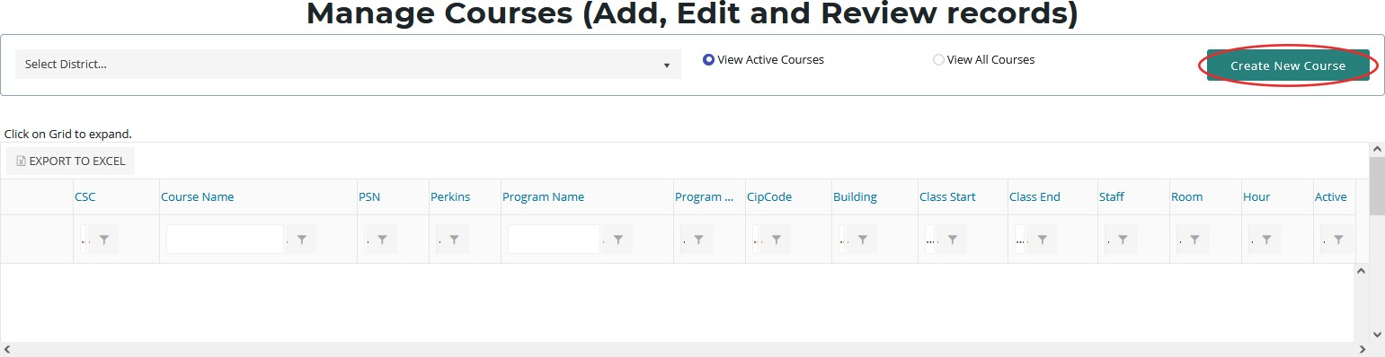

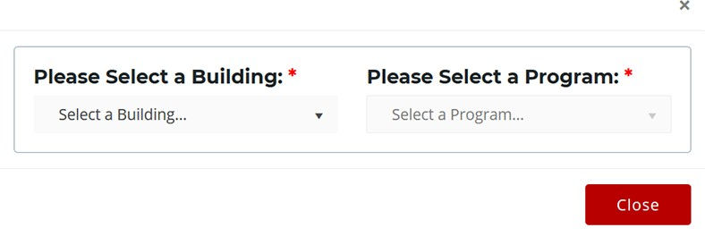

- Click the Select a Building... drop-down menu and select the building that will operate your new course.
- Click the Select a Program... drop-down menu and select the parent program to which your new course belongs.
If you believe a program is missing from your Available Programs list, verify the program’s validity with OCTE to avoid future problems.

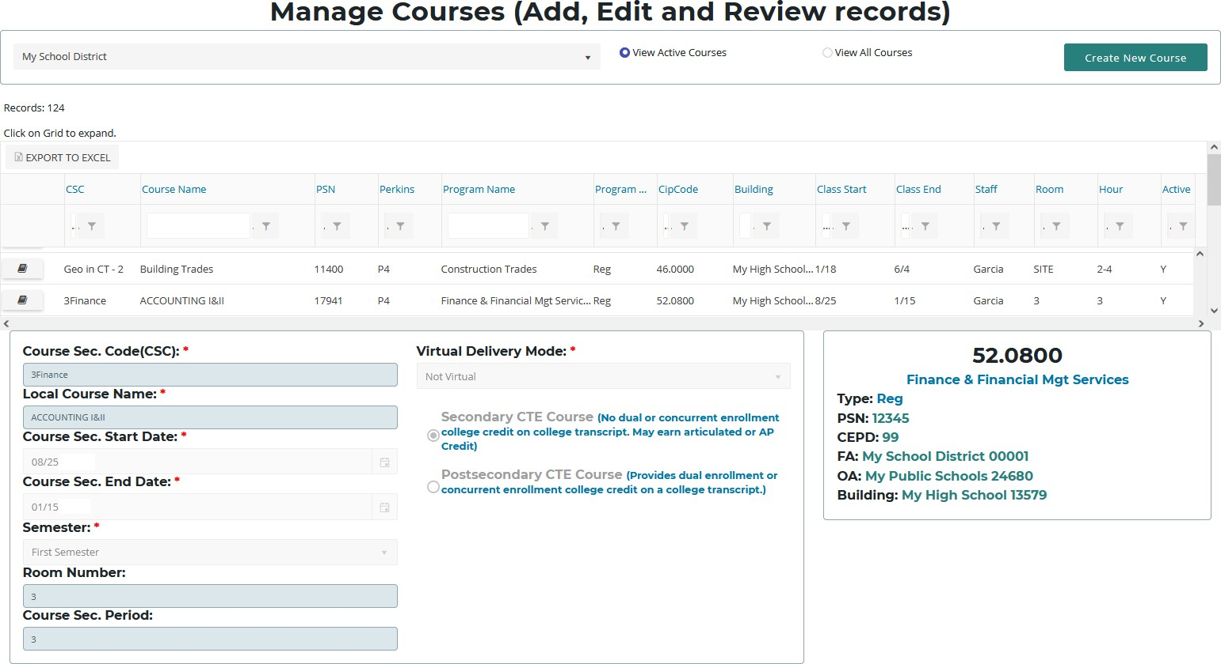

- Enter all course details into the empty text fields. For information related to each field, refer to Course Section Fields on page 21.
- Mark segments within the Segment Profile panel (P4 classes only) or competencies within the Competency Profile panel (P5 classes only).

The Segment Profile and Competency Profile panels contain a series of empty check boxes that correspond to the segments or competencies a course may grant to enrolled students. Generally, you will mark the check boxes within the column labeled "A" to indicate the segments or competencies delivered by a course. However, you may activate up to three additional subsections within any course. To open additional subsections, mark the segment or competency check boxes in any of the other columns labeled "B," "C," or "D." Make sure you have verified all subsections, segments, and competencies by printing the Instructional Design Report (see Instructional Design Report on page 43 for more details) and receiving a signature from your teachers to verify that the information is correct.
Using the Manage Enrollment feature, you may enroll students in any subsection containing active segment or competency selections. Enrolled students who complete the course with a grade of 2.0 or better will receive credit for the segments or competencies delivered by their subsection and progress toward becoming completers. Print off each student list and obtain your teacher’s sign-off indicating that the class list is correct.

Be extremely careful when marking segments and competencies because they directly influence student completer statuses.

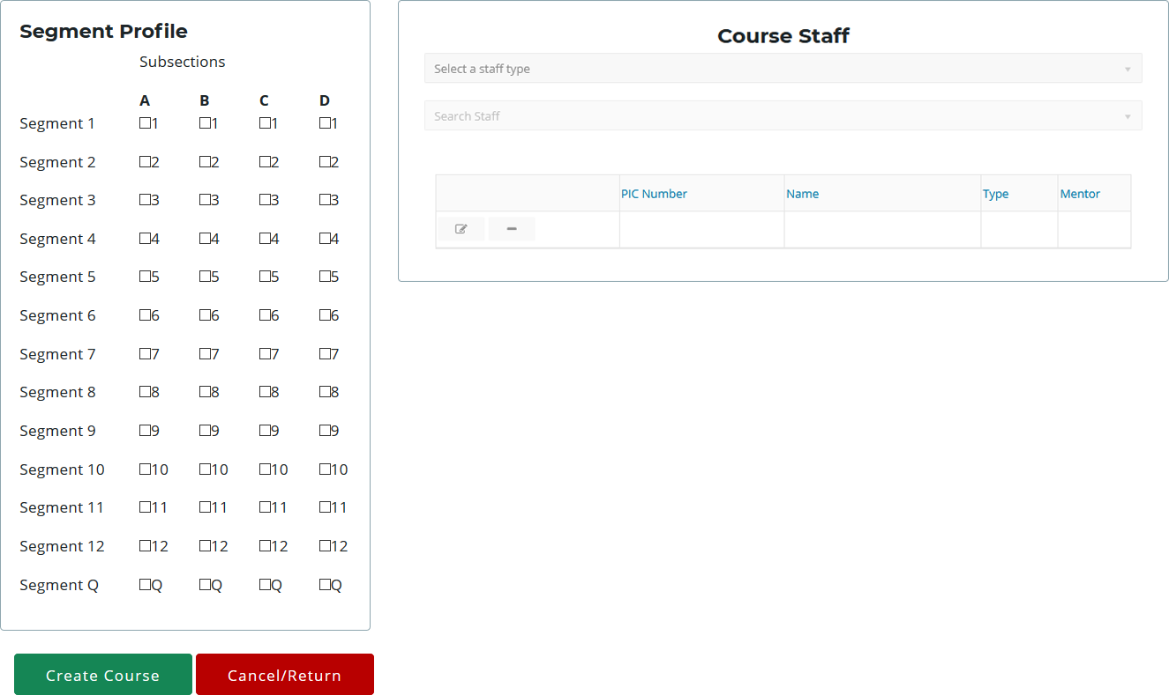

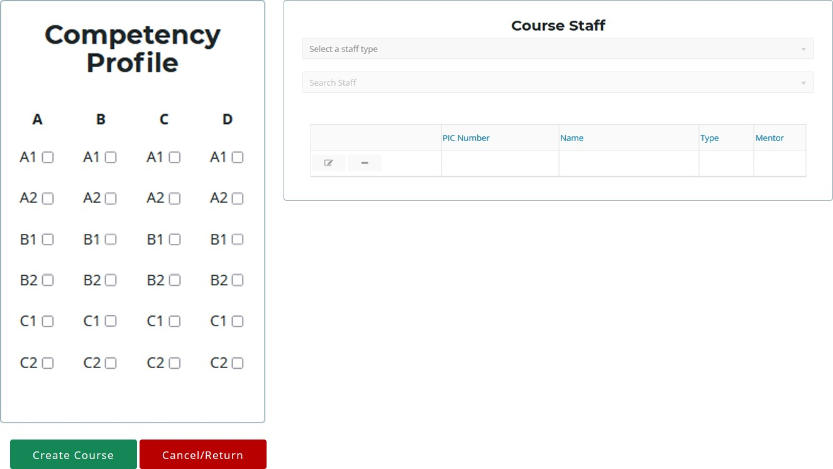

- Click the Create Course button beneath the Segment Profile or Competency Profile panel to add the course to your grid.
You may add staff members to your list via the Course Staff panel or the Manage Staff screen. Both methods are described in Add a Staff Member to the CTEIS Database on page 75.

COURSE SECTION FIELDS

To ensure that the student enrollments within a course section are properly counted for 61a(1) added cost funding, please maintain the following course section fields:

The Course Information Panel

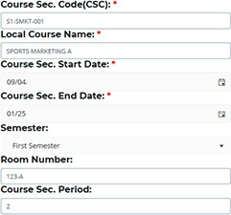Course Sec. Code (CSC) — Course Section Codes uniquely identify each class within a specified building. The CSC is used to match enrollment records in CTEIS with enrollment records in a local student management system.
- This field is user-defined and required.
- To import data, the course section code must match the code used in the local Student Management System (SMS).
- The CSC may be changed if necessary.
- A CSC may be reused if it has been previously deactivated.
- The CSC must be unique within a building.

Local Course Name — The local name that identifies your course. This field is user- defined, but matching it to your local records is recommended.

Course Sec. Start / End Date — The dates when the course section begins and ends.

These fields ensure that your enrolled students are properly counted and are required for all course sections. To enter a date, use the calendar icon to select the correct date, or manually type it into the provided fields using one of the following formats:

(m)m/(d)d/yy, (m)m/(d)d/yyyy, mm-dd-yy, or mm-dd-yyyy Examples: 04/05/67, 04/05/1967, 04-05-67, 04-05-1967

Semester — The semester defines the time of year that a class is in session and the general length of a marking period. The beginning date entered for each course section will determine what options are available in the “Semester” field. This field is critical to the Spring Enrollment Report as it defines the duration of the course and the rules that determine how students are counted for funding.
CTEIS provides the following semester options:
- First Semester - Indicates a course section that runs 18-22 weeks and typically begins in August or September.
- Second Semester - Indicates a course section that runs 18-22 weeks and typically begins in January or February.
- Summer Session - Indicates a course section that begins in June or July and runs during the summer months only. The number of weeks may vary depending on the class location. The only programs that may offer summer courses are:
  - All Agriculture programs (01.0000, 01.0101, 01.0601, 03.0000, 26.1201)
  - Cosmetology (12.0400)
- Trimester/Special Semester - Indicates a course section that runs less than 18 weeks. This type may run at any time during the year.
Room Number — The room or location in which the course section is taught. Course Sec. Period — The period or hour during which the course section begins,
as defined by the school.
Enter the period or hour that the course section begins (as defined by the school), even if the course section runs multiple non-consecutive hours.

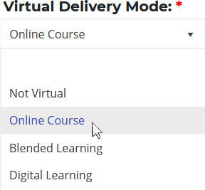Virtual Delivery Mode — A virtual course is a class that is taken through a computer-based or internet-connected environment in which students are separated from their teachers by time, location, or both. A virtual course may be offered at a supervised school facility as a scheduled class period or through self-scheduled learning where pupils have some control over the time, location, and pace of their education. Please refer to the up-to-date MSDS Collections Details Manual for guidance in coding virtual courses, which will be distributed in the fall of 2020.

Virtual learning courses are typically categorized as one of the following:
- Not Virtual (NV) — Provided as an option for districts whose student record systems cannot easily exclude this characteristic.
- Online Course (OC) — A course of study that is capable of generating a credit or a grade that is provided in an interactive internet-connected learning environment, where pupils are separated from their teachers by time or location, or both. For a course to be considered online as opposed to blended, all (or almost all) the course content is delivered online.
- Blended Learning (BL) — A hybrid instructional delivery model where pupils are provided content, instruction, and assessment at a supervised educational facility where the pupil and teacher are in the same physical location and in part through internet-connected learning environments with some degree of pupil control over time, location, and pace of instruction. For a course to be considered blended, at least 30% of the course content is delivered online.
- Digital Learning (DL) — A course of study that is capable of generating a credit or a grade that is provided in an interactive internet-connected learning environment that does not contain an instructor within the online environment itself. There may be a teacher of record assigned to the course, but this teacher does not provide instruction to students through the online environment. For a course to be considered online as opposed to blended, all (or almost all) the course content is delivered online.

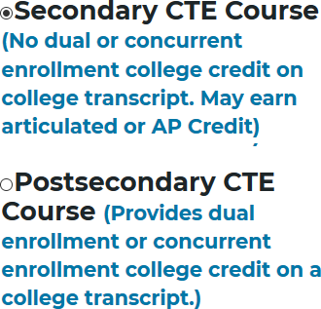Course Type — This section is used to supply the Teacher Student Data Link (TSDL) information required for dually enrolled students and those participating in Early Middle College programs.
See Special Cases on page 28 for more details.

- Select the Secondary CTE Course radio button for general classes in which no postsecondary credit is awarded.

- Select the Postsecondary CTE Course radio button for dually enrolled students and Early Middle College programs in which postsecondary credit is awarded.

The Segment Profile Panel (P4 Courses Only)

Subsections — In Perkins IV courses, subsections are used to indicate the instruction, defined by segments, enrolled students receive within a course. When reporting segments in CTEIS, at least one of the four available subsections must be enabled in each course section, and most reporters use Subsection A. Groups of students receiving different content standards during a single class may be reported either:
- In separately created course sections
- OR by activating additional subsections that grant different sets of segments.

As an example, this could occur when a teacher instructs both first and second-year students simultaneously. In this case, first-year students might receive instruction addressing different content standards, represented by a different set of segments, than those of the second-year students.
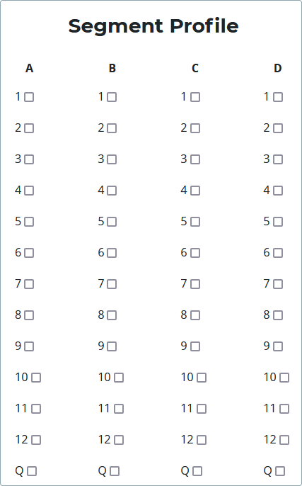Segments — Segments are groups of state CTE program standards that are delivered in CTE courses. Each activated subsection must include at least 1 segment of material. When students earn a grade of 2.0 or better, all segments delivered by their subsections will be permanently added to their profiles. A student must earn all 12 possible segments within a program to become a program completer.
The instructional design (segments) of each course section should be determined by an instructor or CTE Administrator and provided to the building reporter. As a building reporter, you will collect this segment information from a teacher and set up your course sections accordingly by using the labeled checkboxes on the “Segment Profile” panel. Once the
segments have been marked, you must verify the accuracy of your course sections by reviewing the Instructional Design Reports located on the “Building Reports” screen and having the teacher sign off on the instructional design. For information on these reports, please see Instructional Design Report on page 43. For information on how to

create and print these reports, refer to Generate Your Reports on page 44 and Printing from CTEIS on page 45.
Remember, building reporters are NOT responsible for determining instructional design (segments) and should not attempt to create or interpret instructional design.
Instructors or CTE Administrators must provide instructional design.

Segment Q — When a course covers specialized or advanced program content beyond the state program standards, that content is delivered as Segment Q. Segment Q course sections are designed for students who have already received credit for all 12 segments within a program. When segment Q is marked within a subsection, no other segments may be reported within that same subsection.

A student must complete course sections covering all 12 segments with a grade of
  - or better and be identified as a program completer before enrolling in a course section delivering Segment Q. If students who have already completed the program are in the same course as students who are not yet completers, segments may be reported in two separate subsections.

The Competency Profile Panel (P5 Courses Only)

Subsections — In Perkins V courses, subsections are used to indicate the instruction, defined by competencies, enrolled students receive within a course. When reporting competencies in CTEIS, at least one of the four available subsections must be enabled in each course section, and most reporters use Subsection A. Groups of students receiving different competencies during a single class may be reported either:
    - In separately created course sections
    - OR by activating additional subsections that grant different sets of competencies.

As an example, this could occur when a teacher instructs both first and second-year students simultaneously. In this case, first-year students might receive instruction addressing different competencies than those of the second-year students.
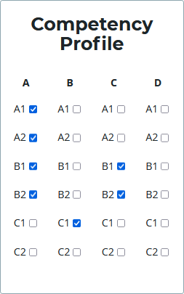Competencies — Competencies are used to indicate the skills and knowledge enrolled students can demonstrate after completing a course. The competencies that comprise each program are defined by OCTE and published in various Excel workbooks, which are available on the CTEIS Knowledge Base at support.cteis.com. Each activated subsection must include at least 1 competency. When students earn a grade of 2.0 or better, all competencies delivered by their subsections will be permanently added to their profiles. A student must earn all competencies available within a program to become a program completer.

The instructional design (competencies) of each course section should be determined by an instructor or CTE Administrator and provided to
the building reporter. As a building reporter, you will collect this competency information from a teacher and set up your course sections accordingly by using the labeled checkboxes on the “Competency Profile” panel. Once the competencies have been marked, you must verify the accuracy of your course sections by reviewing the Instructional Design Reports located on the “Building Reports” screen and having the teacher sign off on the instructional design. For information on these reports, please

see Instructional Design Report on page 43. For information on how to create and print these reports, refer to Generate Your Reports on page 44 and Printing from CTEIS on page 45.
Remember, building reporters are NOT responsible for determining instructional design (competencies) and should not attempt to create or interpret instructional design. Instructors or CTE Administrators must provide instructional design.

Z Competency — When a course covers specialized or advanced program content beyond the state program standards, that content is delivered as a Z competency. Z competency course sections are designed for students who have already received credit for all competencies within a CIP Code. When a Z competency is marked within a subsection, no other competencies may be reported within that same subsection.

A student must complete course sections awarding all available competencies with a grade of 2.0 or better and be identified as a program completer before enrolling in a course section delivering a Z competency. If students who have already completed the program are in the same course as students who are not yet completers, competencies may be reported in two separate subsections.

SPECIAL CASES

FCS CIP Code 19.0000

Family and Consumer Science (FCS) programs contain standardized segments classified by the type of material taught in the classroom and identified in CTEIS by a segment number as follows:

- 1 – Parenting and Family Studies
- 2 – Nutrition and Food Services
- 3 – Consumer and Family Finance
- 4 – Development Across the
Lifespan
- 5 – Health and Wellness
- 6 – Design (Interior and Textile)
- 7 – Hospitality Services
- 8 – Early Childhood Education and Development

The only FCS course eligible for 61a(1) funding is Parenthood Education. However, in order to be eligible to receive 61a(1) funds for Parenthood, districts must also operate FCS courses from at least three separate, non- Parenthood Education categories each school year.

Reminder: You must enroll all FCS students so they may be linked to their teachers via the Teacher Student Data Link (TSDL).

Dual Enrollment and Early Middle College

Any student who is participating in a course for which he/she will earn postsecondary (college) credits is considered a dual-enrollment participant. All courses for dual enrollment participants are required to be reported for the Teacher Student Data Link (TSDL) Report.

Early Middle College (EMC) participants are students who attend an EMC school/program through which a student earns a high school diploma and either an associate’s degree, professional/technical certification, up to 60 transferable college credits or the Michigan Early/Middle College Association (MEMCA) certificate.
To report non-CTE courses in an EMC program, please contact OCTE for guidance.

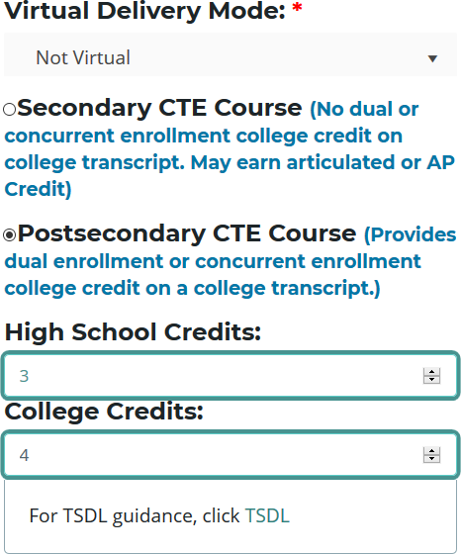To report dual-enrolled students, fill out the course section fields as described in Course Section Fields on page 21. On the right side of the Course Section Fields panel:

- Locate the prompt that states "Please select the appropriate course type:" and select the second option, Postsecondary CTE Course.

- High School Credits: Enter a number from 0 to 10 representing the default number of secondary credit hours you wish to grant to enrollees of the course.

- College Credits: Enter a number from 1 to 10 representing the default number of postsecondary credit hours you wish to grant to enrollees of the course.
You may edit the credits that individual students receive via the Manage Students or the Manage Enrollment screen.

SEARCH COURSES

To search for existing courses:

- Open the Manage Courses screen. For details, refer to Open the Manage Courses Page on page 16. Upon selecting a district, a default list of your currently active courses is displayed.

- The option to View All Courses is available above the course grid if you wish to display previously deactivated classes. You may sort your list in various ways by clicking on any of the column headers within the grid. An upward (↑) or downward- pointing arrow (↓) indicates the order of the sort.

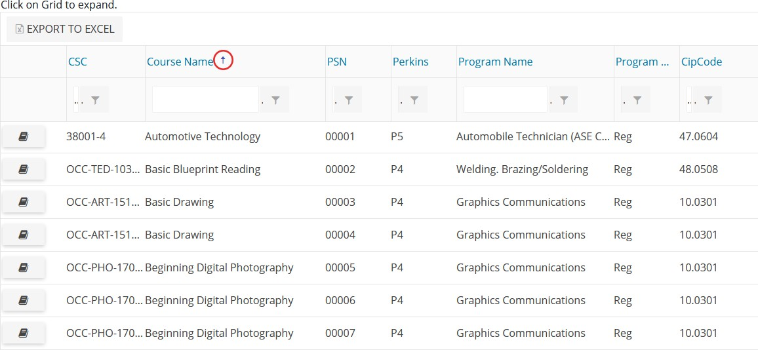

4. Remember that the following features are also available to you:
- Clicking inside a grid expands it so you may view additional records.
- Any column with a funnel icon may be filtered.
- Several columns may be filtered simultaneously.
- The Clear button (x) next to a funnel icon allows you to remove a filter that has been applied.
- Click any book icon to view or edit the details of the selected course.

In the following example:

We typed “health” in the Course Name field and then pressed the “Enter” key. Then we typed “01234” in the Building field and pressed the “Enter” key. Notice that the grid lists only those courses which have a course name of “Health Sciences” and operate within Building 01234.
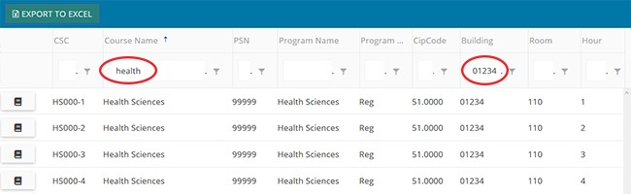

Remember, you must use the Manage Courses screen or a report, such as the Class Student List Report, to allow your teachers to review the number of high school and college credits earned by each student and then sign off that the correct information has been entered into CTEIS.

EDIT COURSES

To update or edit course sections:
- Open the Manage Courses screen. For details, refer to Open the Manage Courses Page on page 16. Upon selecting a district, a default list of your currently active courses is displayed.
- Click the book icon of a course that you want to update. Course Details are displayed in a panel.
- Make the necessary changes to the course detail fields. If the course is not yet running in the current school year, *click the Renew Course for the New Year button at the bottom of the screen first.
- Click the Update Course button to save any changes. The “Course Updated” message is displayed.
- Click the Cancel/Return button to return to the course list grid.
*To renew multiple courses, from the navigation bar, click Data Entry, then Mass Course Renew. On the Mass Course Renew screen, select your district, then mark

any classes you wish to renew in the left hand column. Click the Renew Selected Courses button to renew your selected classes.

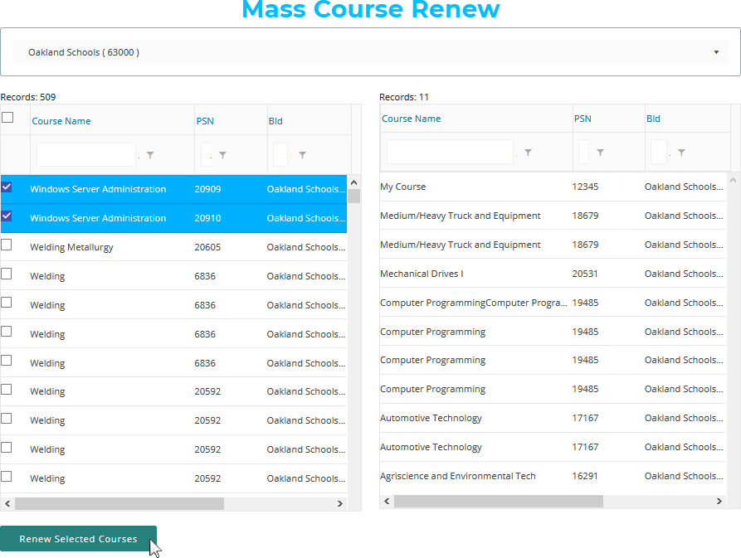

Renewing a P4 course to a P5 course will not copy any competencies, and the competency profile will be left blank.

COPY COURSE INFORMATION

The Copy Course Information feature is useful because it allows you to:

  - Copy the details from a course section in your database and apply them to a new course section. This is beneficial to building reporters who must enter recurring classes.

  - Quickly generate additional sections of a course while preserving segmenting information and other details specific to that class.
Remember that CSCs must remain unique among active courses; therefore you must deactivate old course sections before you may reuse a CSC.

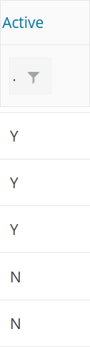Determine Course Status

To determine whether a course is active or inactive:

- Open the Manage Courses screen. For details, refer to Open the Manage Courses Page on page 16.

- Drag the horizontal scroll bar at the bottom of the course grid to the far right to reveal the Active column. A "Y" indicates an active course, whereas an "N" indicates that the course is inactive.

Deactivate an Active Course
To deactivate an active course section:

- Open the Manage Courses screen. For details, refer to Open the Manage Courses Page on page 16. Upon selecting a district, a default list of your currently active courses is displayed.

- Click the book icon of a course that you want to update. Course Details are displayed in a panel.

- Scroll to the bottom of the Manage Courses screen and click the Deactivate Course button.

You may NOT reactivate an inactive course; however, CTEIS preserves the details of inactive courses, allowing you to copy them into fresh course sections at any time.

Copy a Course Section

- Open the Manage Courses screen. For details, refer to Open the Manage Courses Page on page 16. Upon selecting a district, a default list of your currently active courses is displayed.

- Click the book icon of a course that you want to update. Course Details are displayed in a panel.

- Scroll to the bottom of the Manage Courses screen and click the Copy Course button.

- Make the necessary changes to identify the new course section. Changing the “Course Section Start Date” or “End Date” may require you to reselect a “Semester” type from the corresponding drop-down list. Remember that all classes operate with unique CSCs — if you need to deactivate an old course section so that you may assign its CSC to the new course section, follow the steps under Copy Course Information on page 33.

- Scroll to the bottom of the Manage Courses screen and click the Create Course button.

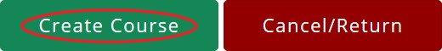

ADD STAFF TO COURSES

Before CTEIS can validate your enrollment information for submission, you must:
  - Assign a primary instructor to each active course section.
  - For TSDL purposes, ensure that you add all additional teachers and parapro- fessionals to the appropriate course sections as well.

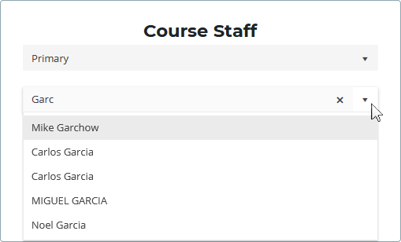Add a Staff Member to a Course

To add a staff member to a course section:
- Open the Manage Courses screen. For details, refer to Open the Manage Courses Page on page 16. Upon selecting a district, a default list of your currently active courses is displayed.
- Click the book icon of the course you wish to assign your staff to. The Course Staff panel is displayed.
- Select a role for the staff member using the Select a staff type drop-down menu. Roles are as follows:
  - Primary — The instructor who is responsible for developing the lesson plans for and teaching the course. This person must have a teaching certificate and needs to be vocationally certified.
  - Additional Full Time — Any teacher, aide, or paraprofessional who assists with instruction for the entire duration of the session.
  - Additional Part Time — Any teacher, aide, or paraprofessional who assists with instruction for part of the session.
  - Secondary Full Time — An additional teacher who assists with instruction for the entire duration of the session and who has a teaching certificate and vocational certification.
  - Secondary Part Time — An additional teacher who assists with instruction for part of the session and who has a teaching certificate and vocational certification.

- In the Search Staff field, enter the first several digits or letters of the staff member's PIC number or last name. CTEIS displays any instructor in Michigan who matches your entry in a drop-down list.
- Select the desired staff member from the drop-down list.

Staff records appear within a grid in the Course Staff panel alongside buttons that allow them to be edited and deleted. If the instructor is a mentor to students within a classroom, click the Edit button within a staff record row, then check the Mentor box and click the Update button. To remove a staff record from a course section, click the Remove button (-) next in that instructor's row of the grid.
A mentor is a professional employee of the district who monitors a pupil’s progress, ensures the pupil has access to needed technology, is available for assistance, and ensures access to the teacher of record. A mentor may also serve as the teacher of record if the mentor meets the definition of a teacher of record.
If a staff member does not appear in your list, you may add that instructor through the “Create New Staff Member” button or the Manage Staff page. For details, refer to Manage Staff on page 72.
CTEIS only recognizes one primary teacher per course section. Other on-site staff should be identified as additional or secondary instructors.

MASS COURSE EDITS

Mass Course Edits are useful in cases where you need to:

- 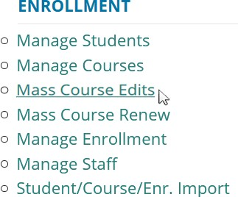Update multiple detail fields across several course section records.

- Adjust the beginning and end dates of old courses to roll them into the current school year.

Try using mass edits in circumstances when:
- Course beginning and end dates need to be altered.
- A building begins block scheduling.
- Semesters or trimesters are implemented mid-year.
- High school or college credits awarded by a class must be corrected.
After editing courses, you are encouraged to verify the instructional design of your courses—refer to Verify Instructional Design on page 119. Building reporters should not attempt to create or interpret instructional design without instructor or CEPD Administrator assistance.

OPEN THE MASS COURSE EDITS PAGE

To open the Mass Course Edits page:

- Log into CTEIS at www.cteis.com using your MEIS username and password.

- From the navigation bar, click Data Entry, then Mass Course Edits.

- If necessary, use the Select District field to choose a district. The grid is populated with active courses within that district.

APPLY MASS COURSE EDITS

To perform mass course edits:

- Click a row in the grid to select the course you would like to edit. To select multiple individual records, hold the Control (Ctrl) key. Hold the Shift key instead to select multiple contiguous records.

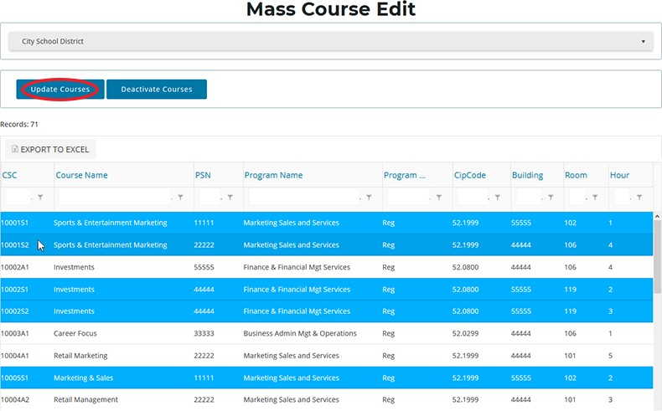

- Click the Update Courses button above the grid.

- Enter new course information within the Edit Instructions window.

- Click the Update Courses button to apply your changes.
As described previously, you can filter and sort columns by clicking on various column headers. Refer to Search Courses on page 30.

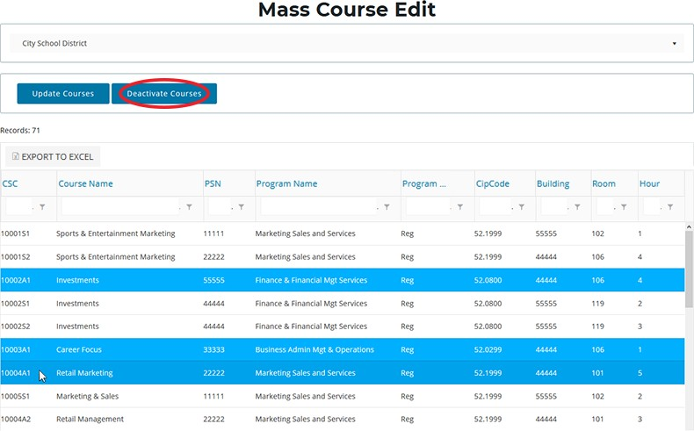

Deactivate Courses

You can use the Mass Course Edits screen to deactivate multiple courses at once:

- Select the courses within the Mass Course Edit grid that you wish to deactivate.

- Click the Deactivate Courses button above the grid, then confirm your selection by clicking the Deactivate Courses button in the resulting pop-up window.
Deactivated courses no longer appear in the Mass Course Edit grid, but do appear as inactive courses when viewed on the Manage Courses screen.

IMPORTING COURSES

Importing courses is important because:
- Importing courses is the easiest way to add and update several course records simultaneously and can be a significant time saver.
- Imported courses can be edited later if necessary.
- Importing courses is more accurate than manual data entry.

Before You Begin Importing Courses

Before you begin importing your data, ensure that you:
- Identify the data that you need.
- Format the data for easy import.
For formatting and other detailed import information, refer to the Appendix: Import Formats on page 130.

IMPORT COURSE DATA

To import data, carry out the following steps:
  - 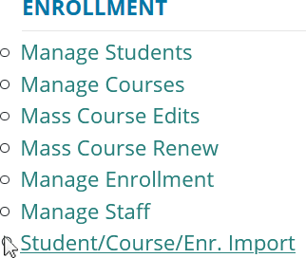From the navigation menu, click Data Entry, then Student/Course/Enr. Import.
  - On the Select building to import screen, click the student icon of the building you wish to import records into.
  - Beneath the Import Courses header, click the Choose File... link and locate your import file.

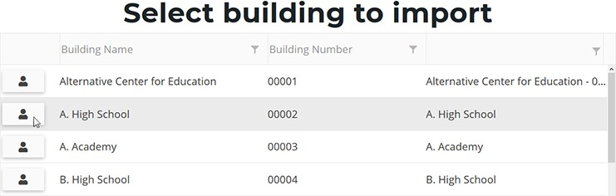

  - 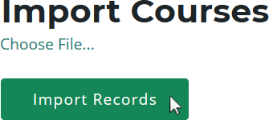Click the Import Records button to upload your file. Errors, if any, are displayed in the Error column of the temporary grid on the resulting screen.

  - To correct any errors, click the Back to List link to reset the screen, adjust your import file, then upload the file again.

  - Click the Process Courses button beneath the grid to import your courses.

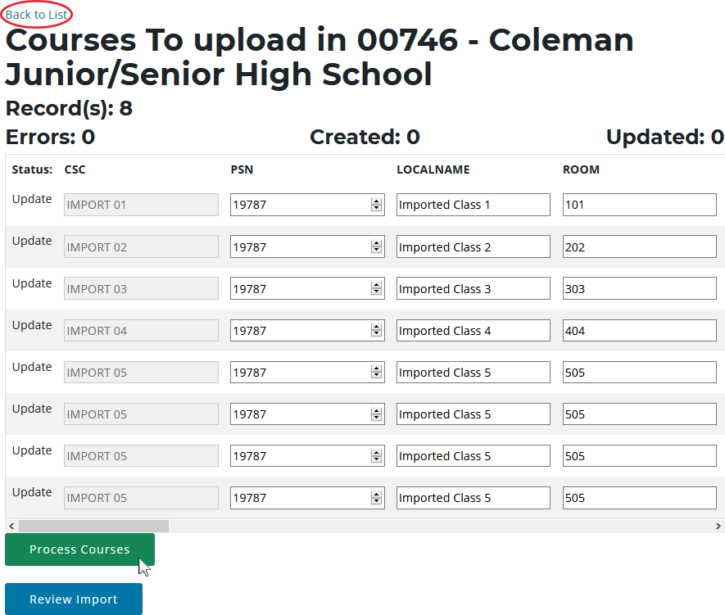

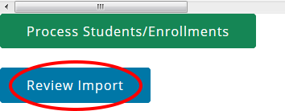Clicking the Review Import button allows you to export the list of import records and their import statuses and errors. This may be useful for offline review and remediation.

REVIEW COURSES

To review your courses, you will need to generate the following reports:

INSTRUCTIONAL DESIGN REPORT

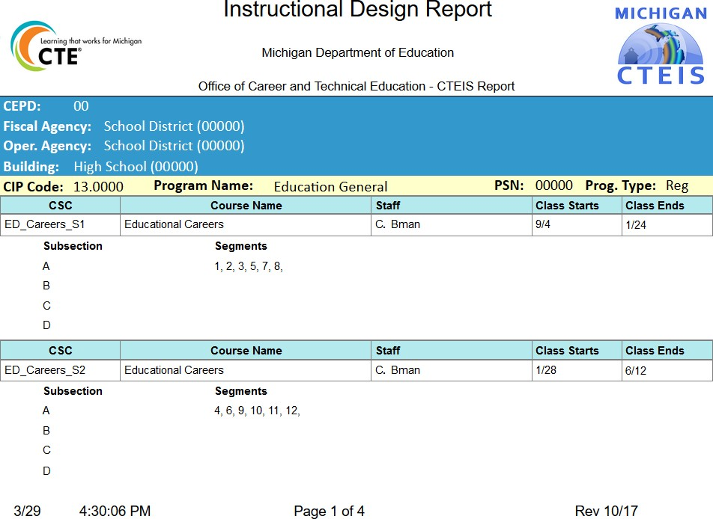The Instructional Design report shows the courses operating during a period of selected years, allowing you to easily view program segment information. A competency instructional design report information sheet will also be provided at a later date. You may use this report to verify that your:
- Course entry within CTEIS is accurate for the current year.
- Courses offer the 12 segments required for your programs to produce completers.
Refer to Verify Instructional Design on page 119 for more details about reviewing instructional design.

LIST OF COURSES BY BUILDING

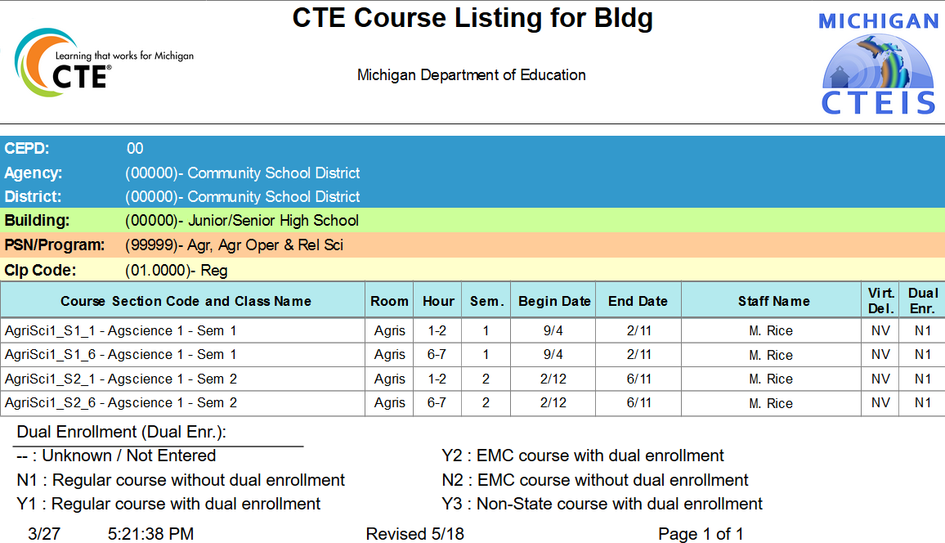This report shows all courses running during the current school year within a selected building. Use this report to verify that:

- Course entry within a specific building in CTEIS is accurate for the current year. Use this report to obtain sign-off from the building administrator verifying that course sections are correct.
- Your course detail fields are accurate.

GENERATE YOUR REPORTS

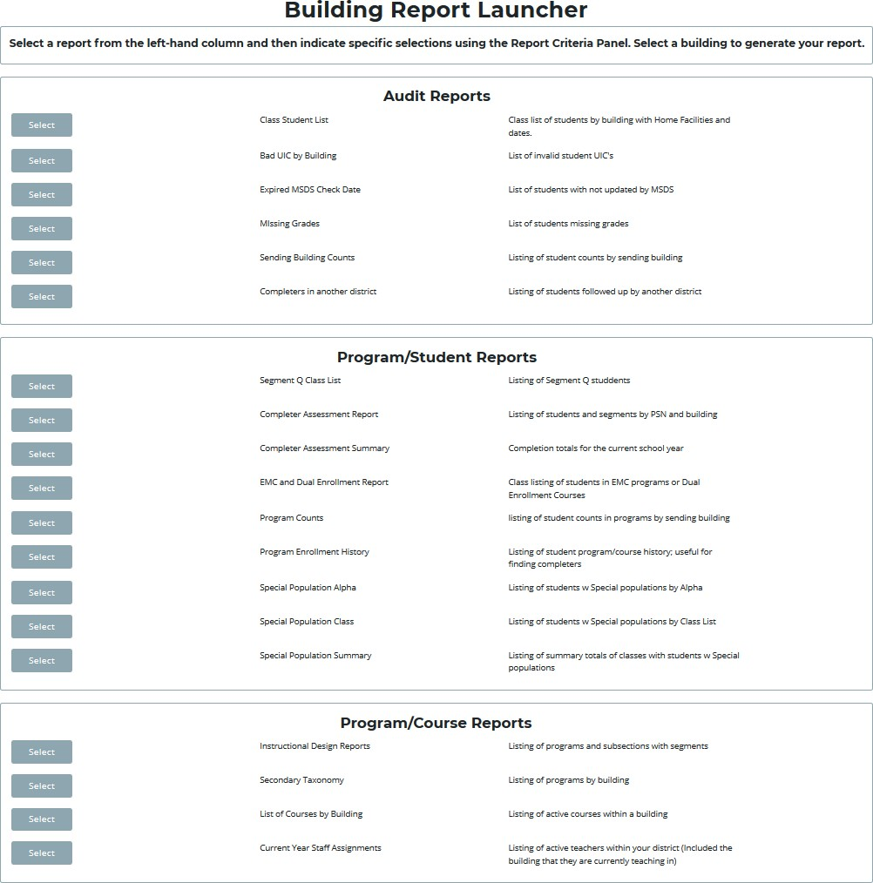To generate the above reports:

- From the navigation bar, click Reports, then Building Reports.

- Select the desired report from the Report Launcher screen.

- Enter your Report Criteria. CTEIS will generate the report based on your report criteria.

Printing from CTEIS

To print your lists and reports, you must first export them to another format. Using the “Export” button and drop-down list, choose Acrobat PDF file.
Save the report and open it in Adobe Acrobat to print hard copies from the application instead of your Web browser.

MANAGE CREDENTIALS

Before submitting your final enrollment data for review, you will need to indicate any certifications or other credentials your students attain during the current school year. Enter all credentials received by students in a given year so that CTEIS may determine when each student qualifies for the Post-Secondary Credential indicator. Each of your programs must either:
  - List the students who receive credentials in the current year
  - OR state that no credentials were provided in the current year.

Credentials will be reviewed for accuracy during the validation process, and you may also view this information as part of a student's profile on the Manage Students screen. The Manage Credentials feature allows you to view, edit, and import student certifications. Obtain sign-off from the instructor indicating that the credentials entered are correct for each student.

OPEN THE MANAGE CREDENTIALS SCREEN

To open the Manage Credentials screen:
    - 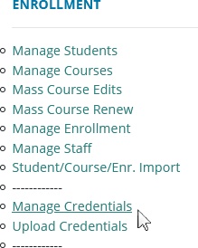Log into CTEIS at www.cteis.com using your MEIS username and password.
    - From the navigation bar, click Data Entry, then Manage Credentials.
    - If necessary, use the Select District... field to choose a district. The grid is populated with active programs within that district. You may sort this grid by clicking on the various column headers.

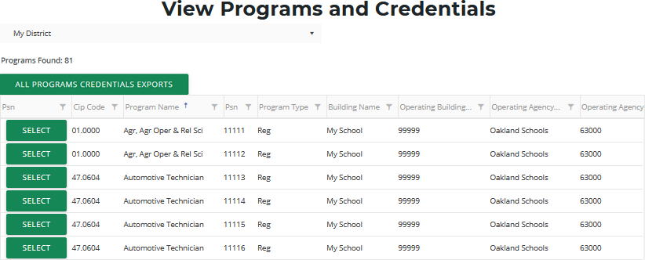

    - Click the All Programs Credentials Exports button at the top of the grid if you wish to view any credentials currently linked to your students as an Excel workbook.
    - Click the Select button of a program to display program details and a list of classes operating within that program.
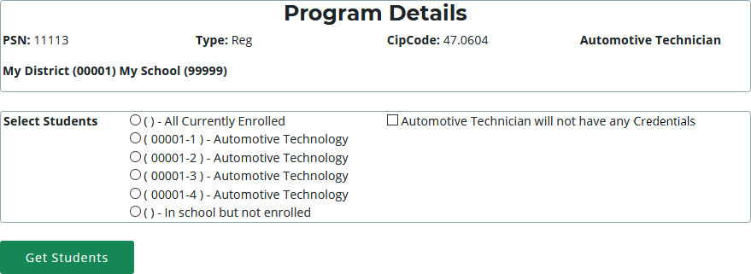

The Program Details panel displays valuable information regarding the selected PSN and allows you to group students according to various radio button selections:
- All Currently Enrolled — Display all students enrolled in any class currently operating as part of the indicated program.
- Enrolled in Course X — Display all students currently enrolled in the selected class.
- In School but Not Enrolled — Display all students who are currently in school and enrolled in the program, but not currently enrolled in a class operating within the indicated program. For example, this includes students who took classes in the program last year, but not this year.

    - If the selected program does not offer certifications — Mark the (selected program) will not have any Credentials checkbox to indicate this program will not provide a credential at this time. You cannot check this box if the program currently lists students earning credentials.

    - Click the Get Students button to generate a list of students according to the selection you made.
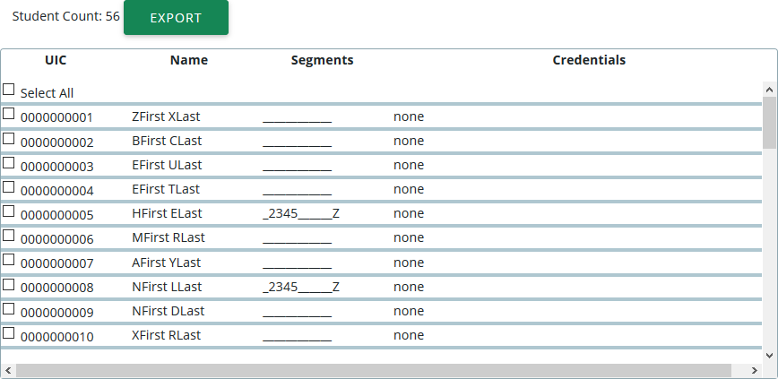

    - Within the Student Selection List, select students by marking their checkboxes.
    - Assign certifications to the marked students by selecting a certification from the drop-down menus below the grid and clicking the Add Credential button.

- Select Authorized Credentials — This is a State-Approved Certification, filtered by CIP Code. It applies to the Post-Secondary Credential indicator.
- Select Supplemental Credentials — This is a certification that is not currently approved. It may apply to the Post-Secondary Credential indicator in the future.
- Suggested Credential — This is a text submission field that allows you to suggest a credential for future consideration.

A certification linked to a student appears within the Credentials column. To delete a credential, click the Remove link.
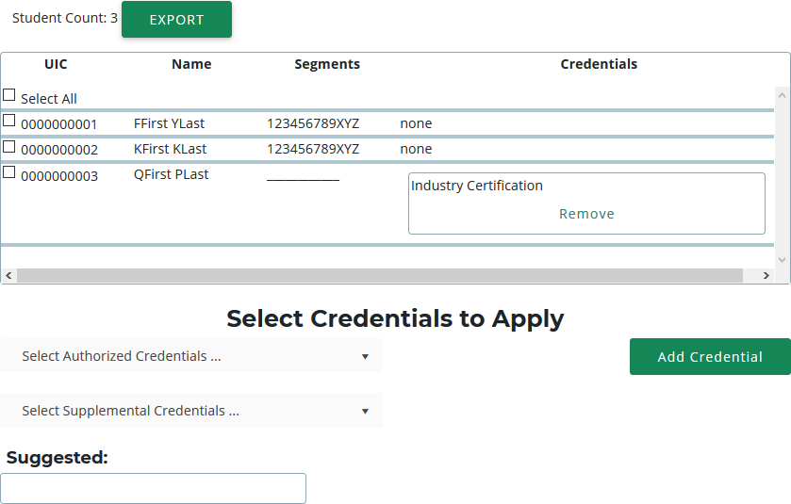

Please note that you may also export your credentials into an Excel file by clicking the Export button above the Student Selection List. You may print and use this file to obtain sign-off from your teachers indicating that the entered credentials are correct.

IMPORT CREDENTIALS
CTEIS can import Excel files that include the following fields:

Column Title | Description
UIC | Student's UIC to receive the credential
PSN | Program Serial Number of the program the student is receiving the credential for
CredentialCode | The code for the credential. These can be found in the spreadsheet of Approved and Supplemental (non-approved) credentials. For instance, ACOMPTIA will be used to indicate the “COMP TIA A+” credential.
CredentialName | The name of the credential. This is especially important for suggested credentials. For authorized and supplemental credentials, this can be left blank and will be looked up.

To import data, carry out the following steps:
- 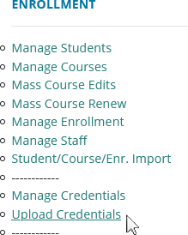From the navigation bar, click Data Entry, then Upload Credentials.
- Choose the file you wish to import, then click the Process Records button to upload and review your file. Errors, if any, are displayed in the Error column of the temporary grid on the resulting screen.

- To correct any errors, modify your file and re-upload it using the steps above.

- Click the Import Records button beneath the grid to import your students.

- To enter programs that will not have any credentials, add a row to your import file with the correct PSN, a UIC of "9999999999," and CredentialCode of "X." CTEIS will then mark the program as offering no credentials. If the program does offer credentials in the current year, this process will fail with an error.

If your import file includes headers beyond the four in the table above, CTEIS will ignore them. The system also ignores the case of the "CredentialCode" and "CredentialName" labels, allowing your file to include variants of those headers spelled with both capitalized and non-capitalized letters.
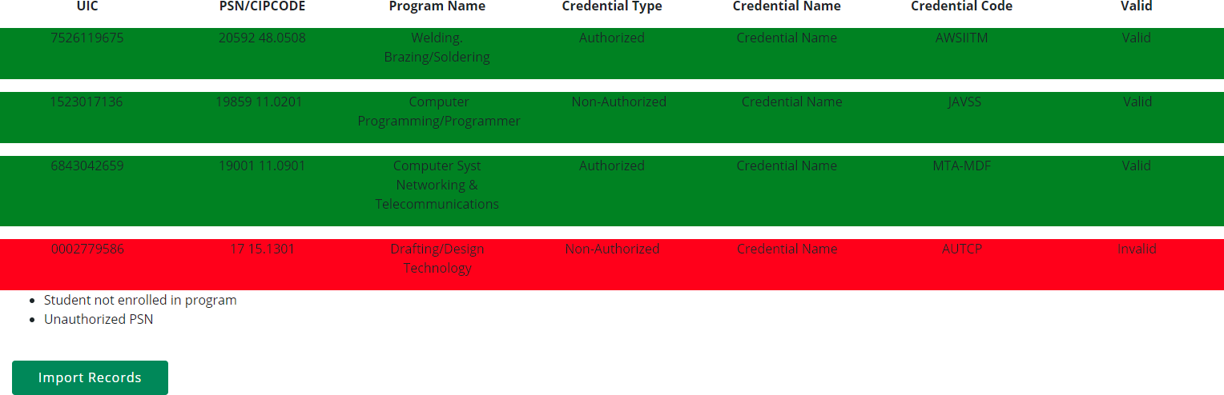

Importing Credentials: Potential Errors and Resolutions

Error | Meaning and Resolution
Missing Fields | Not all the required fields/columns are in the file.
PSN marked as no credentials | PSN was marked as having no credential in the current year, thus you cannot add student credentials. To fix, remove the checkmark indicating no credentials.
Student not enrolled in program | The UIC was not found to be ever enrolled in a course in that program. Check the student record to ensure it is the correct student.
Program not found using PSN | The program provided is not an active program in the indicated building or district. Check the PSN for accuracy.
Unauthorized PSN | The user has not been granted access to students in the identified PSN. Check PSN or contact your Level 5 for access.
PSN has credentials | PSN lists student credentials in the current year and thus cannot be marked as not having credentials.
Credential is invalid for program | Credential code provided is not valid for the CIP code of the indicated PSN.

WORK BASED LEARNING

WHAT IS WORK BASED LEARNING?

Work Based Learning is an element within Career and Technical Education that provides students with the opportunity to learn a variety of skills by expanding the classroom into the community. It narrows the gap between theory and practice through academic preparation with hands-on career development experiences. CTE programs report broad, descriptive information about the types of work based learning offered through the CIP Self-Review in GEMS, but do not need to upload student lists as individual student work based learning data will be collected through CTEIS. Programs will report the types of work based learning the student experienced during the school year, and the number of experiences of each type.

To assist with tracking this information, OCTE and PTD Technology have developed tools to support teachers, work based learning coordinators and data entry staff. The CTEIS Work Based Learning feature captures work based learning experiences entered either manually or through an import process.

WORK BASED LEARNING CONTINUUM

The Work Based Learning Continuum describes the nature of the experiences that students may receive. Resources for teachers, work based learning coordinators and others responsible for identifying work based learning experiences may be found on the OCTE website. Resources include the Work Based Learning Continuum document and CTE Teacher Technical Tool Kit, as well as the materials shared at the OCTE Fall Update. Please visit the OCTE website at www.michigan.gov/octe, click on CTE Instructional Programs and scroll down to the Work Based Learning section.

The letters on the continuum will be used for reporting work based learning in CTEIS as described in the diagram below:
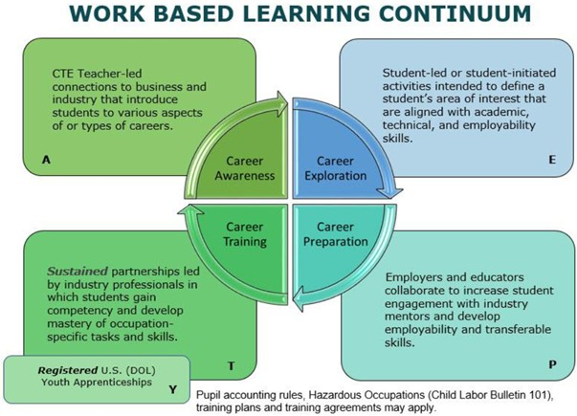

HOW TO ENTER WORK BASED LEARNING

Several different ways exist to enter your students’ work based learning experiences in CTEIS. If you track WBL by program, you will be able to enter these experiences by student by program. If you track WBL through student course offerings, you will be able to enter these experiences along with your enrollment data. Final reporting will be based on the number of experiences a student has in a program during a year. If you enter your experiences by enrollment, you will need to run a consolidation step to consolidate your enrollments entries into a program entry. YOU ARE STRONGLY ENCOURAGED TO CHOOSE TO ENTER EITHER BY PROGRAM OR ENROLLMENTS AS MIXING THE TWO STYLES MAY CAUSE UNINTENDED OVERWRITING OF DATA.

The diagram below demonstrates how work based learning experiences are entered and how some data entry will supersede other data entry:
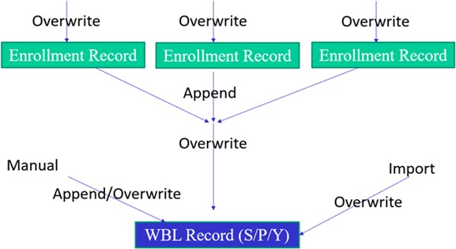

The ways to enter your work based learning experiences are as follows:

- Enrollments

  - Mass Enrollment edit

  - Enrollment import

  - Consolidate into programs

- Programs

  - Manage Work Based Learning – manual entry (and review)

  - Import Work Based Learning (by program)

In all cases, you will be entering in letter codes for each experience into a text field. The codes are as follows:
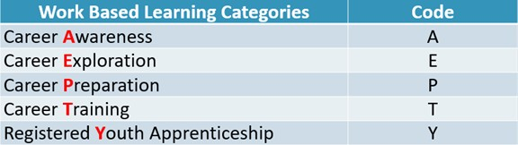

Each experience should be entered as an individual character, and CTEIS will accept up to 30 characters per entry. See the example below:
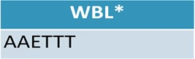

In this example, the characters “AAETTT” have been entered into a WBL text field. This represents a student with two Career Awareness experiences, one Exploration

experience, and three Training events. Please refer to the Work Based Learning Continuum Guide on the OCTE website for additional coding guidance and examples:

https://www.michigan.gov/documents/mde/WBL_Continuum_Guide_703181_7.pdf

MANAGE WORK BASED LEARNING

To manually record work based learning data:

- Log into CTEIS at using your MEIS username and password.

- From the navigation bar, under Enrollment, click Manage Work Based Learning for manual entry, or import your data by clicking Import Work Based Learning.
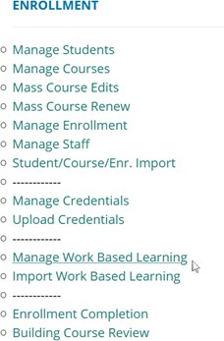

- Select a school district from the Select District…▼ drop-down menu. You may need to scroll within the menu to locate a desired district. All school districts that contain the buildings you are working with should be visible.
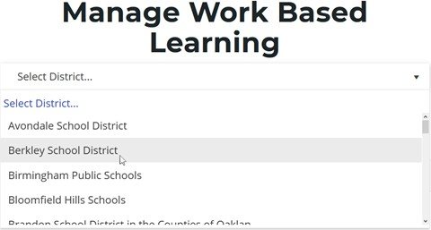

A list of active programs will display in PSN order.
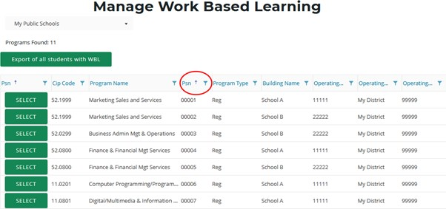

- The display order can be altered by clicking on individual heading labels. For example, if you want to group programs by building, click on the column heading labeled “Building.”
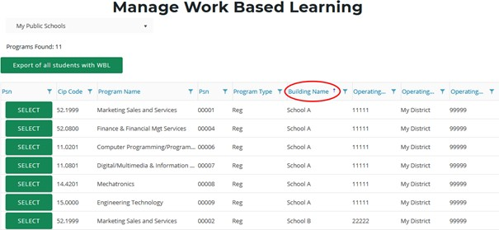

- Click the Select button to the left of the desired program to display program details below.
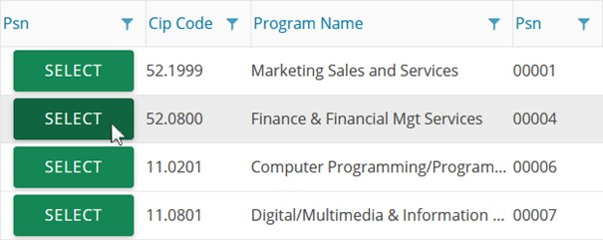

- If the selected program will not have any work based learning experiences, click the check box on the right side of the Select Students panel. This will only be available if no program work based learning experiences are currently entered. A message will be displayed if any experiences are on record, and they will need to be removed from the program before this check box will become available.
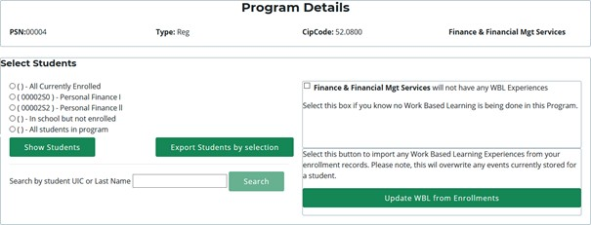

- View a list of students by selecting one of three radio buttons:

  - All Currently Enrolled – Lists each student in CTEIS from the school district who is enrolled in any program.

  - Active Courses – Active courses appear as individual selection options.

  - In school but not enrolled – Lists each student in CTEIS from the school district who is not enrolled in the selected program.

  - All students in program – Lists each student in CTEIS from the school district who is enrolled in the selected program.

After selecting the criterion for the list, click the Show Students button to view students in UIC order.

You may also search for a specific student by entering a UIC or last name into the search field and clicking the Search button.
- To enter work based learning experiences for students, click the checkbox next to their UIC. You may quickly mark all students by clicking the Select All checkbox.
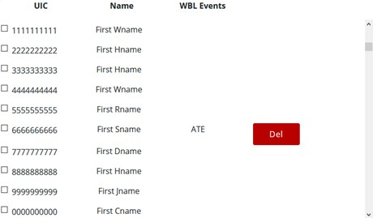

When at least one check box is marked, the Experience Entry panel will be displayed. The available code entries are:

- A – Career Awareness
- T – Career Training
- E – Career Exploration
- P – Career Preparation
- Y – Youth Apprenticeships

- To change the experiences associated with a student, mark the checkbox next to that student’s UIC to reveal a panel labeled Enter Work Based Learning Experience Codes to apply to student group. In this panel, you may enter up to 30 WBL codes and then choose from the following two options:

  - Overwrite Events — This button removes previous experiences from the marked student’s record and replaces them with your newly entered experiences.

  - Append Events — This button adds your newly entered experiences to those previously associated with the marked student.
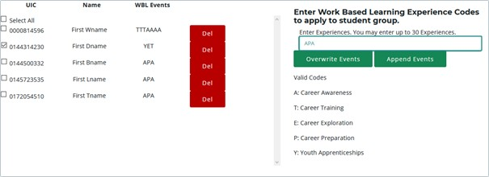

- You may remove a work based learning experience by clicking the Del button within a student’s row.

WORK BASED LEARNING DATA REPORTING TRACKING SHEET

The Work Based Learning (WBL) Data Reporting Tracking Sheet (DRTS) is designed to provide teachers or work based learning coordinators with a standard form they can use to track individual student work based learning experiences across programs. This form is provided as a convenience for districts that do not already have a system for tracking individual student WBL experiences. If a district already has a system in place there is no need to utilize this form. Use of this form is optional.

This form is designed so that teachers or WBL coordinators can track student experiences throughout the year and then provide the form to CTEIS data entry staff who can directly upload the information into CTEIS. This process minimizes additional editing as well as errors in data communication and entry.

You may download the WBL DRTS spreadsheet from the CTEIS Knowledge Base. It is pre-filled with headers for student Unique Identifier Codes (UICs), first names, last names, Program Serial Numbers (PSNs) and program names. A blank column is also included for the entry of work based learning experiences. The options for download are every student enrolled in a program in your district, all currently enrolled, all students enrolled in a current course, or students enrolled in the program that are not currently enrolled. If students have not yet been assigned to courses, only a subset of these choices will be available. See the importing section and appendix below for further instruction on importing with CTEIS.

GENERATING A WORK BASED LEARNING REPORT

CTEIS allows users to quickly generate Excel files containing all students with work based learning experiences. To do so, under Data Entry, click Manage Work Based Learning, select your district, and then click the Export of all students with WBL button at the top of the screen. You may then print or tailor this file for re-import into CTEIS. See the importing section and appendix below for further instruction on importing with CTEIS.
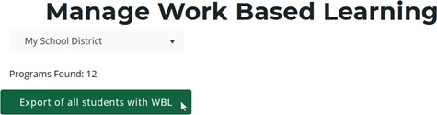

IMPORT WORK BASED LEARNING ENTRY

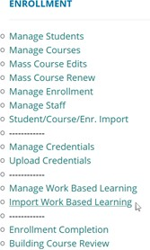Users are encouraged to take advantage of the import functionality of the Work Based Learning feature at the program level. You may also leverage the Work Based Learning Data Tracking Tool to facilitate imports. The WBL Tool is a prefilled spreadsheet of student UICs, first and last names, PSNs, and program names, and it also contains a column in which WBL experiences are entered. Of these fields, only the UIC, PSN and WBL experiences are required. This worksheet is in the required format for the CTEIS import and can be used to quickly update your data when experiences by student are included. Using the WBL tool is not required if your Student Management System already has a means to create an import file.

Keep in mind, importing program WBL events will overwrite any existing events for that student, though students left blank in the template will not be overwritten. Thus, it is important that you coordinate multiple worksheet/tools to ensure data is not inadvertently overwritten.

To import data, carry out the following steps:
- From the navigation menu, click Data Entry, then Import Work Based Learning.
- On the Import Work Based Learning screen, click the Choose File… link and locate your import file.
- Click the Load Records button to upload your file. On the resulting screen, records that are ready to import appear with a green bar beneath them. Errors are displayed in a red bar beneath the associated records.
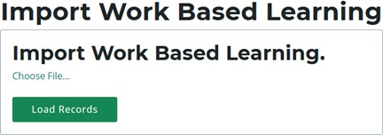

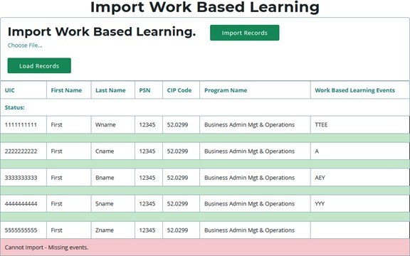

- To correct any errors, adjust your import file, then upload the file again.

- Click the Import Records button above the grid to import your work based learning experiences. Records within your import file that contain errors will be omitted; only error-free entries will be saved to the database.

Specifically, CTEIS will check your import file to ensure that:
  - Students are in the correct PSN.
  - PSNs are in buildings you have access to.
  - WBL experiences are valid and included.

- Verify that your student and program names are correct after import.

MANAGE WORK BASED LEARNING THROUGH ENROLLMENTS

To open the Manage Enrollment screen:
- 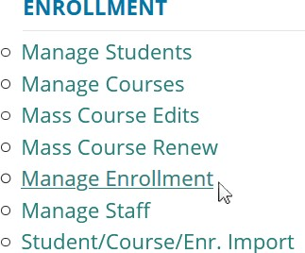Log into CTEIS at www.cteis.com using your MEIS username and password.
- From the navigation bar, click Data Entry, then Manage Enrollment.
- If necessary, use the Please select district... field to choose a district. The grid is populated with active courses within that district.

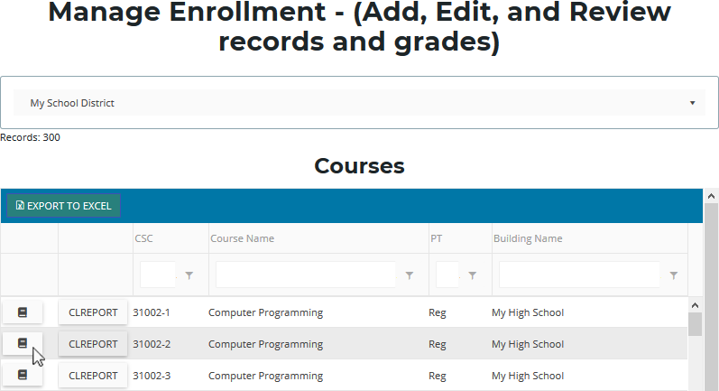

- Click the book icon of a course that you want to update. Enrolled students are displayed in a grid that you may sort by clicking on the various column headers.

To add work based learning experiences via Manage Enrollment:
- Select students by clicking their rows within the data grid.
- Click the Update Enrolled Students button to open the Update Selected Enrollments panel.

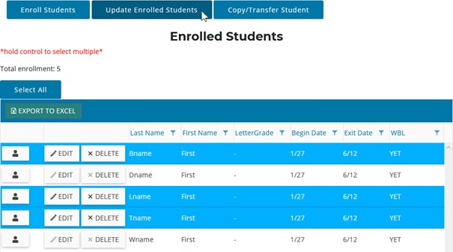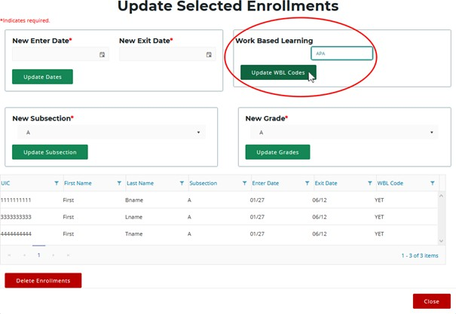

- In the Work Based Learning panel, enter the codes for any work based learning experiences you wish to add to the student records, then click Update WBL Codes. Please note that this will overwrite any work based learning experiences already displayed in the Enrolled Students grid.
- When utilizing the Manage Work Based Learning feature, please note that you may choose to replace work based learning experiences according to data entered via Manage Enrollment. To do this, select a program and then click the Update WBL from Enrollments button.
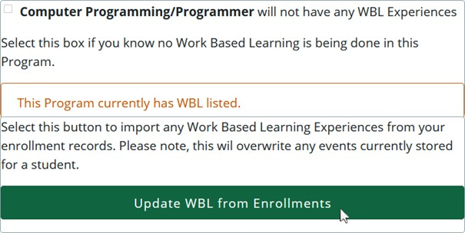

The “Update WBL from Enrollments” process will review all enrollment records for a student within a program and append all WBL experiences together. This aggregated list of WBL experiences will then be copied onto the student’s program record, overwriting what is currently stored and updating the program record with the enrollment information. Please keep in mind, if you choose to use enrollments to record your WBL experiences, you will need to run this step prior to submitting your Spring Enrollment Collection.

ADDITIONAL WORK BASED LEARNING INFORMATION

Work Based Learning Import Table

Column | Column Heading | Content | Content Description
A | UIC* | Student Unique Identifier Code (UIC) | A unique code assigned to each student by CEPI for reporting students in the Michigan Student Data System (MSDS)
B | FirstName | Student First Name | Student first name as entered into CTEIS and MSDS
C | LastName | Student Last Name | Student last name as entered into CTEIS and MSDS
D | PSN* | Program Serial Number | Unique 5-digit number assigned by OCTE to state approved CTE programs representing a unique combination of Educational Entity Master (EEM) building code, CIP Code, and program type (Reg = State-Approved Program; EMC = EMC State-Approved Program; RegE = Emerging Program; EMCE = EMC Emerging Program)

E | Program Name | Official OCTE  program name associated with the CIP code | Official OCTE program name associated with the program CIP Code.  Generally matches the name listed on the National Center for Education Statistics IPEDS website for the CIP Code
F | WorkBasedLearningEvents* | Code field for work based learning experiences | Field in which district staff enter a code for each work based learning occurrence experienced by the student in the specified PSN during the school year

- Column F: Districts enter a code for each work based learning occurrence experienced by the student in the specified PSN during the school year in the following format:

  - Enter codes without spaces between them.

  - Enter one code for each discrete work based learning occurrence. Refer to the work based learning guidance document and examples found at:

https://www.michigan.gov/documents/mde/WBL_Continuum_Guide_ 703181_7.pdf.

For example, if a student participated in two career fairs (level A), one job shadow (level E) and three practicums (level T) during the school year, the entry in the WorkBasedLearningEvents* column would look like this:

WorkBasedLearningEvents*
AAETTT

- If a program has no work based learning events, the UIC field should be set to 9999999999 and the column F should contain the capitalized word NONE.

- At the end of the year, a spreadsheet containing a completed column F is provided to a CTEIS data entry staff person for upload into the system. This spreadsheet may not be reused; a new spreadsheet with a blank WorkBasedLearningEvents column must be filled out each year. Adding additional events for a new school year to a spreadsheet with prior year data will result in duplicate entries. Uploading a new spreadsheet will overwrite the existing WBL data for the year, and any upload may overwrite data contained in CTEIS depending on the method used to enter that data.

Work based learning data is due and submitted with the Spring Enrollment collection at the end of each school year. For the 2020-2021 year, this data is:
- Due to CEPD Administrators: June 16, 2022
- Due to OCTE: June 23, 2022

For further assistance, please contact Celena Mills (MillsC1@michigan.gov) or Lee Greenacre (GreenacreL@michigan.gov) at OCTE.

MANAGE STAFF

CTEIS requires proper instructor information for each course section, which you may update using the Manage Staff screen.

OPEN THE MANAGE STAFF PAGE

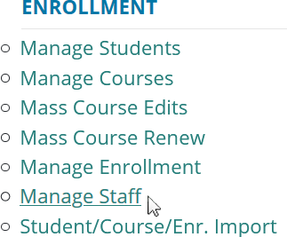To open the Manage Staff page:

- Log into CTEIS at www.cteis.com using your MEIS username and password.

- From the navigation bar, click Data Entry, then Manage Staff. Here, you can view, add, or edit teacher records.
You may also add staff members to your list via the Data Entry menu ➔ Manage Courses screen. Both methods are described in Add a Staff Member to the CTEIS Database on page 75.

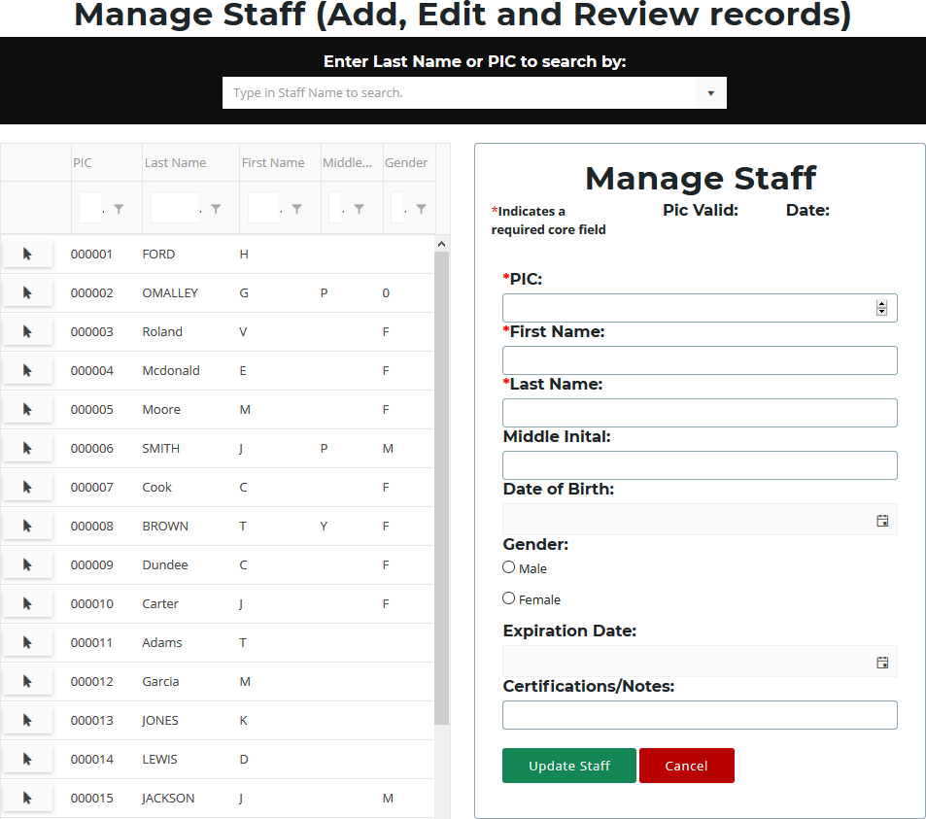

Points to Remember When Managing Staff

  - While examining the Manage Staff grid, verify that all teachers and paraprofessionals within your operating buildings are reported.

  - Make sure that primary teachers are linked to their respective course sections as you enter new staff records into CTEIS. The process of linking teachers to course section records is explained in Add Staff to Courses on page 36.

STAFF INFORMATION FIELDS

CTEIS gives reporters the option to include several pieces of data when updating or creating staff records. While many of the input fields are provided for local use, when creating a new staff record, please remember that fields marked with an asterisk (*) do require valid input.

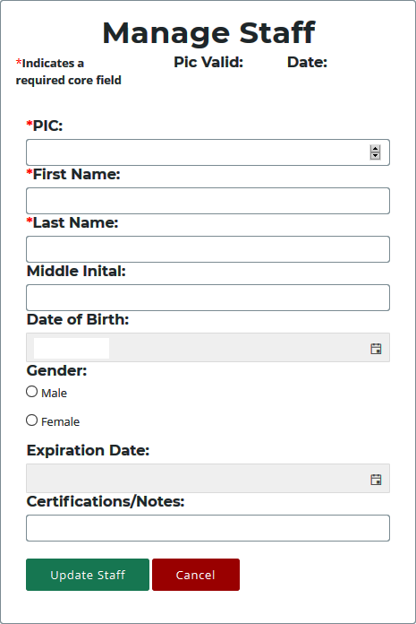PIC Valid / Date — These fields indicate whether a staff member’s PIC is currently valid as well as the date it was assigned to the instructor. This information is supplied by OCTE and is not editable.

PIC — Enter the Personal Identification Code as reported for the Registry of Educational Personnel (REP).

The State of Michigan provides a helpful Personnel Search User Guide, which includes instructions on how to search for an existing PIC number. To access it, open a Web browser and go to www.michigan.gov/cepi. From the left navigation panel, click on the CEPI Applications ➔ Registry of Educational Personnel link and browse the Manuals drop-down list.

First Name / Last Name — Enter the instructor’s first and last name. These fields are required.

Middle Initial / Date of Birth / Gender (Optional) — Enter the instructor’s middle initial, birth date, and gender. These fields are not required and you may utilize them at your discretion.

Expiration Date (Optional) — This field is not required and is provided for reporters who wish to enter the expiration date of the instructor’s teaching certificate. Typed dates will be accepted in the following formats:

(m)m/(d)d/yy, (m)m/(d)d/yyyy, mm-dd-yy, and mm-dd-yyyy Examples: 04/05/67, 04/05/1967, 04-05-67, 04-05-1967

Certifications / Notes (Optional) — This field is not required and is provided for reporters who wish to include information regarding a staff member’s certification status or classroom function.

ADD A STAFF MEMBER TO THE CTEIS DATABASE

If a staff member does not exist within the CTEIS database, you will need to add a new staff record in one of the following two ways:

Method one:

- 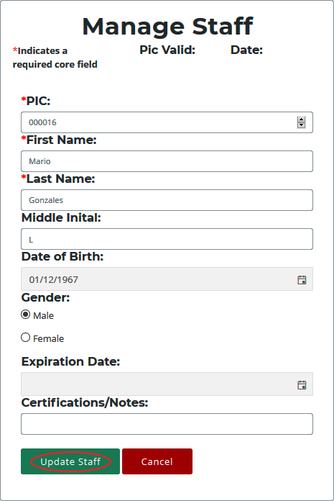In the Manage Staff panel, enter staff details in the provided fields including the instructor’s PIC, last name, and first name.
- Click the Update Staff button. A Valid PIC message is displayed along with the current date. The new teacher is added to the Staff Members grid and is now avail- able to add to your course section records.

Method two:

You may also add staff members to your list by selecting any course record on the Manage Courses screen and utilizing the Course Staff panel. For details, refer to Add Staff to Courses on page 36.

EDIT STAFF INFORMATION

If you need to edit or update a staff member’s information, use the following steps:

- Open the Manage Staff page. For details, refer to Open the Manage Staff Page on page 72.

- Click the arrow icon of a staff member whose information you want to update. That instructor's information will be displayed in the Manage Staff panel.

- Edit the staff member’s details.

- Click the Update Staff button to save your changes.

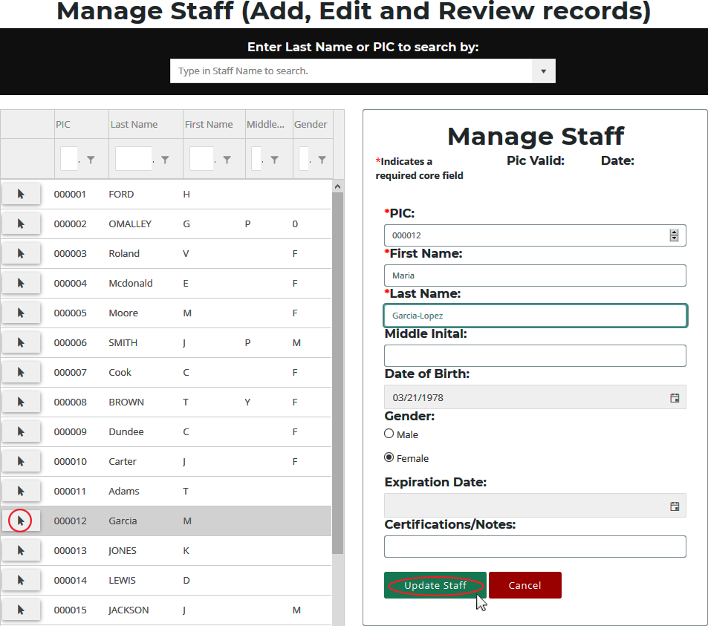

MANAGE STUDENTS

Student records are an important part of your spring Enrollment and Completion Collection and must be entered carefully because:

- Some student information in CTEIS supplements data required by the MSDS.

- Addresses, phone numbers, and email addresses on file in the CTEIS database are used during the Follow-Up reporting cycle that begins each fall.

- Federal reports require student data, especially student credentials and special populations.

OPEN THE MANAGE STUDENTS SCREEN

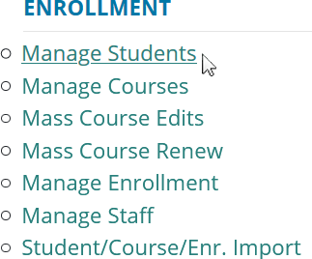To open the Manage Students screen:

  - Log into CTEIS at www.cteis.com using your MEIS username and password.

  - From the navigation bar, click Data Entry, then Manage Students.

NAVIGATE THE MANAGE STUDENTS SCREEN
- Select a building from the Select Building... drop-down menu to load students from that building into the student grid. You may view students who have left school by selecting the Include Students Who Left School checkbox.

- To search for a student, enter either a UIC or a last name into the Search By UIC/LastName search box and then click the Search button.

- Sort your list by clicking on any column headers.
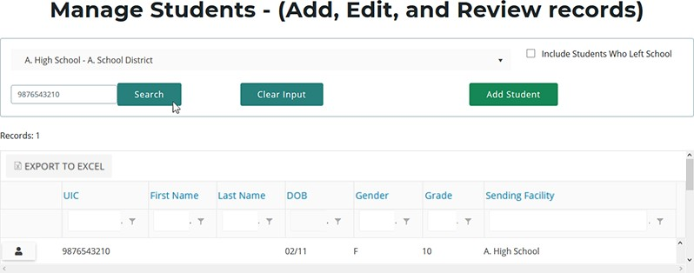

ADD A NEW STUDENT RECORD

If a student does not exist within the CTEIS database, you will need to add a new student record using the following process:

- Open the Manage Students screen. For details, refer to Open the Manage Students Screen on page 77.

- Click the Add Student button. The Student Details panel opens.
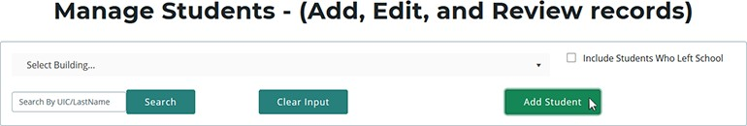

- Enter the Student Core Information and demographic details.

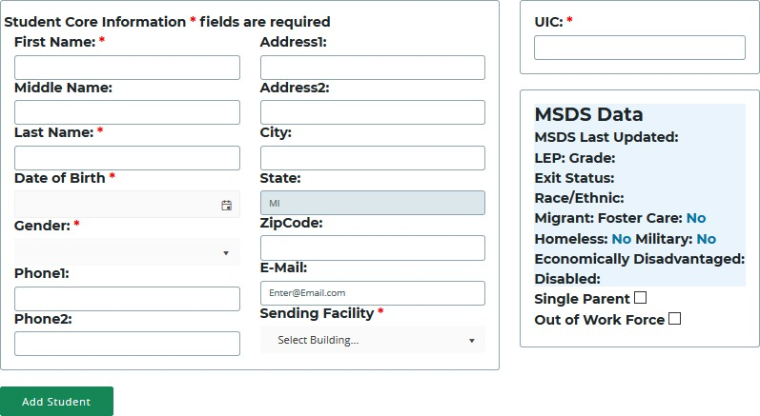

For details on how to enter this information, refer to Student Demographic Fields on page 79.

- Click the Add Student button.
Instead of updating or adding new student records to CTEIS individually, you may use the recommended file import process. Refer to Importing Students on page 87.

STUDENT DEMOGRAPHIC FIELDS

The following information is maintained for your student records. The first four fields on the Student Details panel marked with an asterisk (*) plus the UIC indicate the five core fields CTEIS uses to match your entries to the records in the state's Michigan Student Data System (MSDS).

Student Details Panel

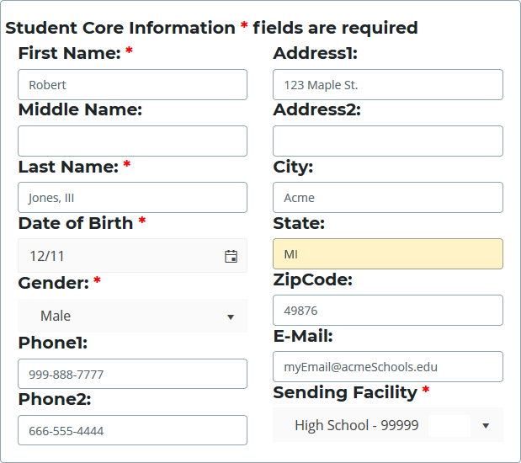First Name / Middle Name / Last Name — Enter the student's full name (last, first, and middle initial) as it appears in your official student database or on a birth certificate. The name you enter must match the one found in the UIC master file.
Including the student's middle name can increase your chances of obtaining a match.
Date of Birth — Enter the student’s date of birth. This date must match the UIC master file and will be accepted in mm/dd/yyyy format.
Gender — Choose the student’s gender from the drop-down menu. This selection must match the information in the UIC master file.
Address1 / Address2 / City / State / ZipCode — Enter the student’s address information. These fields help reporters conducting the annual Follow-Up survey to make contact with student completers.
Phone1 / Phone2 / E-Mail — Enter the student’s phone number, alternate phone number, and e-mail address. These fields help reporters conducting the annual Follow- Up survey to make contact with former students.

Sending Facility — Use the corresponding drop-down menu to choose the school where the student takes regular academic courses. In the case of homeschooled students:
- If the ONLY courses the student is taking in a public school are CTE courses, then the sending facility should be the building where the CTE courses are being taken.

- If the student is enrolled in any non-CTE courses in a public school such as music or special education, then the sending facility should be the building where the student is taking any non-CTE courses.

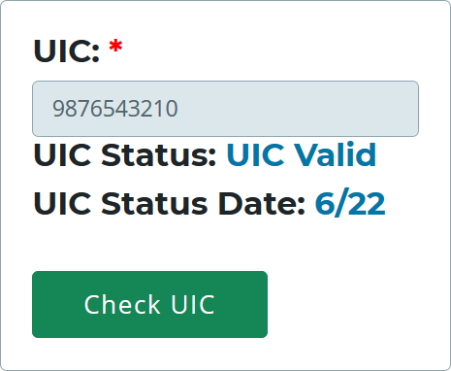UIC Panel

UIC — All students enrolled in state- approved CTE programs, including home- schooled and privately-schooled students, have a Unique Identifier Code (UIC) assigned by CEPI (the Center for Educational Performance and Information). This UIC must be entered before CTEIS will accept student data, and your entry must also match the code on record in the Michigan Student Data System (MSDS).

When entering a UIC in the Student Details panel, you may use the Check UIC button to verify the status of a student’s UIC. You may also enter a student's last name, first name, or date of birth and then click the Check UIC button to search for a current UIC on file. In the event of a missing UIC, contact your local UIC Resolver to obtain the relevant information.
UIC Status / UIC Status Date — These are read-only fields that display whether a student’s UIC is currently valid and the date when the UIC was last verified. You may use the Check UIC button while reviewing a student record to verify that the student’s UIC matches the one on record in the MSDS. To view details related to UIC error codes, please see Issue Tables on page 113.

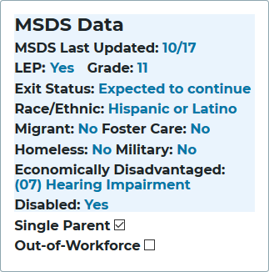MSDS Data Panel

MSDS Last Updated — This is a read- only field that displays the date when the student’s demographic information was last updated from the MSDS. If the student is new, this field will show that an MSDS update is pending. If this date is earlier than the school year start date, CTEIS will flag the student as expired.

LEP — This is a read-only field that indicates if the student has a Limited English Proficiency. This field is updated periodically with information from the MSDS. A missing
value indicates that an MSDS match update has not been performed yet—see the “MSDS Last Updated” definition above for further information.

Grade — This is a read-only field that displays the student’s current grade level. This field is updated periodically with information from the MSDS. A missing value indicates that an MSDS match update has not been performed yet—see the “MSDS Last Updated” definition above for further information.

Exit Status — This is a read-only field that displays the student’s current exit status. By default, a student’s exit status is “19-Expected to continue.” This field is updated periodically with information from the MSDS. A missing value indicates that an MSDS match update has not been performed yet—see the “MSDS Last Updated” definition above for further information.

Race / Ethnic — This is a read-only field that displays the student’s race and ethnicity. This field is updated periodically with information from the MSDS. A missing value indicates that an MSDS match update has not been performed yet—see the “MSDS Last Updated” definition above for further information.

Migrant — This is a read-only field that indicates if the student is a migrant worker. This field is updated periodically with information from the MSDS. A missing value indicates that an MSDS match update has not been performed yet—see the “MSDS Last Updated” definition above for further information.

Foster Care — This is a read-only field that indicates if the student is in or has aged out of the foster care system.

Homeless Children and Youth— This is a read-only field that indicates an individual who lacks a fixed, regular, and adequate nighttime residence and includes children and youths who:
- Are sharing the housing of other persons due to loss of housing, economic hardship, or a similar reason; are living in motels, hotels, trailer parks, or camping grounds due to the lack of alternative adequate accommodations; are living in emergency or transitional shelters; or are abandoned in hospitals.
- Have a primary nighttime residence that is a public or private place not designed for or ordinarily used as a regular sleeping accommodation for human beings.
- Are living in cars, parks, public spaces, abandoned buildings, substandard housing, bus or train stations, or similar settings.
- Migratory children who qualify as homeless...because the children are living in circumstances described above.

Military — This is a read-only field that indicates if the student has a parent who is a member of the armed forces and is on active duty.

Economically Disadvantaged / Disabled — These are read-only fields that indicate if the student is identified as economically disadvantaged, low-income, or possessing any disabilities. These fields are updated periodically with information from the MSDS. A missing value indicates that an MSDS match update has not been performed yet—see the “MSDS Last Updated” definition above for further information.

Single Parents, including single pregnant women — At the secondary level, single parents, including single pregnant women, are individuals who meet ALL of the following criteria:
- Age 19 or below.
- Without a high school diploma.
- Unmarried or legally separated from their spouse.
- Pregnant, or have a minor child or children for which the parent has custody or joint custody.

Out-of-Workforce — The term “out-of-workforce individual” means an individual who is a displaced homemaker, as defined in section 3 of the Workforce Innovation and Opportunity Act (29 U.S.C. 3102); or:
- Has worked primarily without remuneration to care for a home and family, and for that reason has diminished marketable skills;
- OR is a parent whose youngest dependent child will become ineligible to receive assistance under part A of Title IV of the Social Security Act (42 U.S.C. 601 et seq.) not later than 2 years after the date on which the parent applies for assistance under such title;
- AND is unemployed or underemployed and is experiencing difficulty in obtaining or upgrading employment.

PROGRAM DETAILS AND CURRENT ENROLLMENT

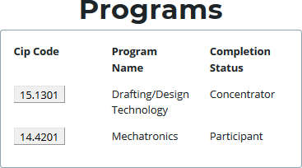The Programs panel allows you to view a student's completer status. Click on a CIP Code button to open the Program Enrollment Details panel and view a chart of the segments that the student has received credit for as well as those pending for the current semester. These segments are denoted as follows:
- An “X” within one of the numbered segment columns indicates the student has received a passing grade in a course delivering that segment.
- An “E” within a segment column indicates that the student is currently enrolled in a course delivering that segment.

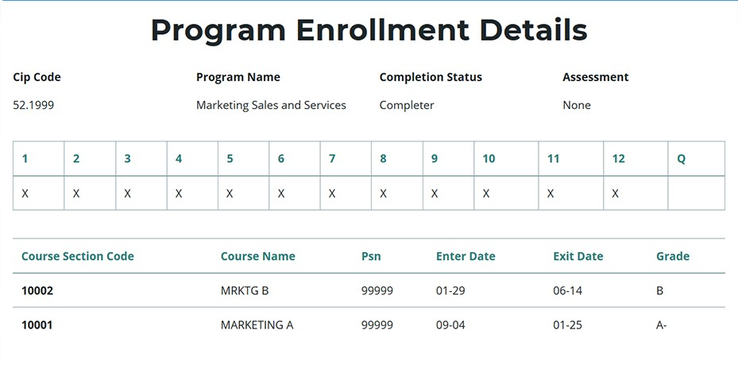

Segment information and course grades must be validated with your teachers for each student using a report such as the Student List Report.

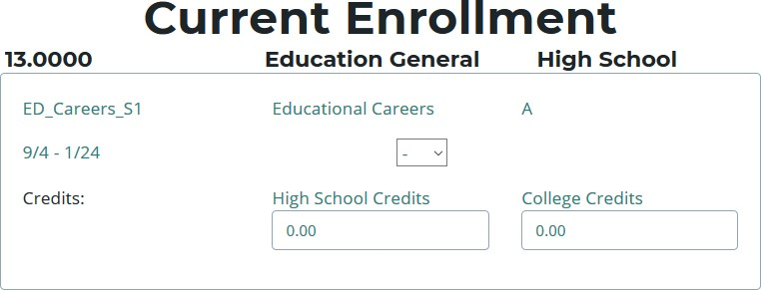The Current Enrollment panel displays the courses that a student is currently enrolled in. You may modify a student's grade for a course by clicking within the Grade drop-down menu and selecting a code to apply. Similarly, if the student is dual-enrolled, you may edit the credits that student will earn from a course

using the High School Credits and College Credits spin boxes. Credentials currently attached to a student are listed below this panel.

EDIT OR REVIEW AN EXISTING STUDENT

To edit or review a student’s demographic details:

- Open the Manage Students screen. For details, refer to Open the Manage Students Screen on page 77.

- Choose the student’s sending facility from the Select Building... drop-down menu to load students from that building into the student grid. Alternatively, enter the student’s UIC or last name into the Search By UIC/LastName search box and then click the Search button.

- Click the student icon of a student that you wish to update. Student Details are displayed in a panel

- Make the necessary changes to the student’s information.

- Click the Update Student button below the Student Details panel.

IMPORTING STUDENTS

Importing students is important because:
- Importing students is a very efficient way of adding and updating several student records simultaneously.
- Imported student records can be edited later if necessary.
- Importing students is more accurate than manual data entry.

Before You Begin Importing Students

Before you begin importing your data, ensure that you:
- Identify the data that you need.
- Format the data for easy import.
For an error resolution guide and other detailed information, refer to the Appendix: Import Formats on page 130.

IMPORT STUDENT DATA

To import data, carry out the following steps:
  - From the navigation menu, click Data Entry, then Student/Course/Enr. Import.
  - On the Select building to import screen, click the student icon of the building you wish to import records into.
  - Beneath the Import Students/Buildings/Grades header, click the Choose File... link and locate your import file.

  - 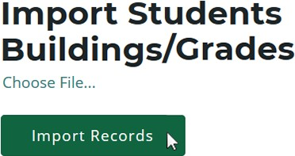Click the Import Records button to upload your file. Errors, if any, are dis- played in the Error column of the tem- porary grid on the resulting screen.
  - To correct any errors, click the Back to List button to reset the screen, adjust your import file, then upload the file again.
  - Click the Process Students/Enrollments button beneath the grid to import all error-free student records.

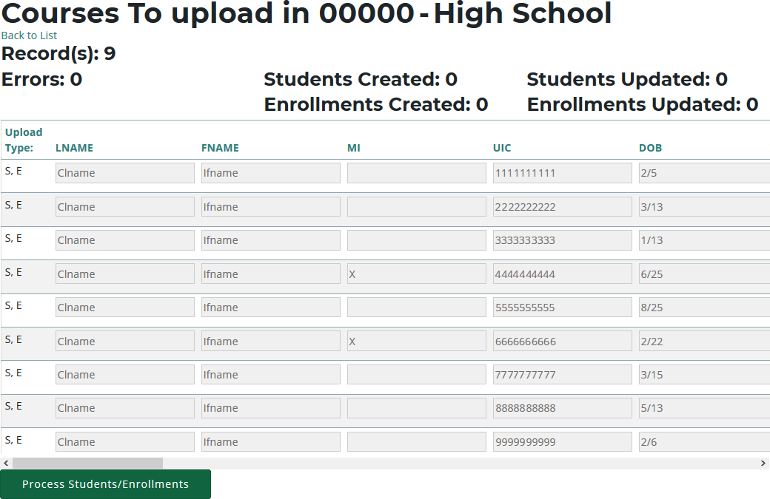

Clicking the Review Import button allows you to export the list of import records and their import statuses and errors. This may be useful for offline review and remediation.

REVIEW STUDENTS

You can review students by using:
- The Check UIC button.
- Reports: Bad UIC by Building and UIC With No Current MSDS.

CHECK UIC BUTTON

- 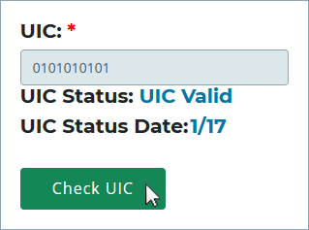UICs are checked every time a student record is stored manually.

- In the UIC panel of the Manage Students screen, you can enter a student’s core fields and click the Check UIC button to verify a student UIC without saving the student record.

- CTEIS automatically checks UICs included with imported records but may take 2- 3 days to do so. To expedite this process, use the Check UIC button.

- The results from using the Check UIC button will tell you if the UIC provided is recognized as a primary or secondary UIC, or if it is unlinked. This is useful for resolving UIC errors.

To use the Check UIC button:
- Open the Manage Students screen. For details, refer to Open the Manage Students Screen on page 77.
- Choose the student’s sending facility from the Select Building... drop-down menu to load students from that building into the student grid. Alternatively, enter the student’s UIC or last name into the Search By UIC/LastName search box and then click the Search button.
- Click the student icon of a student whose UIC you wish to verify. UIC information is displayed in a panel.
- Click the Check UIC button to ensure that the entered UIC is valid and that CTEIS is able to locate the student's core information within the MSDS.

BAD UIC BY BUILDING REPORT

This report displays invalid UICs. It also shows the UIC, student name, gender, date of birth, and associated errors for all the enrolled students within a building. Use this report to locate and print students who do not pass the enrollment validation check.
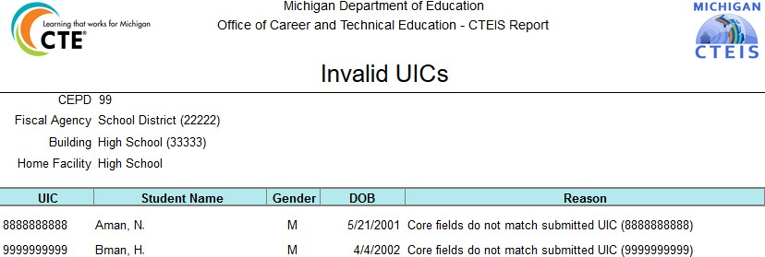

UIC WITH NO CURRENT MSDS REPORT

This report displays a list of students with invalid or expired UICs. Use this report to verify that all of your students have been updated through CTEIS and contain matching records within the MSDS. Check with your UIC Resolver to fix student UIC and MSDS issues.
For information on how to create and print these reports, refer to Generate Your Reports on page 44.

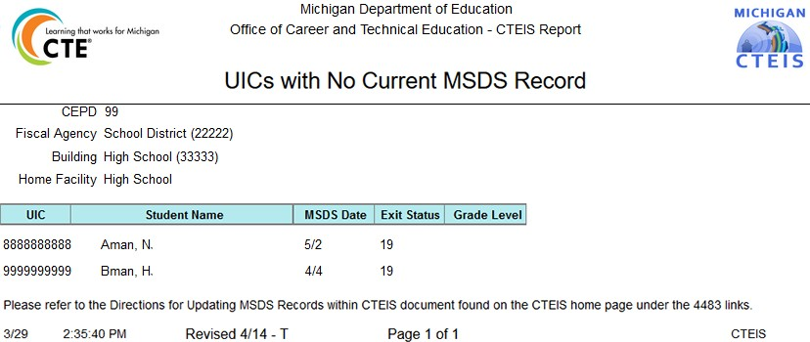

MANAGE ENROLLMENT

Course section enrollments are entered and updated within CTEIS during each new school year. While managing enrollments, you can edit enrollment lists, copy or transfer students from one course section to another, view courses operating within the current school year, and print class enrollment lists. Updating student grades is also part of this process.

OPEN THE MANAGE ENROLLMENT SCREEN

To open the Manage Enrollment screen:
  - Log into CTEIS at www.cteis.com using your MEIS username and password.
  - From the navigation bar, click Data Entry, then Manage Enrollment.
  - If necessary, use the Please select district... field to choose a district. The grid is populated with active courses within that district.

  - Click the book icon of a course that you want to update. Enrolled students are displayed in a grid that you may sort by clicking on the various column headers.
  - Click the CLREPORT button to quickly access and print a class student list report. Use this report to obtain sign-off from your teachers for each student’s grade and segments.
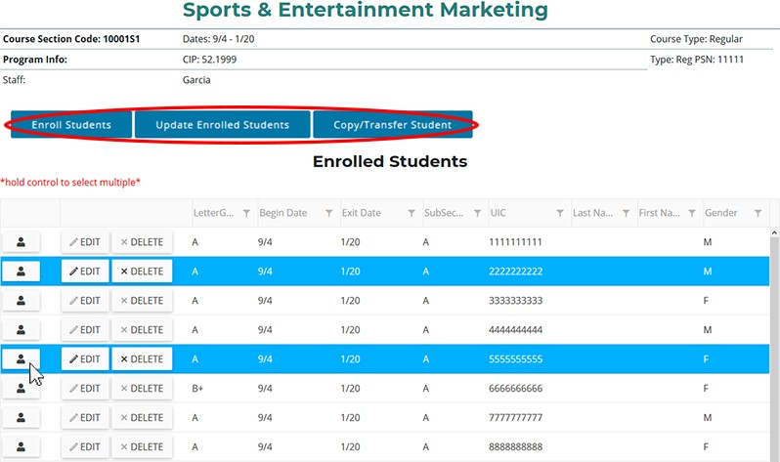

The area above the Enrolled Students panel displays valuable information regarding the selected course including the Course Section Code, Local Course Name, PSN, CIP Code, beginning and ending dates, and primary instructor. This information changes as you edit class information using your Manage Courses screens. The Enroll Students, Update Enrolled Students, and Copy/Transfer Student buttons below this information allow you to manipulate your enrollment list and are described in further detail in the following sections.

ENROLL STUDENTS

To enroll students into CTE courses in CTEIS:

- Open the Manage Enrollment screen. For details, refer to Open the Manage Enrollment Screen on page 91. Upon selecting a district, a default list of your currently active courses is displayed.

- Click the book icon of a course to which you wish to add new enrollments. Enrolled students are displayed in a grid.

- Click the Enroll Students button. The Enroll Students pop-up window opens.

- Select a sending facility to browse for students using the Select District... drop- down list.
You may enter specific criteria within the Search By UIC or Search by first name or last name fields to search for specific students.

- A list of students available for enrollment is displayed in the Students grid.
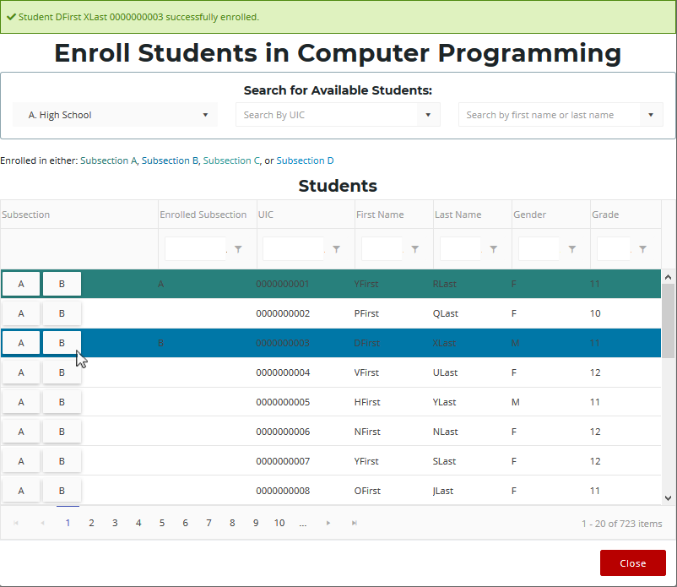

- Select a student's Subsection button to enroll him or her into that subsection of the course. Highlighted rows within the Students grid indicate students who have already been enrolled in the course section.
When a student is enrolled into a CTE course, an enrollment record is created using the default beginning and exit dates associated with the selected course section. To change beginning or ending dates, refer to Edit Courses on page 31.

EDIT ENROLLED STUDENTS

To edit your enrollment records:
- Open the Manage Enrollment screen. For details, refer to Open the Manage Enrollment Screen on page 91. Upon selecting a district, a default list of your currently active courses is displayed.
- Click the book icon of a course containing enrollments that you wish to update. Enrolled students are displayed in a grid.
- Click rows in the grid to select the student enrollments you would like to edit.
- Click the Update Enrolled Students button. The Update Selected Enrollments pop-up window opens.

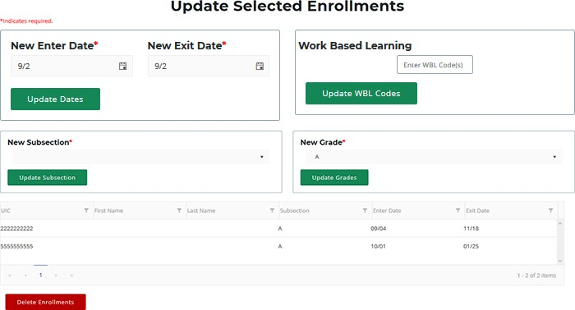

- Edit any of the following fields:
  - New Enter Date / New Exit Date — Add new enter or exit dates in the input fields, then click the Update Dates button to alter the dates that the selected students entered or left this course.
  - Work Based Learning — Add new WBL codes in the input field, then click the Update WBL Codes button to edit the work based learning experiences associated with the selected students.

  - New High School Credits / New College Credits — Add new high school or college credits in the input fields, then click the Update Credits button to edit the credits granted to students enrolled in this course.
  - New Subsection — Select a subsection from the drop-down menu, then click the Update Subsection button to place the marked students into a different subsection within the course.
  - New Grade — Select a code from the drop-down menu, then click the Update Grades button to modify the course grade for each of the selected students.
  - Delete Enrollments — Click this button to delete the selected students’ enrollment records from the course section.
After you complete your edits, print the Student List Report and obtain sign-off from your instructors to verify that your students will be granted credit for the correct course grades and segments.

COPY/TRANSFER MARKED STUDENTS

To copy or transfer your enrollment records from one course section to another:
- Open the Manage Enrollment screen. For details, refer to Open the Manage Enrollment Screen on page 91. Upon selecting a district, a default list of your currently active courses is displayed.
- Click the book icon of a course containing enrollments that you wish to copy or transfer. Enrolled students are displayed in a grid.
- Click rows in the grid to select the student enrollments you would like to edit.
- Click the Copy/Transfer Student button. The Copy/Transfer Selected Enrollments pop-up window opens.
- Use the New Course drop-down list to select the course you would like to copy or transfer the selected students into.
- Enter the Enter Date, Exit Date, and Subsection that the selected students are to retain when copied or transferred.

- Click either of the two buttons:

  - Copy Enrollment — Click this button to keep student enrollment records within the original course intact and to duplicate them into the course section indicated in the “Available Building Courses” field.

  - Transfer Enrollment — Click this button to remove student enrollment records from the original course and move them into the course section indicated in the “Available Building Courses” field.

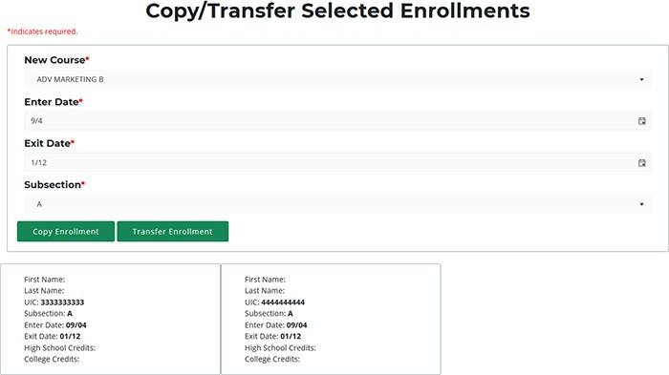

After you complete your edits, print the Student List Report and obtain sign-off from your instructors to verify that your students will be granted credit for the correct course grades and segments.

GRADE INPUT

The coding systems used to provide students with grades at the end of a course vary according to each district’s standards. CTEIS reporters should strive to input all grades, either manually or via import, exactly as issued by an instructor. Student grades are required for all regular wage-earning course sections as well as Family and Consumer Science programs.

You may enter grades into CTEIS at any time. When entering grades, adhere to the following requirement:

- Semester-length (first, second, trimester, or special) course sections need one letter grade for each student reported as enrolled in a course section on the Spring Enrollment and Completion Collection Report.

Districts should report the official course grade recorded on the student’s transcript in CTEIS. If the official course grade recorded on the transcript is “Pass,” “Pass” may be reported in CTEIS, regardless of the district criteria for determining a passing grade.
This includes if the district counts grades below 2.0 as “Pass.” However, if the official course grade recorded on the student’s transcript is a letter grade, then the letter grade should be reported in CTEIS.

To input or edit course section grades in CTEIS:
- Open the Manage Enrollment screen. For details, refer to Open the Manage Enrollment Screen on page 91. Upon selecting a district, a default list of your currently active courses is displayed.
- Click the book icon of a course containing enrollments that you wish to copy or transfer. Enrolled students are displayed in a grid.
- Click the Edit button of an enrollment that you wish to update.
For grade code information, refer to Letter Grade Definitions and Comparable GPAs on page 99.

- Click the cell within the Letter Grade column, then select a grade code from the drop-down menu and click the Update button to apply it to the record.
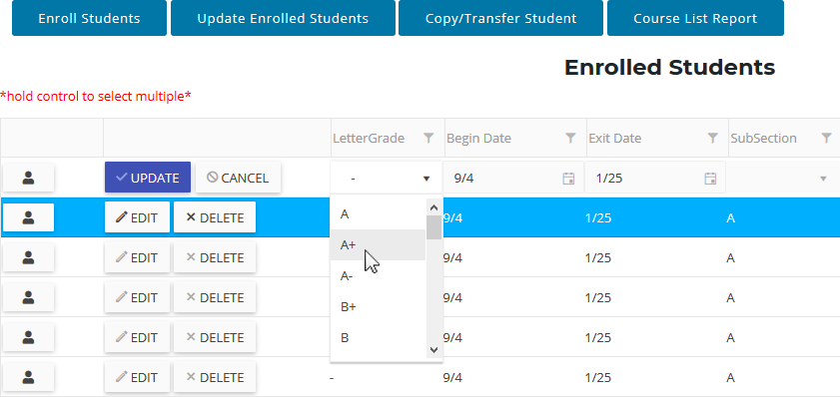

You may also import grades into the CTEIS database as letter codes or numeric GPAs. Refer to Importing Enrollments (with Grades) on page 100.

LETTER GRADE DEFINITIONS AND COMPARABLE GPAS

If your district uses a point system for grades and provides no letter grade, use the following comparison table to determine the comparable letter grade.

The following codes are used to mark student letter grades in a course section:

Letter Grade | Comparable Grade
A+ | 4.0
A | 4.0
A- | 3.7
B+ | 3.3
B | 3.0
B- | 2.7
C+ | 2.3
C | 2.0
C- | 1.7
D+ | 1.3
D | 1.0
D- | 0.7
E+ | 0.3
E | 0.0
F | 0.0
I | Incomplete
L | Left course without completion
N | Credit with no grade/audit
P | Pass
R | Dropped course
W | Withdrew
Z | No grade
— | (Clears the 'Crs Grade' field)

Please note that the “No Grade” choice (labeled “Z”) from the drop-down menu is not the same as an “N” grade, which is given to a student who audits a class.

IMPORTING ENROLLMENTS (WITH GRADES)

Importing enrollments is important because:

- Importing enrollments is a very efficient way of updating several records simultaneously.

- Imported enrollment records can be edited later if necessary.

- Importing enrollments is more accurate than manual data entry.

Before You Begin Importing Enrollments

Before you begin importing your data, ensure that you:

- Identify the data that you need.

- Format the data for easy import.
For an error resolution guide and other detailed information, refer to the Appendix: Import Formats on page 130.
The import process is similar to importing students, which is discussed in Importing Students on page 87. However, grade import files differ in that they must also include column headings labeled CSC and CRSGRD. Importing is also the only method in which reporters may enter numeric grades (on a 4-point scale) into CTEIS.

VERIFY IMPORTS

Be sure to verify your enrollments. Open the Manage Enrollment screen, locate the courses containing imported data, and check the accuracy of your students, enter and exit dates, and grades. Also verify that your students are in the correct course subsection as imported students are placed into Subsection A by default.

When printing your verification reports, ensure that your teachers verify the following:

- Student class lists

- Student grades

- Segments for each section or subsection

- Work-Based Learning

- Credentials

REVIEW ENROLLMENT INFORMATION

It is important to verify that students are enrolled in the correct course and subsection. To verify a student’s enrollment information, course sections, segment profiles and other related information:

- Open the Manage Students screen. For details, refer to Open the Manage Students Screen on page 77.
- Choose the student’s sending facility from the Select Building... drop-down menu to load students from that building into the student grid. Alternatively, enter the student’s UIC or last name into the Search By UIC/LastName search box and then click the Search button.

- Click the student icon of a student that you wish to review. Student Details are displayed in a panel

- In the Programs panel, click on a CIP Code button to open the Program Enrollment Details panel and view a chart of the segments that the student has received credit for as well as those pending for the current semester.

- Verify that the students are enrolled in the correct subsection and assigned the correct segments. Obtain sign-off from instructors to ensure that your information is correct.

THE PROGRAM ENROLLMENT DETAILS PANEL

- Provides a chart of the segments a student has received credit for as well as those pending for the current semester.

- This chart is an invaluable tool for viewing a student’s segment profile and determining whether or not that student will be eligible to receive a “Completer” status at the end of the school year.

- An “X” within one of the numbered segment columns indicates the student has received a passing grade in a course delivering that segment.

- An “E” within a segment column indicates that the student is currently enrolled in a course delivering that segment.

Ask your teachers to review enrollments using the following report:

CLASS STUDENT LIST REPORT

The Class Student List report contains details of the courses operating within a selected building including segment information, grades, and student enter and exit dates. Use this report to verify that your:

- Students have been enrolled into the correct courses for the current year.

- Students are placed in the appropriate subsection and will receive credit for the correct segments.
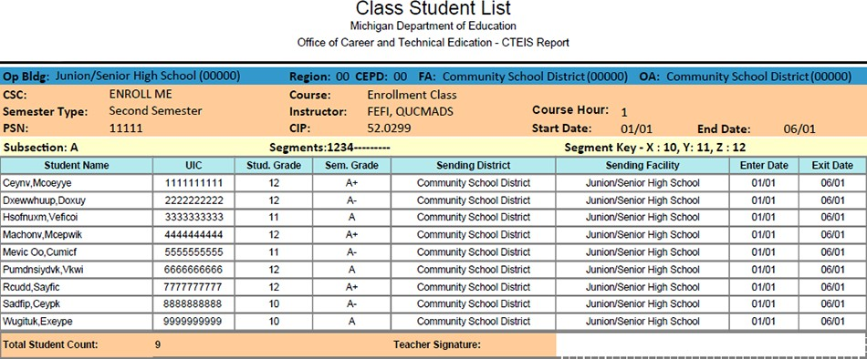

FALL COURSE AND STAFF ENTRY

In order to ensure that OCTE can accurately answer questions about the number of operating CTE programs each year, districts will be required to submit a report indicating all PSNs that will operate in the coming school year and the primary teacher who will be providing instruction. To minimize the amount of additional work required of districts, OCTE will collect this information by simply requiring districts to enter at least one course section for each teacher for each PSN into CTEIS, then submit this information in the fall. Of course, districts may choose to enter all of the course sections to be offered for this collection. Furthermore, you may continue to update your course details such as course dates, virtual learning delivery, and high school or college credit awarded prior to the spring collection deadline.

In fall 2021, the Fall Course and Staff Entry will be due to CEPD administrators by September 23, 2021 and to OCTE by September 30, 2021.

To review and submit your fall course and staff information:

  - 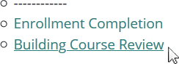Log into CTEIS at www.cteis.com using your MEIS username and password.

  - From the navigation bar, click Data Entry, then Building Course Review.

  - Use the Select District drop-down list to indicate the district for which you are compiling reports. The data grid displays a list of your active buildings.

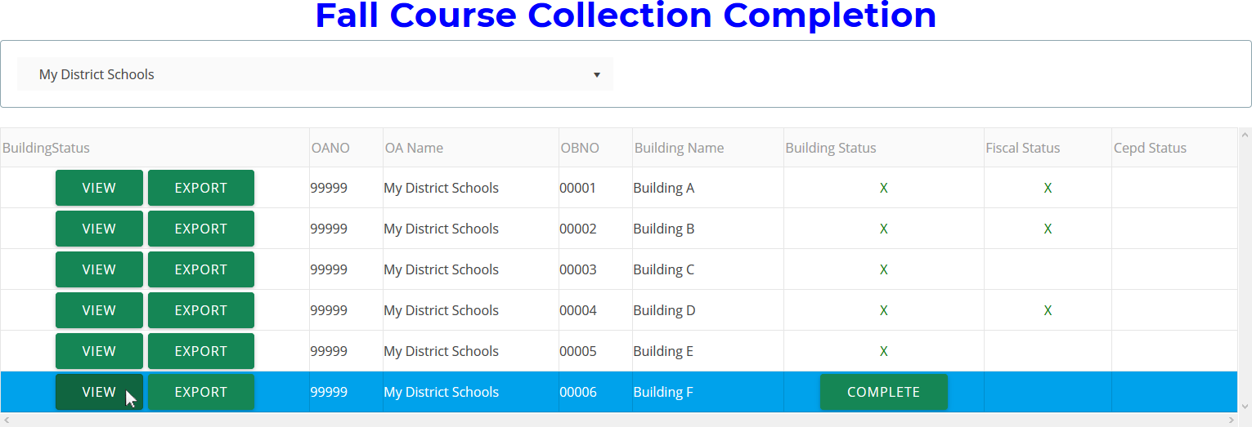

  - Click the View button to the left of a building name to run the building review routine. The review process lists all courses you have entered as well as their details.

  - Add staff members to any courses that appear highlighted in red by utilizing the Course Staff panel on the Manage Courses screen. You may click the Export to Excel button to export course lists into an Excel spreadsheet.
If course staff are currently unknown, you may leave them blank. However, you are encouraged to enter your staff to the best of your ability by the submission deadline.

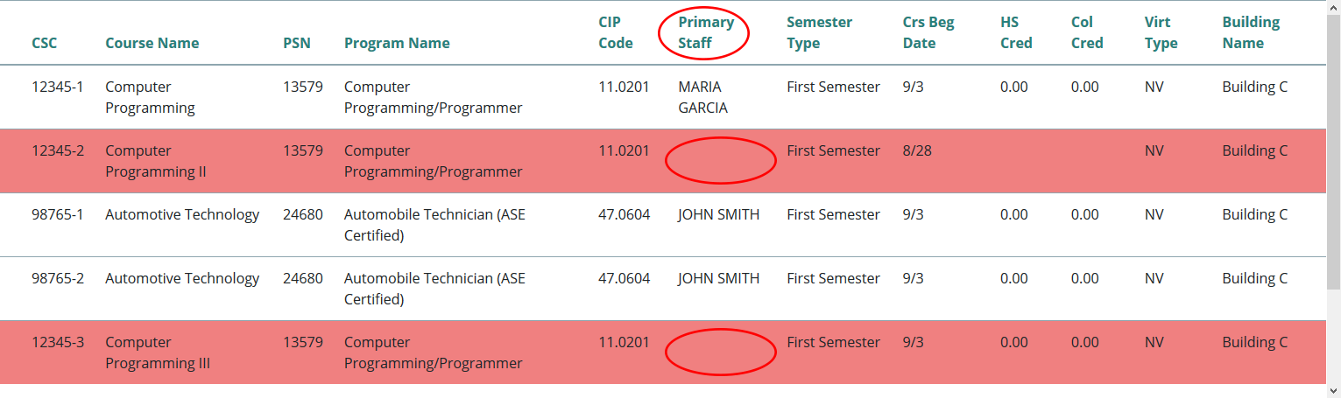

  - When your courses are error-free, click the Complete button within a building's row to submit its data for review.

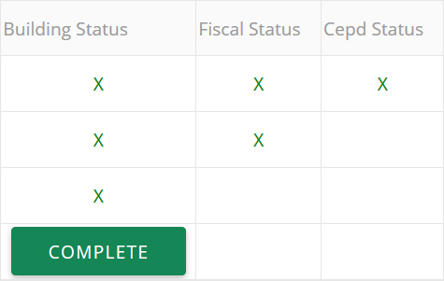

ENROLLMENT VALIDATION

Reporters should utilize the CTEIS validation tool frequently as your data entries must match those on record in the Michigan Student Data System before you may submit your final information. Validation provides you with valuable information regarding the accuracy of your data as well as access to additional reports that allow you to analyze your potential completion profile.

Some important points to note:

- It is recommended that you validate your data early and often—this process can alert you to student issues that need to be resolved in a timely manner.

- Your final data must pass a validation check before CTEIS will allow you to complete your spring Enrollment and Completion submission; however, you may access many valuable reports even with incomplete data. These include:
  - Completer Assessment
  - Instructional Design
  - Program History

VALIDATE YOUR ENROLLMENT DATA

- 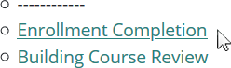Log into CTEIS at www.cteis.com using your MEIS username and password.

- From the navigation bar, click Data Entry, then Enrollment Completion.

- Use the Select Year drop-down list to indicate the year for which you are compiling reports. The data grid displays a list of your active buildings.
Generally, you will choose the current school year so you can begin validating your enrollment information. However, you may use the Select Year drop-down list to access reports from previous years as well.

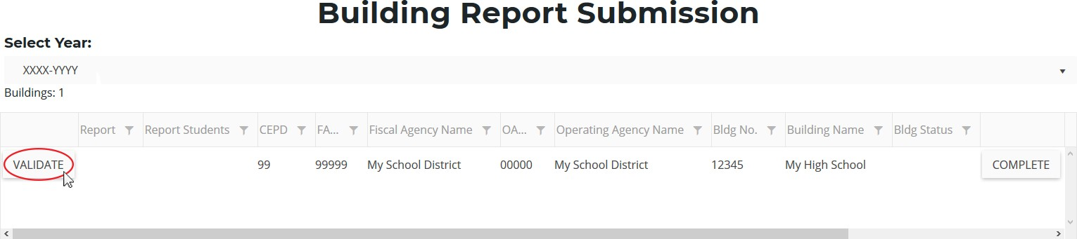

- Click the Validate button to the left of a building name to run the report validation routine. The validation process ensures that none of your records are missing any required information.

- Correct any errors that appear within the Building Enrollment Errors grid. You may click the Export to Excel button to export error lists into an Excel spreadsheet. For information on how to correct errors, refer to Troubleshoot Enrollment Data Entry Issues on page 108.

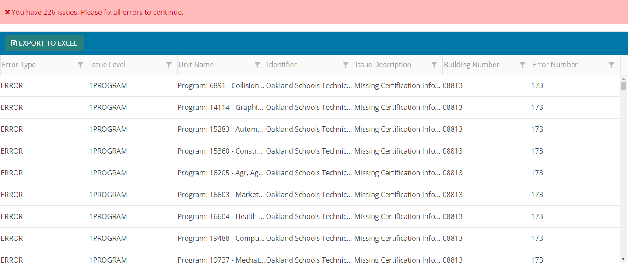

- Click the 4483 Rpt button to view your Data Verification and Enrollment Report, which provides a summary of your course details and counts your student enrollments. Use this report to obtain sign-off from course instructors verifying that all courses have been properly added to CTEIS and students have been correctly tabulated.
To view this report with additional student information, click the 4483 Std button. This report is useful for verifying your individual student enrollments.

- Save or print your report using the available export options.
Use the Completer Assessment Report (CompA) and Program Enrollment History Report as given in Review Completers on page 119 to help you to identify errors, verify enrollments, and ensure that students receive credit for the proper segments. Ensure that teachers have reviewed the report and signed off on it to indicate that your information is correct.

TROUBLESHOOT ENROLLMENT DATA ENTRY ISSUES

The process of validating your enrollment data generates a list of errors and warnings discovered within your entries. You can troubleshoot problems by first determining the type of problem CTEIS is showing you.

- The ErrType column will describe whether your issue is an error or a warning. The Error Level and UnitName columns will indicate if the error is linked to a course, student, or enrollment record and will also indicate which entry contains the error.

Should you encounter errors related to student UICs, you can attempt to resolve the issues by following these steps:

- Check your student’s core information (last name, first name, date of birth, and gender) within CTEIS to determine whether it matches the fields found in the MSDS.
The “Last Name” field should include any necessary suffixes (Jr., II, etc.).
The student’s middle initial is NOT required to match a record to the MSDS; however, entering a full middle name can greatly improve the system's matching capability.

- In the MSDS, if a student has multiple primary UICs, ensure that they have all been linked by your UIC resolver.
You can search for student core information within the MSDS to help determine a primary UIC.

- If primary UICs can NOT be linked due to students having similar names, contact the CTEIS Help Desk for assistance.

Please note that you will need to contact your UIC Resolver if you do not have access to the MSDS. Remember that CTEIS generally requires 1-3 days to resolve newly- linked UICs, but you can manually update them by clicking the Update Student button on the Manage Students screen.

REVIEW STUDENT UICS AND GRADES

You may use the following reports to troubleshoot data entry errors linked to student UICs and grades:

BAD UIC BY BUILDING REPORT

This report displays invalid UICs. It also shows the UIC, student name, gender, date of birth, and associated errors for all the enrolled students within a building. Use this report to locate and print students who do not pass the enrollment validation check.

CURRENT YEAR MISSING GRADES REPORT

This report will list the students within your courses who have no grades assigned to them.
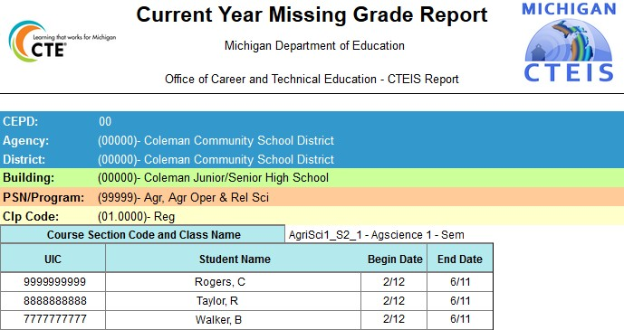

UIC WITH NO CURRENT MSDS REPORT

This report displays a list of students with invalid or expired UICs. Use this report to verify that all of your students have been updated through CTEIS and contain matching records within the MSDS. Check with your UIC Resolver to fix student UIC and MSDS issues.
For information on how to create and print these reports, refer to Generate Your Reports on page 44.

ENROLLMENT ISSUES

During your reporting process, you may encounter three different types of issues:

- UIC errors that occur either when you are on the Manage Students ➔ UIC Panel and push the “Check UIC” button, or when you run a validation check from the Enrollment Completion ➔ Enrollment Collection Completion page.

- Non-UIC errors that occur when you run a validation check from the Enrollment Completion ➔ Enrollment Collection Completion screen.

- Warnings that appear when you run a validation check from the Enrollment Completion ➔ Enrollment Collection Completion screen.

The following tables are divided into three sections, and each section addresses one of the above issues. The first column is italicized and displays whether your data is affected at the UIC, program, student, class, enrollment, or other level. Each error code that you might potentially encounter within CTEIS is displayed in red within the second column of this guide. The third column provides a suggested course of action for resolving the error or warning.
Errors MUST be corrected and warnings should be closely inspected to complete the validation process.

Incorrect information may result in issues such as:
- Students becoming enrolled in the wrong course.
- Students receiving credit for incorrect segments.

You must use the reports described in Review Completers on page 119 to make sure that your data is accurate.

ISSUE TABLES

Error Level | Error Message | Resolution
Student Core Information Error Messages
Resulting from using the “Check UIC” Button or CTEIS Validation
UIC | Core fields do not match submitted UIC (NNNNNNNNNN) – Check the student’s Core field (First name, Last Name, DOB and Gender against what was submitted in MSDS) | Review this student on the Manage Students screen and contact your MSDS resolver if necessary.
UIC | Last Name, First Name, and DOB found with different Gender for submitted UIC (NNNNNNNNNN) – May need resolution by your UIC resolver (link the two UICs) or check the gender of the student | Review this student on the Manage Students screen and contact your UIC resolver if necessary.
UIC | No UIC found matching these core fields - – Check the student’s Core field (First name, Last Name, DOB and Gender against what was submitted in MSDS) | Review this student on the Manage Students screen and contact your MSDS resolver if necessary.
UIC | Submitted UIC (NNNNNNNNNN) Invalid; UIC found based on fields (XXXXXXXXXX) – Contact CTEIS Helpdesk to change the UIC to the new primary UIC | Contact the CTEIS Help Desk for assistance.
UIC | Submitted UIC: NNNNNNNNNN does not match core fields. – Check the student’s Core field (First name, Last Name, DOB and Gender against what was submitted in MSDS) | Review this student on the Manage Students screen and contact your MSDS resolver if necessary.
Students who are not enrolled but have credentials or work based learning experiences in the current year are subject to UIC checks and may cause these validation errors.

Error Level | Error Message | Resolution
Error Messages
for Enrollment Report Processing
Program | FCS program did not meet requirements; students cannot be counted: | FCS requires a program to run at least 1 Parenthood class and 3 unique Non- Parenthood classes in a given year for the students to be counted for funding. Please ensure all classes are entered; if not, they will need to be removed.
Program | Invalid CIP: | If you believe this is a valid CIP code that your building is authorized to run, please contact OCTE for further instruction.
Program | Program [PSN] - [programName] missing credentials: | Go to the Manage Credentials screen and ensure that students within the program have had proper credentials assigned.
Program | Program [PSN] - [programName] missing WBL: | Go to the Manage Work Based Learning screen and ensure that students within the program have had proper WBL experiences assigned.
Program | PSN not in Building [building number]: | Contact the CTEIS Help Desk for assistance.
Student | - 27 or older, cannot be funded:  - Younger than 12, cannot be funded: | Use the “Manage Students” screen to check that the student’s date of birth has been entered correctly.
Student | Graduated Student must have an exit date: | Contact OCTE for assistance.
Student | - Invalid/Wrong Gender:  - Invalid/Missing/Wrong Race Ethnic:  - Invalid/Missing/Wrong School Grade:  - Handicap w/o Handicap Type/ or Invalid Handicap Type: | Contact the CTEIS Help Desk for assistance.
Student | Must be Michigan resident: | Verify that the student does live in Michigan and then press the “Update Student” button on the Student Demographics screen.

Error Level | Error Message | Resolution
Student | UIC has no current MSDS record: | Students who are not enrolled but have credentials or work based learning experiences in the current year are subject to UIC checks and may cause this validation error. Contact the CTEIS Help Desk for assistance.
Class | Building is closed: | Contact your Level 5 Fiscal Agent for assistance.
Class | - Course Missing Dual Enrollment Eligibility Type:  - Dual Enrollment Eligibility Type [eligibility type code - description] Invalid: | Select the appropriate Dual Enrollment Eligibility type from the Manage Courses screen.
Class | - Course Missing Virtual Delivery value:  - [virtual delivery code] is an Invalid Virtual Delivery Value: | Select the appropriate Virtual Delivery type from the Manage Courses screen.
Class | - Invalid Class Dates:  - Invalid Class Dates for 1st Semester:  - Invalid Class Dates for 2nd Semester:  - Invalid Class Dates for Summer Semester: | Check the course section record dates in Data Entry  Manage Courses. The dates must occur within the current school year and should reflect actual class dates.
Class | Invalid PSN: | If you believe this is a valid PSN that your building is authorized to run, please contact OCTE for further instruction.
Class | No Classes found for this Building: | If there should be courses running in the named building, enter them under Manage Courses. If no course sections need to be entered for this building, no further action is needed.
Class | No or wrong Semester Type: | In Manage Courses (under the Data Entry menu) choose the appropriate semester type for this course section record.
Class | No Primary Teacher: | At the bottom of the Manage Courses screen, select the primary teacher.
Class | Only 1 Segment Identified. Please Review: | Verify segment information for this course section record with the instructor.

Error Level | Error Message | Resolution
Class | Only Virtual Delivery courses can have a mentor: | Uncheck the "Mentor" checkbox for this course on the Manage Courses screen.
Class | Op. Fac. Not Found: | Contact OCTE and, if classes should be reported for this building, ask that the building be marked as a building that is able to submit CTEIS reports.
Class | Subsect [subsection A, B, C, or D] : Subsections with Seg Q cannot have other segs: | Edit the class on the Manage Courses screen so that the program contains either some Segments 1 - 12 or Segment Q.
Class | - Teacher [teacher's last name] Missing PIC:  - Teacher [teacher's last name] PIC invalid: | Contact OCTE for assistance.
Enrollment | [uic] ([studentLastName], [studentFirstName]) - Graduated Student cannot be enrolled: | Contact OCTE for assistance.
Enrollment | [uic] ([studentLastName], [studentFirstName]) reported in both Reg and EMC programs for [cipCode] – Report student in one PSN for this CIP Code - either REG OR EMC - not both: | Districts may not report students in both Reg and EMC PSNs with the same CIP Code in the same building in a given year. The student must be reported (for the entire year) only in the PSN in which he or she was enrolled at the end of the year.  All courses taken during the year (in a given CIP Code and building) should be reported in only the PSN in which the student ended the school year.
Enrollment | Enroll Error - [uic] ([studentLastName], [studentFirstName]) - Dual Enrollment without college credit | Review this student and update college credit using the Manage Enrollment screen.
Enrollment | Enroll Error - [uic] ([studentLastName], [studentFirstName]) - Student Enrolled [number of times] times in a class [course section code] | Delete the excess enrollment in Manage Enrollment so that the student has ONE correct enrollment record.
Enrollment | Enroll Error - [uic] ([studentLastName], [studentFirstName]) - Student Enrollment dates out of alignment [course section code] | Check the student enrollment dates in Manage Enrollment. The student dates should be within the dates that the course section record runs.

Error Level | Error Message | Resolution
Enrollment | Enroll Error - [uic] ([studentLastName], [studentFirstName]) - Student Enrollment has no End Date [course section code] | Go to the Manage Enrollment screen and make sure that the end date is entered correctly.
Enrollment | Enroll Error - [uic] ([studentLastName], [studentFirstName]) - [subsection value] is an invalid subsection for [course section code] | Verify the student enrollment information using the Manage Courses screen, or use the Manage Courses screen to check class subsection information.
Enrollment | One or More Enrollments Missing Semester Grades - Please Review the Missing Grades Report: | Enter the appropriate grade for the student using the Manage Enrollment screen.
Enrollment | Zero enrollment for this class: | This often occurs when improper start and end dates are chosen. Use the Manage Enrollment screen to verify enrollment data or deactivate the class if it is no longer running.
Other | - First semester course without enrollments or without Beg Date or End Date:  - Second semester without enrollments or without Beg Date or End Date:  - Summer session without enrollments or without Beg Date or End Date:  - Special/Trimester without enrollments or without Beg Date or End Date: | Check Manage Enrollment and make sure to enroll students in the class. If the class is not running or should not be reported, then deactivate the course section record using the Manage Courses screen.

Error Level | Error Message | Resolution
Warning Messages
for Enrollment Report Processing
Enrollment | Enroll Warning - [uic] ([studentLastName], [studentFirstName]) - Dual Enrollment without college credit | Review this student and update college credit using the Manage Enrollment page.
Enrollment | Enroll Warning - [uic] ([studentLastName], [studentFirstName]) - Student Enrolled [numberOfTimes] times in a class [courseSectionCode] | Delete the excess enrollment in Manage Enrollment so that the student has ONE correct enrollment record.
Enrollment | Enroll Warning - [uic] ([studentLastName], [studentFirstName]) - Student Enrollment dates out of alignment [courseSectionCode] | Check the student enrollment dates in Manage Enrollment. The student dates should be within the dates that the course section record runs.
Enrollment | Enroll Warning - [uic] ([studentLastName], [studentFirstName]) - Student Enrollment has no End Date [courseSectionCode] | Go to the Manage Enrollment screen and ensure that the end date is entered correctly.
Enrollment | Enroll Warning - [uic] ([studentLastName], [studentFirstName]) - [subsectionValue] is an invalid subsection for [courseSectionCode] | Verify the student enrollment information using the Manage Courses screen, or use the Manage Courses screen to check class subsection information.
Other | Counted students less than total | Check Manage Enrollment and Building Reports to ensure students are properly enrolled in all classes.
Other | Course no longer reported for collections | Contact the CTEIS Help Desk for assistance.

REVIEW COMPLETERS

It is important to understand how students earn a "Completer" status and to ensure that you maximize the completers that your programs produce. The greatest causes of students not appearing as completers include:

- Improper instructional design of programs.

- Reporters enrolling students into an incorrect subsection.

- Students not attaining a grade of 2.0 or better in all classes.

VERIFY INSTRUCTIONAL DESIGN

You must verify the instructional design of your courses and review student progress toward program completion throughout the data entry cycle by obtaining sign-off from instructors. Appropriate instructional design is crucial for producing student completers, who are defined as having completed coursework that delivered the instructional material of all 12 program segments by receiving a grade of 2.0 or above in each of their courses.

By regularly checking to see that the combined course sections within each of your active programs deliver all 12 segments, you can ensure that students who meet the enrollment and grade criteria will become program completers. To facilitate this process, CTEIS offers helpful Instructional Design Reports for your use. Use these reports to ensure that a path to completion exists.

COMPLETER ASSESSMENT REPORT

After validating your data, run the Completer Assessment report.

This report highlights current-year students who will be eligible to become completers based on their segment profiles. Use the Completer Assessment report to view the segments your students have received and determine if they are progressing toward completion as expected. Ask teachers to review this report to verify that the correct segments have been entered for each student.
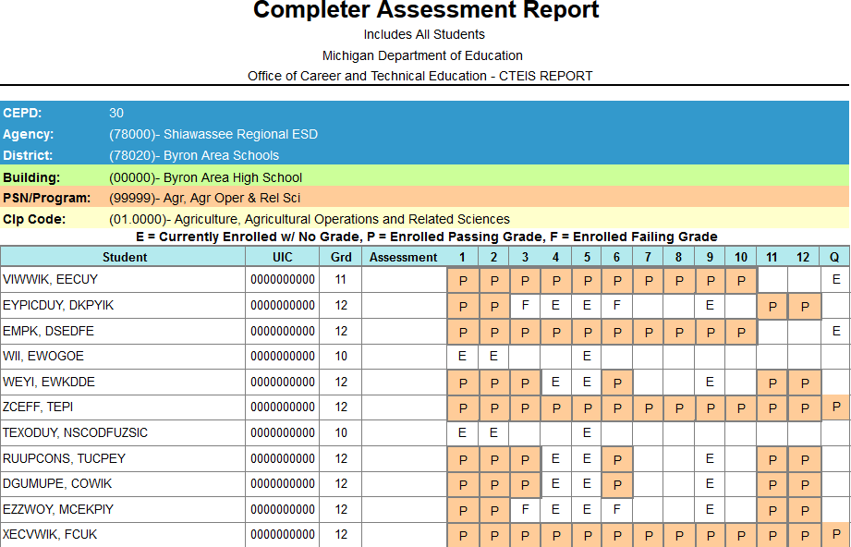

PROGRAM ENROLLMENT HISTORY REPORT

The Program Enrollment History report displays the historical information of all students enrolled within a selected program including segment profiles and recorded assessment scores. Use this report to verify that:
- Your students have been enrolled into the correct courses for the current year.
- Your courses offer the 12 segments required for your students to become completers.

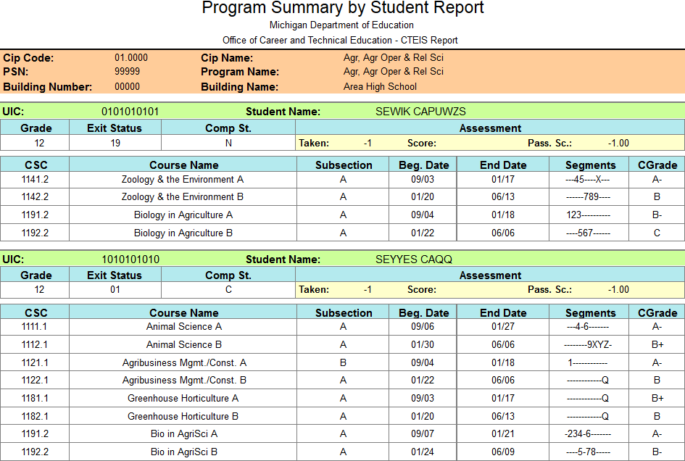

You may also use this report to verify that your students will receive credit for the expected segments and are progressing towards completion. Ask teachers to review and sign this report to indicate that all information is correct regarding their courses. If you find discrepancies in this information, please ensure that the student:
- Has a valid UIC.
- Is enrolled in the proper subsection.
- Received the correct grade.

COMPLETE YOUR REPORT

When you have verified that all your information has been correctly entered and all students are progressing within their programs as planned, you are ready to mark your data complete.

You must enter all student, course, and enrollment information into CTEIS, and your data must also pass the validation check prior to the report completion deadline in June. When these criteria are fulfilled in the spring, CTEIS will permit you to mark your report complete and submit your data to your Fiscal Agency Authorized Official for review. Please contact the CTEIS Help Desk if you require any assistance with interpreting warnings or clearing errors during the validation process.

FURTHER ASSISTANCE

Updates, newsletters, due dates, and links to important documentation can be found on the CTEIS homepage at www.cteis.com.

If you have any technical questions, please contact the CTEIS Help Desk at cteis.help@PTDtechnology.com or (800) 203-0614 x128.

APPENDICES

GENERAL CTEIS INFORMATION

STEPS FOR GAINING ACCESS TO WWW.CTEIS.COM

- You must link a MEIS account to a MILogin Third-Party Account. If you do not have a MEIS account, you can create one online at mdoe.state.mi.us/meis. Click on the Create a New MEIS Account link and follow the provided instructions.

- Your Fiscal Agency Authorized Official must activate your CTEIS account. If you are unable to login to www.cteis.com, please contact your Fiscal Agency Authorized Official and request access to CTEIS. Directions for Authorized Officials regarding user management and role delegation can be accessed on the CTEIS Knowledge Base at support.cteis.com/Portals/3/ManageUsersGuide.pdf.

LOGGING INTO CTEIS

To access the CTEIS website, type www.cteis.com into any Internet browser address bar. This will open the login page for CTEIS, where you may enter your MEIS account user name and password. Your Fiscal Agency Authorized Official will create your user account in CTEIS and set up the appropriate access rights.

For assistance with linking your MILogin Third-Party account, please see the OCTE article on the CTEIS Knowledge Base at support.cteis.com/Portals/3/Create-MILogin- Third-Party-Account.pdf.

TROUBLESHOOTING YOUR LOGIN

- Make sure your MEIS login works at the MEIS website (mdoe.state.mi.us/meis). If you cannot login to the MEIS website, contact the MEIS Help Desk at (517) 335- 0505.

- If your login works on the MEIS website and not the CTEIS website, contact your Fiscal Agency Authorized Official and make sure you have been granted proper access to CTEIS.

- If you are still unable to login to CTEIS after following the above steps, please contact the CTEIS Help Desk at cteis.help@PTDtechnology.com or (517) 333- 9363, extension 128, or toll-free at (800) 203-0614, extension 128.

CTEIS TERMS/ABBREVIATIONS

1SI, 1S2, 2SI,  3SI, 4SI, 5SI,  6SI, 6S2: | Perkins Quality Indicators (accountability factors)
ACTE: | Association for Career and Technical Education
CEPD: | Career Education Planning District
CEPI: | Center for Educational Performance and Information
CIP: | Classification of Instructional Program
CPI: | Core Performance Indicators
CTE: | Career and Technical Education
CTEIS: | Career and Technical Education Information System
FA: | Fiscal Agency
FANO: | Fiscal Agency Number (five-digit number that represents a fiscal agency)
FCS: | Family and Consumer Science
LTCS: | Less-Than-Class-Size (entered as a regular course section in CTEIS)
MDE: | Michigan Department of Education
MEIS: | Michigan Education Information System
MSDS: | Michigan Student Data System
OA: | Operating Agency (district in which CTE courses are “operated”)
OANO: | Operating Agency Number (five-digit number that represents the oper- ating agency)
OB: | Operating Building (school where a student takes CTE courses - the courses are “operated” there)
OBNO: | Operating Building Number (five-digit number that represents an oper- ating building)

OCTE: | Office of Career and Technical Education
Operating District: | District where a student takes CTE courses (see also: Operating Agency)
PIV: | Perkins IV (Carl D. Perkins Career and Technical Education Act of 2006)
PV: | Perkins V (Strengthening Career and Technical Education for the 21st Century Act of 2018)
PSN: | Program Serial Number
SRSD: | Single Record Student Database (now “MSDS:” Michigan Student Data  System)
TRAC: | Technical Review, Assistance & Compliance
WE: | Wage-Earning

DEADLINES FOR 2021 - 2022

Due September 23 | Fall Course and Staff Entry
Due November 4 | Fall Expenditure Report
Due January 6 | Follow-Up Survey Report
Due June 16 | Spring Enrollment and Completion Collection Report, including:
- EMC and dual enrollment data
- Credentials
- Work based learning experiences

ADDITIONAL DEFINITIONS

Completer: | A student who has successfully completed, with a grade of C (2.0) or better, courses totaling all 12 segments of instruction.
Concentrator: | A student who has successfully completed, with a grade of C (2.0) or better, courses totaling 8 segments of instruction.
Fiscal District: | The education agency or ISD responsible for the financial activities and use of the State Aid, Section 61a(1) funds.
OCTE: | Office of Career and Technical Education Attention: Valerie Felder  Post Office Box 30712 Lansing, Michigan 48909  Telephone: (517) 335-1066 Email: FelderV@michigan.gov
Program Serial Number (PSN): | A unique five-digit number assigned to a specific career and technical education program (CIP Code) that identifies the CEPD, district, and building in which a program is located. Identifies a particular CIP code within a particular building.  Example:

CIP Code | Program Name | PSN
52.1999 | Marketing Sales & Services | 12345

CTE SEGMENTS AND GRADES

Segments and Grades Example 1

Program A Instructional Design:
st
- Course 1 (1 semester) Segments 1, 2, 3, 4, 5, 6
- Course 2 (2 semester) Segments 7, 8, 9, 10, 11, 12
nd

Program A Student 1 Grade Profile
Course 1 Grade | 3.0
Course 1 Segments | 1 | 2 | 3 | 4 | 5 | 6
Segment Grades | 3.0 | 3.0 | 3.0 | 3.0 | 3.0 | 3.0
Course 2 Grade | 2.5
Course 2 Segments |  |  |  |  |  |  | 7 | 8 | 9 | 10 | 11 | 12
Segment Grades |  |  |  |  |  |  | 2.5 | 2.5 | 2.5 | 2.5 | 2.5 | 2.5
Aggregate Profile | 1 | 2 | 3 | 4 | 5 | 6 | 7 | 8 | 9 | 10 | 11 | 12
 | 3.0 | 3.0 | 3.0 | 3.0 | 3.0 | 3.0 | 2.5 | 2.5 | 2.5 | 2.5 | 2.5 | 2.5

Student 1 completed 12 segments by receiving a 2.0 or above in the courses taken. Student 1 is considered a completer.

Program A Student 2 Grade Profile
Course 1 Grade | 2.0
Course 1 Segments | 1 | 2 | 3 | 4 | 5 | 6
Segment Grades | 2.0 | 2.0 | 2.0 | 2.0 | 2.0 | 2.0
Course 2 Grade | 1.5
Course 2 Segments |  |  |  |  |  |  | 7 | 8 | 9 | 10 | 11 | 12
Segment Grades |  |  |  |  |  |  | 1.5 | 1.5 | 1.5 | 1.5 | 1.5 | 1.5
Aggregate Profile | 1 | 2 | 3 | 4 | 5 | 6 | 7 | 8 | 9 | 10 | 11 | 12
 | 2.0 | 2.0 | 2.0 | 2.0 | 2.0 | 2.0 | 1.5 | 1.5 | 1.5 | 1.5 | 1.5 | 1.5

In segments 7 through 12, Student 2 received a grade of 1.5, so these segments will not be counted toward completer status. Student 2 is not a completer.

Segments and Grades Example 2

Program B Instructional Design:
- Course 1 (1 trimester)Segments 1, 3, 5, 7, 9
st
- Course 2 (2 trimester)Segments 2, 4, 6, 8, 10
nd
- Course 3 (3 trimesters)Segments 8, 9, 10, 11, 12
rd

Program B Student 1 Grade Profile
Course 1 Grade | 2.5
Course 1 Segments | 1 |  | 3 |  | 5 |  | 7 |  | 9
Segment Grades | 2.5 |  | 2.5 |  | 2.5 |  | 2.5 |  | 2.5
Course 2 Grade | 2.0
Course 2 Segments |  | 2 |  | 4 |  | 6 |  | 8 |  | 10
Segment Grades |  | 2.0 |  | 2.0 |  | 2.0 |  | 2.0 |  | 2.0
Course 3 Grade | 3.0
Course 3 Segments |  |  |  |  |  |  |  | 8 | 9 | 10 | 11 | 12
Segment Grades |  |  |  |  |  |  |  | 3.0 | 3.0 | 3.0 | 3.0 | 3.0
Aggregate Profile | 1 | 2 | 3 | 4 | 5 | 6 | 7 | 8 | 9 | 10 | 11 | 12
 | 2.5 | 2.0 | 2.5 | 2.0 | 2.5 | 2.0 | 2.5 | 3.0 | 3.0 | 3.0 | 3.0 | 3.0
Student 1 completed 12 segments by receiving a 2.0 or above in the courses taken. Student 1 is considered a completer.

Program B Student 2 Grade Profile
Course 1 Grade | 2.0
Course 1 Segments | 1 |  | 3 |  | 5 |  | 7 |  | 9
Segment Grades | 2.0 |  | 2.0 |  | 2.0 |  | 2.0 |  | 2.0
Course 2 Grade | 2.0
Course 2 Segments |  | 2 |  | 4 |  | 6 |  | 8 |  | 10
Segment Grades |  | 2.0 |  | 2.0 |  | 2.0 |  | 2.0 |  | 2.0
Course 3 Grade | 1.5
Course 3 Segments |  |  |  |  |  |  |  | 8 | 9 | 10 | 11 | 12
Segment Grades |  |  |  |  |  |  |  | 1.5 | 1.5 | 1.5 | 1.5 | 1.5
Aggregate Profile | 1 | 2 | 3 | 4 | 5 | 6 | 7 | 8 | 9 | 10 | 11 | 12
 | 2.0 | 2.0 | 2.0 | 2.0 | 2.0 | 2.0 | 2.0 | 2.0 | 2.0 | 2.0 | 1.5 | 1.5
In segments 11 and 12, Student 2 received a grade of 1.5, so these segments will not be counted toward completer status. Student 2 is not considered a completer.
NOTE: Segments 8 and 10 were delivered through two different courses. CTEIS uses the highest provided grade when determining the segments to count toward completer status.

IMPORT FORMATS

Using Microsoft Excel, you may import data for:
  - Courses
  - Students
  - Enrollments (with grades)

Excel Spreadsheet Format

The Excel spreadsheet is a versatile file type you may use to import your student, enrollment, class, and grade data into CTEIS. The following rules apply to Excel spreadsheets:

- Columns may appear in any order, but column headings must match the accepted Excel specifications exactly, including capitalization. Remove unwanted spaces—CTEIS may interpret these blank characters as part of the column header text.

- Specify that all cells contain text information, not numeric or “general” data, to avoid conversion errors when you upload your spreadsheet into CTEIS.

The Excel format provides a certain degree of flexibility in that only the required columns need to be present in the spreadsheet in order to successfully upload it. If your file contains more fields than are required for a particular import, CTEIS will simply ignore information it cannot use, including blank columns. Remember, your Excel import file should contain only one worksheet.

Sample Records:
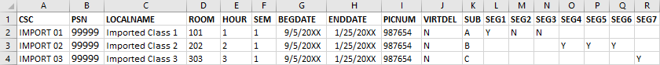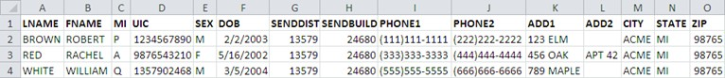

COURSE DATA HEADING FORMATS

Excel Format – Course Data Headings

Column Information |  | Acceptable Values / Instructions | Required  / Default
Column Heading | Description
CSC | Course Section Code | Unique identifier for course within school management system | Y
PSN | Program Serial Number | Parent program reference. Must be within the building you are importing data into | Y
LOCALNAME | Course Local Name |  | Y
ROOM | Room Number | Room designation where the course is held | Y
HOUR | Hour |  | Y
VIRTDEL | Virtual Delivery | Indicate a virtual delivery course and its nature. Acceptable values:  NV — Not Virtual  VC — Virtual Course BL — Blended Learning DL — Digital Learning | N  Default: NV
SEM | Semester | Must be a valid semester value:  - First Semester  - Second Semester  - Summer Session  - Special Semester  - Trimester | Y
BEGDATE | Course Beginning Date | Typed dates will be accepted in the following formats: (m)m/(d)d/yy, (m)m/(d)d/yyyy, mmddyy, and mmddyyyy | Y
ENDDATE | Course End Date | Typed dates will be accepted in the following formats: (m)m/(d)d/yy, (m)m/(d)d/yyyy, mmddyy, and mmddyyyy | Y
PICNUM | PIC Number of Primary Instructor | This must be a valid PIC Number within CTEIS and the PIC system | Y

Column Information |  | Acceptable Values / Instructions | Required  / Default
Column Heading | Description
DUAL | Dual Enrollment | Y/N values  N: Secondary CTE Course — No dual or concurrent enrollment college credit on college transcript. May earn articulated or AP credit.  Y: Postsecondary CTE Course — Provides dual or concurrent enrollment college credit on college transcript. | N  Default: N
CCRED | College Credit | If dual enrollment enabled, default college credit granted | N  Default: 0
HSCRED | High School Credit | If dual enrollment enabled, default high school credit granted | N  Default: 0
SUB | Subsection | Must be a valid subsection (A, B, C, D) | N  Default: A
SEG1 | Segment 1 | Y/N values | N  Default: Y
SEG2 | Segment 2 | Y/N values | N  Default: N
SEG3 | Segment 3 | Y/N values | N  Default: N
SEG4 | Segment 4 | Y/N values | N  Default: N
SEG5 | Segment 5 | Y/N values | N  Default: N
SEG6 | Segment 6 | Y/N values | N  Default: N
SEG7 | Segment 7 | Y/N values | N  Default: N

Column Information |  | Acceptable Values / Instructions | Required  / Default
Column Heading | Description
SEG8 | Segment 8 | Y/N values | N  Default: N
SEG9 | Segment 9 | Y/N values | N  Default: N
SEG10 | Segment 10 | Y/N values | N  Default: N
SEG11 | Segment 11 | Y/N values | N  Default: N
SEG12 | Segment 12 | Y/N values | N  Default: N
SEG13 | Segment Q | Y/N values | N  Default: N

Excel Format – Segment Data Headings

If segment data is left blank, the import process will:

- Set the segment to Segment #1 for a wage-earning course or Segment #2 for a FCS course if the course section does not already exist.

- Copy pre-existing segments if the course section remains from a previous year.

STUDENT AND ENROLLMENT (WITH GRADES) HEADING FORMATS

Excel Format – Student and Enrollment (with Grades) Headings

Column Information |  | Acceptable Values / Instructions | Include When Reporting:
Column Heading | Description |  | Students | Enrollments | Grades/WBL
LNAME | Student Last Name | Must match the UIC Master | ✓ | ✓ | ✓
FNAME | Student First Name | Must match the UIC Master | ✓ |   |  
MI | Student Middle Initial |  |   |   |  
UIC | Student UIC | - Must pass checksum  - Must be unique  - First name, last name, birth date, and gender verified with the UIC Master | ✓ | ✓ | ✓
SEX | Gender Code | M/F values | ✓ |   |  
DOB | Date of Birth | Acceptable date formats: (m)m/(d)  d/yy, (m)m/(d) d/yyyy, mmddyy, and mmddyyyy | ✓ |   |  
SENDDIST | Sending District | Must be a valid sending district based on the Educational Entity Master (EEM) | ✓ |   |  

Column Information |  | Acceptable Values / Instructions | Include When Reporting:
Column Heading | Description |  | Students | Enrollments | Grades/WBL
SENDBUILD | Sending School or Facility | - Must be a valid sending building within the above sending district; verified with the EEM  - For codes beginning with zero, ensure the leading zero appears in your file | ✓ |   |  
PHONE1 | Phone 1 | (###) ### - #### |   |   |  
PHONE2 | Phone 2 | (###) ### - #### |   |   |  
ADD1 | Address 1 |  |   |   |  
ADD2 | Address 2 |  |   |   |  
CITY | City or Town |  |   |   |  
STATE | State | 2-letter abbreviation for state |   |   |  
ZIP | Zip Code | ##### ( - ####) |   |   |  
EMAIL | E-mail | Student’s primary  e-mail address |   |   |  
SP | Single Parent | Y/N values (Default: N) |   |   |  
DH | Displaced Homemaker | Y/N values (Default: N) |   |   |  
CSC | Course Section Code | *To import data for this class, you must enter it into CTEIS first |   | ✓ | ✓

Column Information |  | Acceptable Values / Instructions | Include When Reporting:
Column Heading | Description |  | Students | Enrollments | Grades/WBL
BEGDATE | Student Begin Date | Date student began enrollment |   |   |  
ENDDATE | Student End Date | Date student ended enrollment |   |   |  
WBL | Work Based Learning Experiences | Indicate work based learning experiences.  Acceptable values:  A — Career Awareness E — Career Exploration P — Career Preparation  T — Career Training Y — Youth Apprenticeships |   |   |  
SUB | Subsection | The subsection of a course a student is enrolled in— defaults to Subsection A if left blank |   | ✓ |  
CRSGRD | Course Grade | Letter grade received by the student in the current course section |   |   | ✓
MGNT | Migrant | Y/N values (Default: N) |   |   |  

