CTEIS Spring Tasks Training User Exercise.
In this exercise, you'll be able to familiarize yourself with the key features and functions of CTEIS enrollment screens. Designed to help you get hands-on experience, this training provides prompts to walk you step-by-step through preparing your Year-End enrollment data. Whether you’re a new user, or looking to refine your skills, this practice session is an excellent way to build your expertise. Follow the instructions carefully, and don’t hesitate to contact the CTEIS Helpdesk if you need assistance with technical issues.
Goal: Create New Courses in your building.

Login:
- Login into Train.cteis.com using your MILogin for Business Username and password.
- Click "Data Entry" in the top header menu after logging in. Focus on the Enrollment column. Contact your Level 5 Fiscal Agency Authorized Official for help if the Enrollment column is not visible.
- Select Manage Courses

Create a new course:
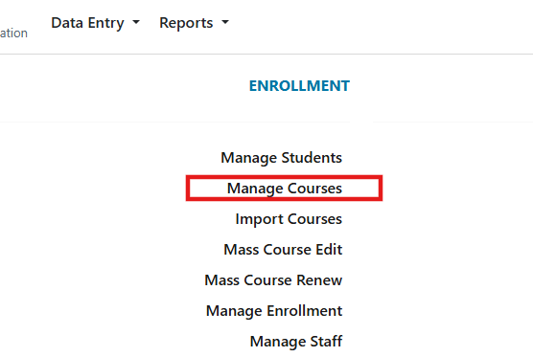

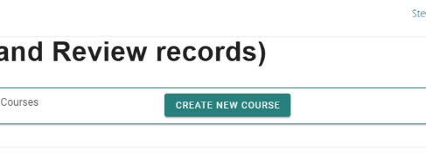
- Select: Create New Course

- Choose a building for the new course.
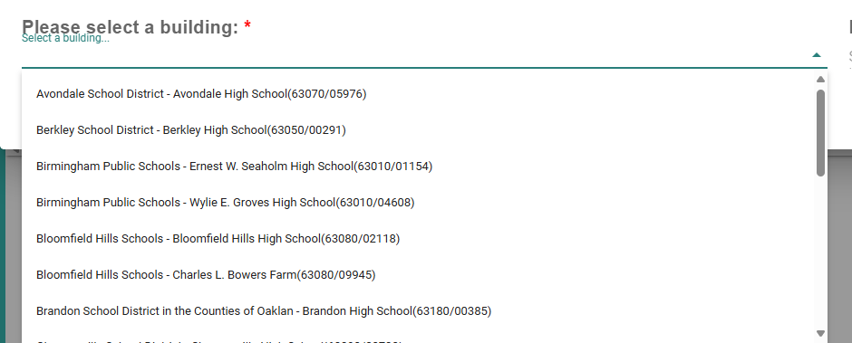

- Select a Perkins V program (P5). P5 programs are indicated after the course name and program type. The arrows highlight: Course Name, Program Type (REG-regular, EMC-Early Middle college), Perkins Type (P4, P5), and CIP code.
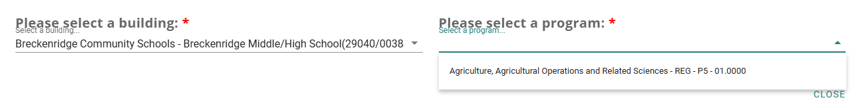
Perkins Type
Program Type
Program Name

CIP code

Note: It is possible that the building you select may not host a P5 program. If so, try another building. If you are unable to find a P5 program, a P4 program may be used, but you will enter segments instead of competencies.

- Enter all the course details listed below. See (manage courses) for more information on course details.
- Course Section Code: P5TC1
- Local Course Name: P5 Test Course 1
- Start Date: 09/01/2024
- End Date: 11/1/2024
- Semester 1
- Room: 121
- Course Section Period: 3
- Virtual Delivery: Not Virtual
- Check Secondary CTE Course
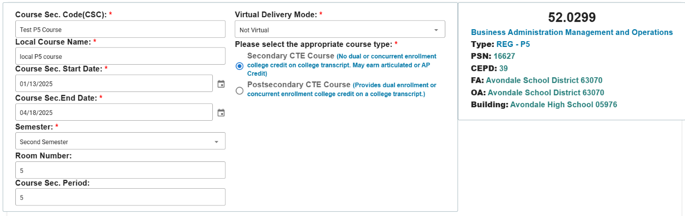

- Enter competencies: A1, A2, for subsection A, and B1, B2 for subsection B in the competency profile panel. If you have a P4 course, please enter segments.

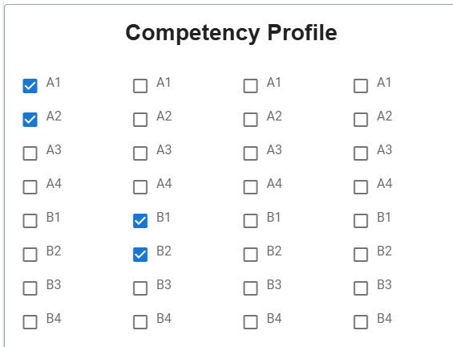

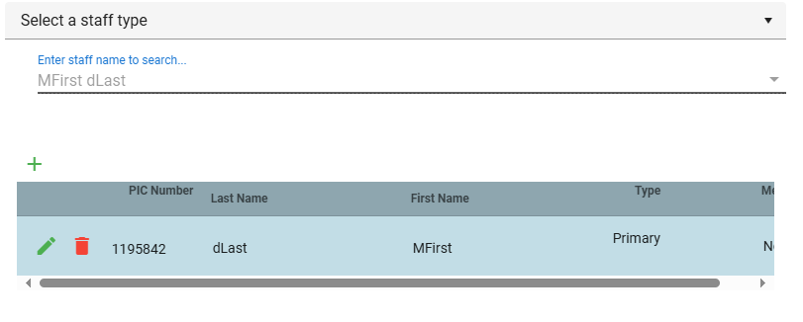
- Add the Staff member as the Primary Staff person: Search for a staff member with a last name of “DLast” and select the one on the top of the list.

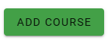
- Review all your entries and when satisfied, select:

- If successful, you will get a green success message in the lower right corner.
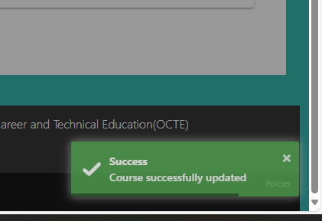

- Verify your course was entered by searching for it on the course table. Enter “Test” in the Course Name column heading. Select the “Book” icon and review the course details.
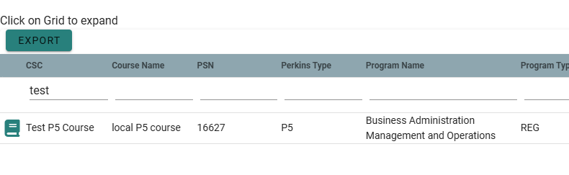

- Add a second P4 course using the details listed below:
- Course Section Code: P4 TC2
- Local Course Name: P4 Test Course 2
- Start Date: 6/1/2024
- End Date: 11/1/ 2024
- Semester 1
- Room 121
- Course Section Period: 3
- Virtual Delivery: Not Virtual
- Check Secondary CTE Course

- Follow the instructions outlined above to add Primary Staff and save the course details. Verify that your course was entered by searching for it on the course table.
- Find the P5 TC1 course you created. Edit the course to end on December 11, 2024. Save your changes.

