CTEIS Spring Tasks Training User Exercise.
In this exercise, you'll be able to familiarize yourself with the key features and functions of CTEIS enrollment screens. Designed to help you get hands-on experience, this training provides prompts to walk you step-by-step through preparing your Year-End enrollment data. Whether you’re a new user or looking to refine your skills, this practice session is an excellent way to build your expertise. Follow the instructions carefully, and don’t hesitate to contact the CTEIS Helpdesk if you need assistance with technical issues.
Goal: To enroll students into a course section.
- Log in to Train.cteis.com using your MILogin for Business Username.
- Click "Data Entry" in the top header menu after logging in. Focus on the Enrollment column and select Manage Enrollment. If the Enrollment column is not visible, reach out to your Level 5 Fiscal Agency Authorized Official for help.
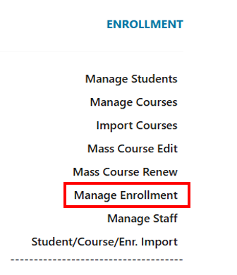
Example:

- Select the “P5 Test Course 1” from the create course exercise in the course table. To locate the course, the district must match the previous exercise. Input the Course Section Code to search for the course. Click on the book icon to select the course. If you did not complete the previous exercise, please select a course from the course table.
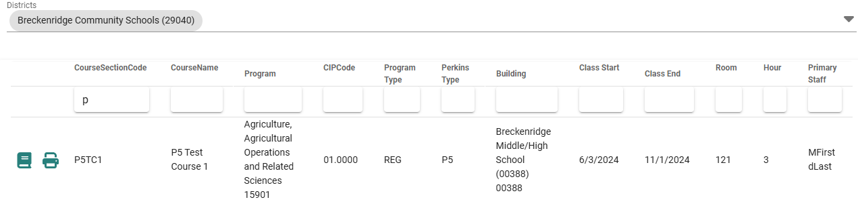

- Add enrollments to the course by clicking on the Add Enrollment button and selecting the building using the drop-down menu.
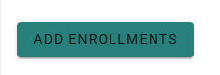

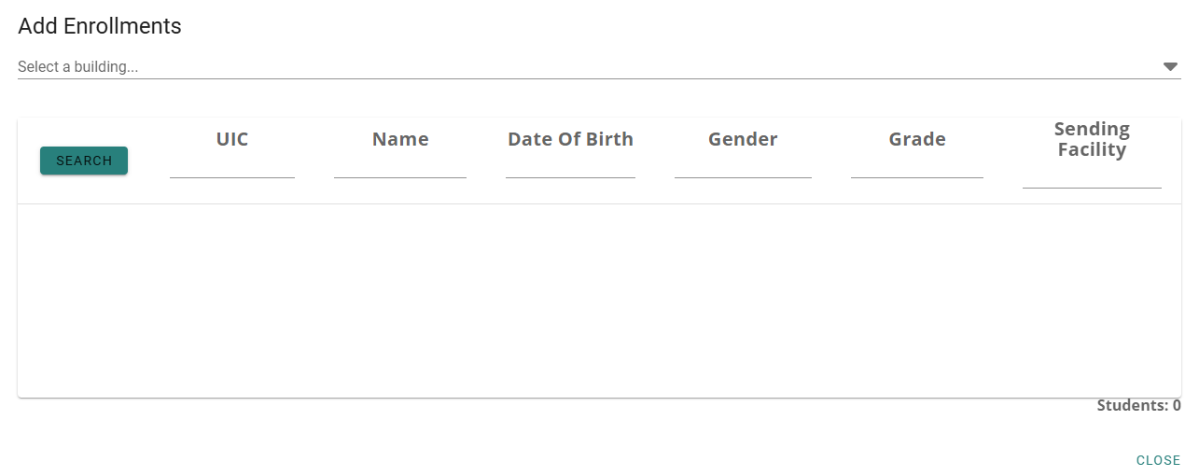

  - Locate the students you created by entering the UICs in the panel. Click on the subsection to the left of the student’s UIC to add them to the course.
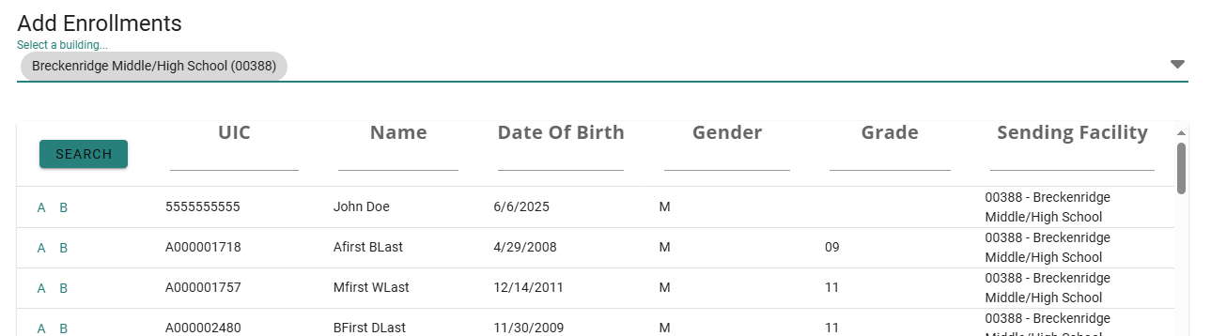

  - CTEIS will automatically update your changes. Press Close at the bottom right to exit out of the screen.
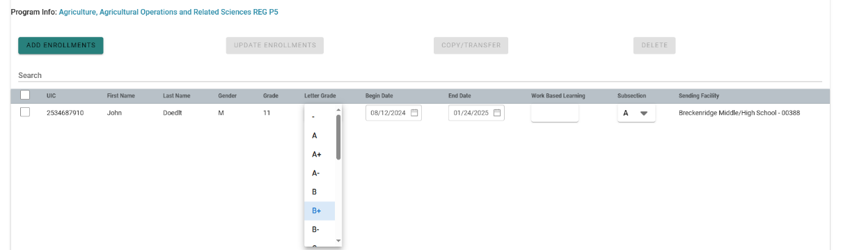
  - Using the same course, update a student’s letter grade using the drop-down menu under the letter grade column. CTEIS will automatically save your changes.

- Review enrollments from the Student Page
  - From the enrollment menu, select Manage Students and select the previously used building. In the student panel, select the student from your previous entries and click the student icon to the left of the UIC to open the student’s data panel. View the changes you made in the student’s Program Enrollment History panel.
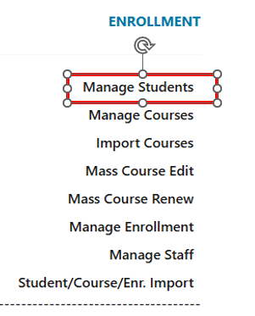

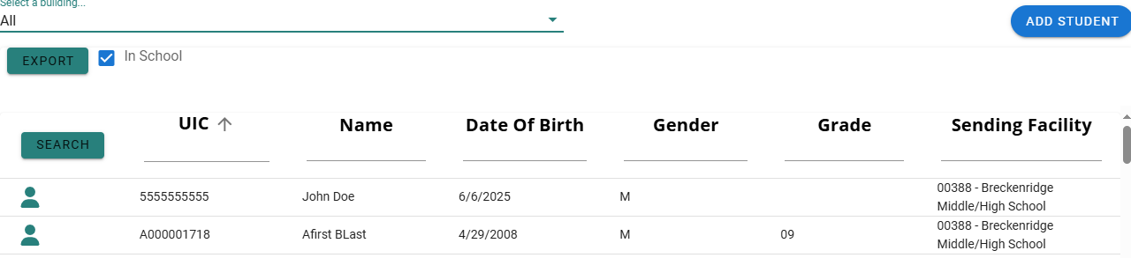

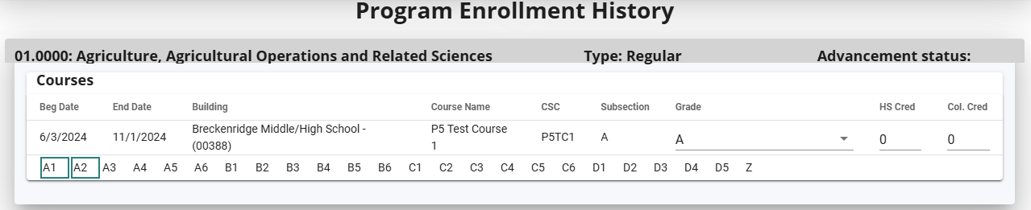

- Review Building Reports. To view Building Reports, click on the “Reports” option in the header menu and select “Building Reports.” The available reports are listed below:
    - Class Student List
    - Missing grades
    - Student Advancement Export
    - EMC and Dual Enrollment Report
    - Program Enrollment History Report
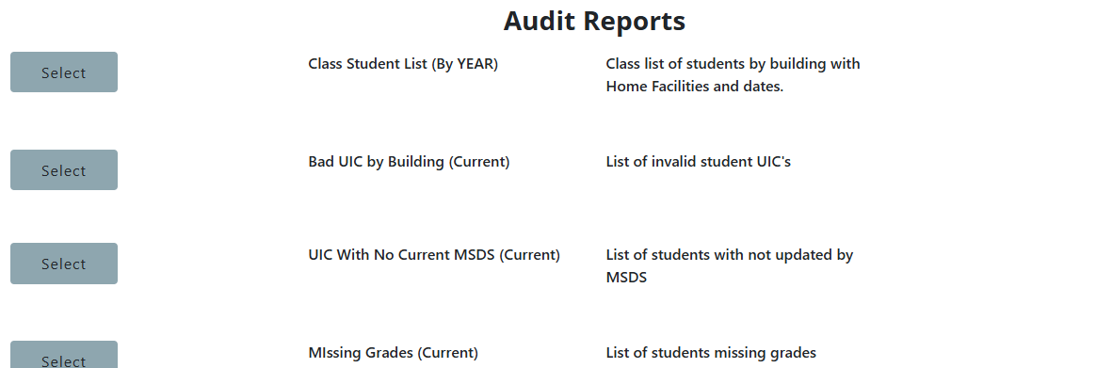

Building Reports are valuable tools for verifying student data. When data is entered into CTEIS, these reports are generated and can help assist in completing your enrollment report.

