CTEIS Spring Tasks Training User Exercise.
In this exercise, you'll be able to familiarize yourself with the key features and functions of CTEIS enrollment screens. Designed to help you get hands-on experience, this training provides prompts to walk you step-by-step through preparing your Year-End enrollment data. Whether you’re a new user or looking to refine your skills, this practice session is an excellent way to build your expertise. Follow the instructions carefully, and don’t hesitate to contact the CTEIS Helpdesk if you need assistance with technical issues.
Goal: To add a student record to CTEIS
- Log in to Train.cteis.com using your MILogin for Business Username. Please note: You will automatically be logged into the CTEIS training site; no third-party verification is needed.
- Click "Data Entry" in the top header menu after logging in. Focus on the Enrollment column. If the Enrollment column is not visible, reach out to your Level 5 Fiscal Agency Authorized Official for help.
- Select the Manage Students option from the menu.
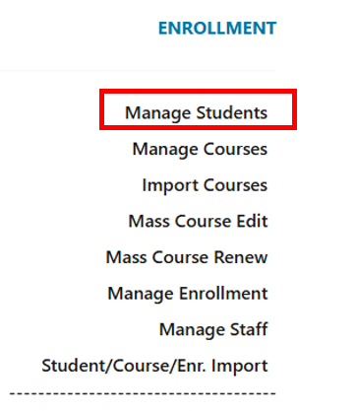
Example:

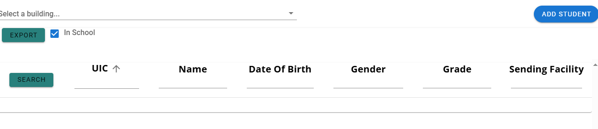

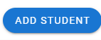

- Click on the Add Student button. Create a new student by entering the following data into the system:
- First Name: John
- Last Name: Doe
- DOB: 6/6/2007
- UIC: Enter a random 10-digit number.
- Gender: Male
- Sending Facility: Enter the building from the previous course exercise or select one.
- Enter in address (make one up)

- Leave the Single Parent and Out of Work Force fields blank.
- Click the Save Student button to save your entries. You should see a Success confirmation message from CTEIS. The MSDS data panel is automatically adjusted. Please see the Manage Students guide for a detailed description of the MSDS data panel.
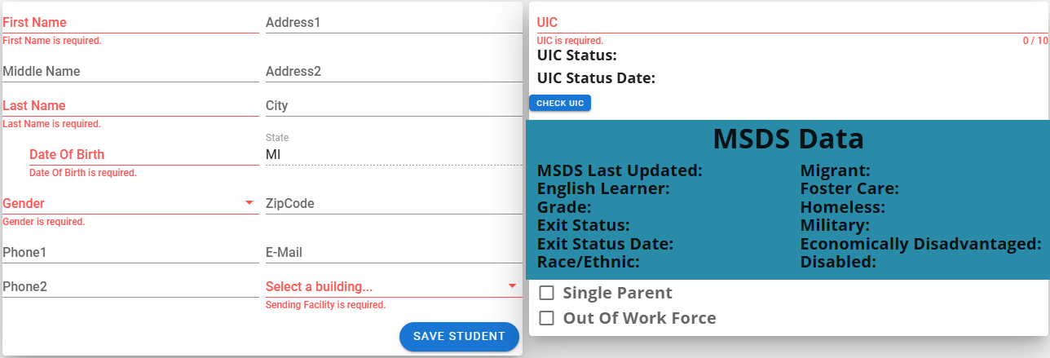

- Review your entries. In the Student data panel, enter the UIC for the “John Doe” student you created. The student should appear in the student data panel.
- Create a student enrollment import file. (Importing templates can be found on the knowledge base under Imports).
- Using the student Excel import template provided on the knowledge base, fill in the columns with student data.
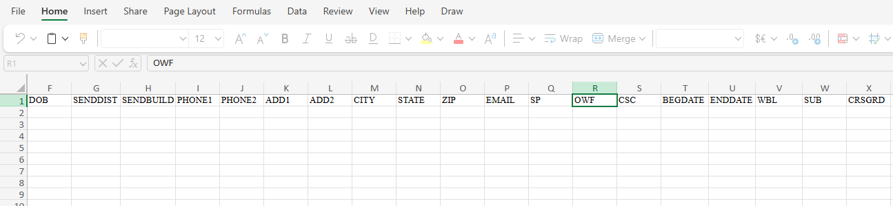

- To import the data into CTEIS, select the Student/Course/Enr. Import link under the enrollment column. Select the building.
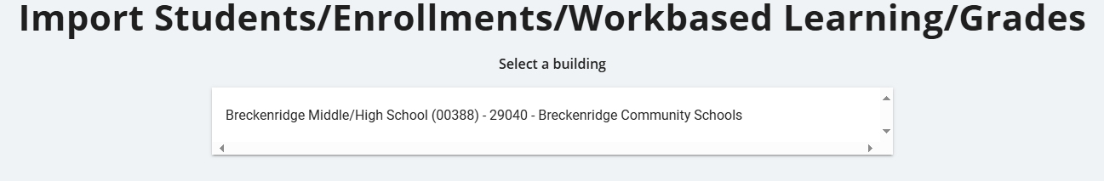

- Select the Import Enrollment File button. CTEIS will prompt you to select the student Import file you created. To load the file, click open, and the student data should appear on the screen.
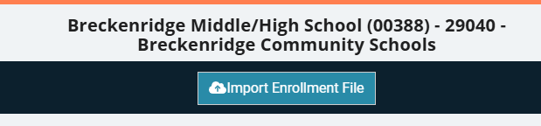

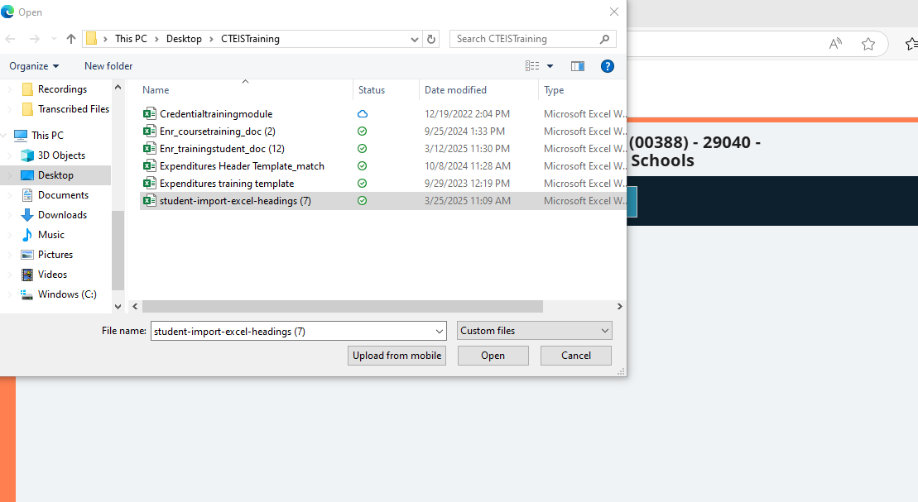

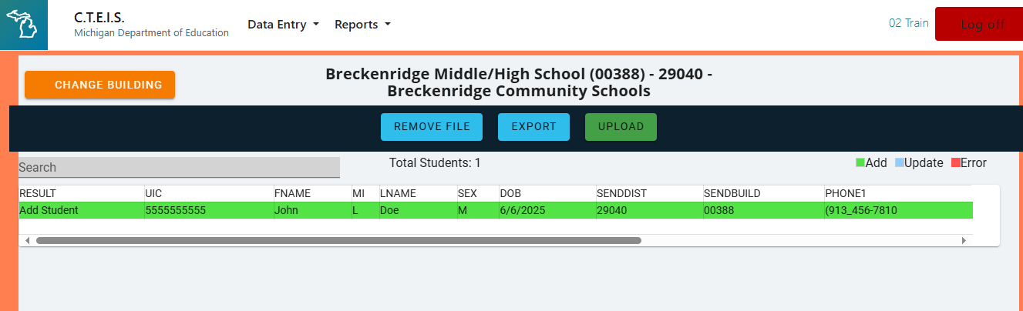

- If there are errors in your file, you must remove the file, correct the errors offline, and upload the file again. You should see a green “Add” color on the student row of your import file. Click the Upload button, and you will receive confirmation from CTEIS.
- To verify your import, navigate to the Data Entry header and select Manage Students. Upon successful entry of the import, you will see the student data in the student grid.

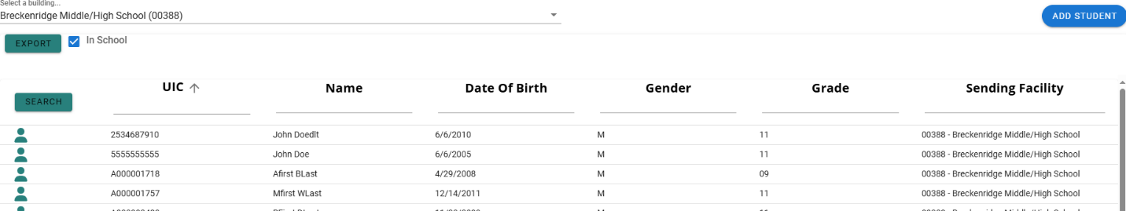

- To edit a student record, search for the student John Doe by entering the UIC in the field provided and clicking the search button.
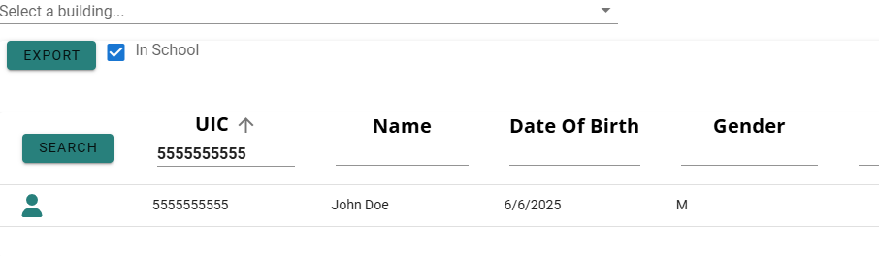

- Click the student icon to select the student record. You may edit contact information by entering data into the fields and clicking the Save Student button.

