Woodworking (48.0701) Student advancement example
Instructional Design.
- 3-semester program
- Z is available in the 4th semester if the student completes.
EXAMPLE |  |  |  |  |  | Competencies
Course | Sem | Grade | A1 | A2 | A3 | A4 | B1 | B2 | B3 | B4 | B5 | C1 | C2 | C3 | C4 | C5 | Z
Beg WW | 1 |  | X | X |  |  | X | X |  |  |  | X | X
Inter WW | 2 |  |  |  | X | X |  |  | X | X |  |  |  | X | X
Adv WW | 3 |  |  |  |  |  |  |  |  |  | X | X |  |  |  | X
Adv Topics | 4 |  |  |  |  |  |  |  |  |  |  |  |  |  |  |  | X

Student One
- Student One takes 3 courses.
- Passes all courses with 2.0 or above
- Receives credit for all competencies.
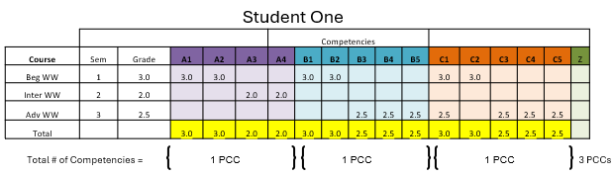
- Student One has 3 PCCs and is a Completer

Student Two
- Student Two takes 2 courses
- Passes both courses
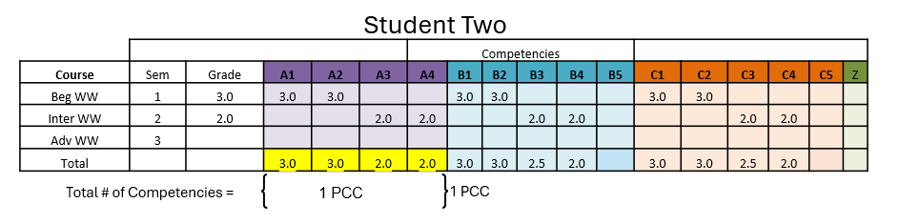
- Student Two has 1 PCC and is a Participant

Student T
Student Three
- Student Three takes 2 courses
- Fails one course
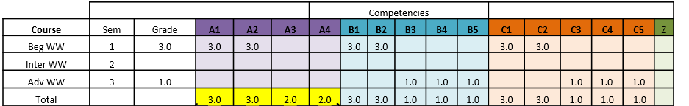
- Student Three has 1 PCC
1 PCC
Total # of Competencies =
1 PCC
Student Three

