Program A: Instructional Design.
- 2 Semester program
- Q is available in the 4th semester if the student completes
- Course 1 (1st semester) Segments 1, 2, 3, 4, 5, 6
- Course 2 (2nd semester) Segments 7, 8, 9, 10, 11, 12
Student One
- Student One takes 2 courses
- Passes all courses with 2.0 or above
- Completed 12 segments with a 2.0 or above
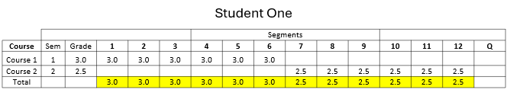
- Student One is a Completer

Student Two
- Student Two takes 2 classes
- In segments 7 through 12, Student Two received less than a 2.0
- Student Two completed 6 segments
- Student Two is a Participant
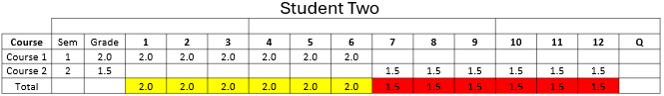

Program B: Instructional Design
- 3-semester program
- Q is available in the 4th semester if the student completes
- Course 1 (1st trimester) Segments 1, 3, 5, 7, 9
- Course 2 (2nd trimester) Segments 2, 4, 6, 8, 10
- Course 3 (3rd trimesters) Segments 11, 12

Student Three
- Student Three takes 3 courses
- Completed 12 segments by receiving a 2.0 or above.
- Student Three is a Completer
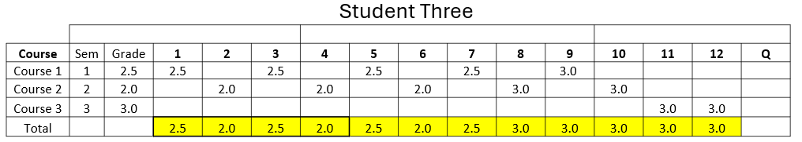

Student Four
- Student Four takes 3 courses
- In segments 11 and 12, Student Four received less than a 2.0, so these segments will not be counted toward completer status.
- Student Four completed 10 segments and is a Concentrator
