SPRING/SUMMER ENROLLMENT

The Spring Enrollment report is completed in mid-June, and the CTEIS system will use the data you enter to determine your student counts, student advancement statuses, and the students your Follow-Up personnel will contact.
This information feeds into the CPIs and other federal reports, and student count information dictates how OCTE will distribute Added Cost funds to the many CTE programs across Michigan in the next school year. Because the information from this report is used to determine funding allocations as well as to fulfill federal reporting requirements, it is important that all data is complete and accurate.
The Spring/ Summer Task listed below is to assist with spring enrollments. To ensure that you maximize your student advancement, the following information outlines best practices for data entry and verification:

- Make sure that you complete your enrollments, including:
  - All courses entered
  - All students enrolled
- Verify that UIC’s are valid
- Ensure that MSDS records are updated
- Make sure that grades and course completion status is entered into CTEIS
- Verify that all Migrant Student data is entered
- Verify that all Competency Course Profiles are finalized
- Staff and supporting staff must be valid and updated.
- Work Based Learning must be entered.
- Any credentials earned up to this point must be entered if to be considered for the funding formula
- Review enrollments using supporting reports to ensure students are progressing correctly.
- All enrollments must pass validation before you can complete and submit your report
- Complete and submit your report.

Best Practices for Data Entry
Course and Student Data can be entered manually using the following CTEIS screens:
- Manage Courses
- Manage Students
- Manage Enrollment
Data Entry by Imports- Utilizing the File Import feature is highly recommended. This tool can save you valuable time and will minimize data entry errors. You may upload error-free records into your CTEIS database at any time; furthermore, if CTEIS detects problems with your import file, it will generate a list of warnings and errors for you to review. The system stores the affected records until you correct your data file and import it again.
Data Review- It is important to review your data. Reviewing data can be done with the help of CTEIS validation and reporting tools. These reports and tools allow you to quickly verify data entries and ultimately ensure that your information is complete and accurate. CTEIS validation tools are useful for illuminating invalid data, that is, information that does not meet the system's specified criteria; however, information that has been entered improperly will not always produce errors.
Examples of common data entry mistakes include:
- Enrolling students into the wrong course section.

- Incorporating incorrect competencies into your courses.
Mistakes such as these can reduce student advancement within your programs. To prevent this, you are required to review your instructional design and the available summary reports with the individuals who provide your information.

WORK BASED LEARNING
What is Work Based Learning?
Work Based Learning is an element within Career and Technical Education that provides students with the opportunity to learn a variety of skills by expanding the classroom into the community. It narrows the gap between theory and practice through academic preparation with hands-on career development experiences. Programs will report the types of Work Based learning the student experienced during the school year, and the number of experiences of each type.
To assist with tracking this information, OCTE and PTD Technology have developed tools to support teachers, Work Based learning coordinators, and data entry staff. The CTEIS Work Based Learning feature captures Work Based learning experiences entered either manually or through an import process.

Work Based Learning Continuum
The Work Based Learning Continuum describes the nature of the experiences that students may receive. Resources for teachers, Work Based learning coordinators, and others responsible for identifying Work Based learning experiences may be found on the OCTE website. Resources include the Work Based Learning Continuum document and CTE Teacher Technical Tool Kit, as well as the materials shared at the OCTE Fall Update. Please visit the OCTE website at: www.Michigan.gov/octe, click on CTE Instructional Programs, and scroll down to the Work Based Learning section. The letters on the continuum will be used for reporting Work Based learning in CTEIS as described in the diagram below:
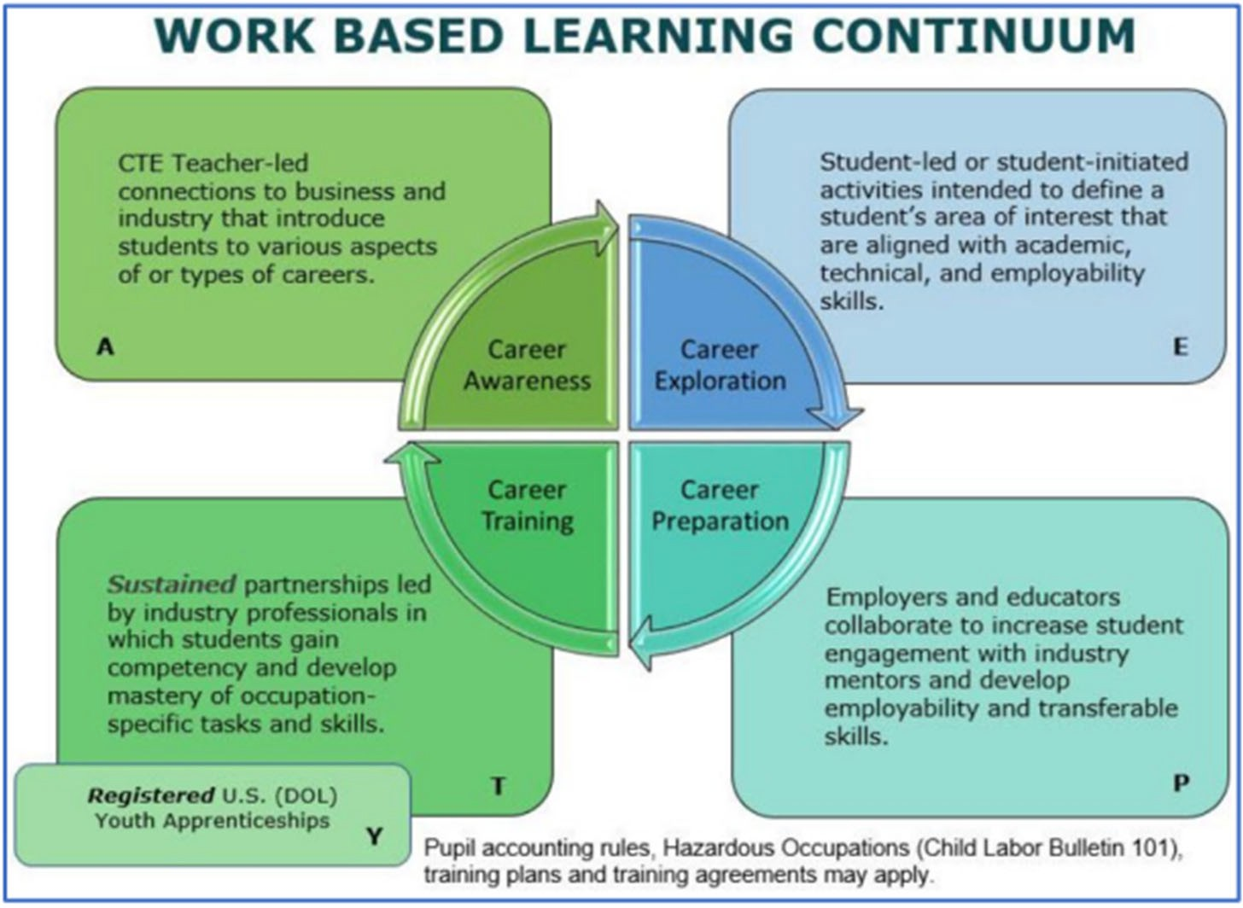

Full instructions on how to enter Work Based Learning can be found here.

What is a Credential?
A credential is a qualification of a specific set of competencies related to a particular industry or occupation. Credentials can be used to signal that an individual has acquired the knowledge, skills, and abilities required in a specific occupation or industry.
Before submitting your final enrollment data for review, you will need to indicate any certifications or other credentials your students attain during the current school year. Enter all credentials received by students each year so that CTEIS may determine when each student qualifies for the Post-Secondary Credential indicator.
Each of your programs must either:
- List the students who receive credentials in the current year.
- State that no credentials were provided in the current year.
Credentials will be reviewed for accuracy during the validation process, and you may also view this information as part of a student's profile on the Manage Students screen. The Manage Credentials feature allows you to view, edit, and import student certifications.
- Instructions on how to Manage Credentials using CTEIS screens can be found here
- A list of Current State-approved credentials can be found here

